**1) Write a leave letter to the Principal by using different alignments, correct formats in MS Word.**

**Procedure:**

**Step 1:** Open MS-Word by click on START button; go to All Programs, then select Microsoft Office Word.

**Step 2:** To open a new document, Click on Office Button then select New - > Blank Document then click on create option.

**Step 3:** Then select TEXT AREA, and then write Leave Letter as a heading, Select the text, click on bold button to make it bold as **“LEAVE LETTER”,** and change the font size to 16.

**Step 4:** Then write date and place in a format as follows

DATE**:** 01/09/2022,

Hyderabad.

Then Select the text and make it right by clicking on right alignment button 

**Step 5:** Then write To address as follows and select this text and make it left by clicking on left alignment button 

To

The Principal,

SIVA SIVANI DEGREE COLLEGE,

KOMPALLY,

SECUNDRABAD.

**Step 6**: Then write Subject according to your letter. And select this text and press tab button for two times.

**Step 7:** Then write the body of the letter according to your letter. And select this text and make it justification by clicking on justify alignment button 

**Step 8:** Then write “Thanking you Mam,” select this text and make it to center by clicking on center alignment button 

**Step 9**: Now write the “From address” as follows

Yours Faithfully,

xxxxx.

Then make it right by clicking on Right alignment button 

**Step 10**: This is the final step in writing leave letter. In this step, we have to save the letter as “leave letter.docx” by selecting “Save” option from Office button. Then a prompt window will ask you to write a file name. Now you have to give the file name and press the save button.

**OUTPUT:**

Date:01/09/2022,

Hyderabad.

To

The Principal,

SIVA SIVANI DEGREE COLLEGE,

KOMPALLY,

SECUNDRABAD.

Sub: Requesting for 5 days leave

Respected Mam,

I XXXX studying B.COM(CA) I SEM in your college. As I am going to my home on the occasion of festival and also to celebrate my birthday on the next day. So I kindly request you to grant me leave for 5 days i.e.,05/09/2022-08/09/2022.

Thanking You Mam,

Yours Faithfully,

XXXXX,

BCOM(CA), I SEM.

**2) Create a letter to invite of your college Fresher’s party to your friends by using Mail Merge in MS Word.**

**Procedure:**

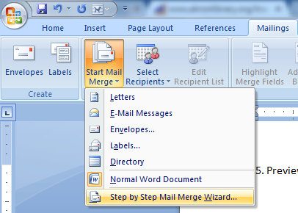**To get started:**

* Click on the **Mailings** tab, then the Start **Mail** **Merge** button, and then **Step by Step Mail Merge** Wizard…

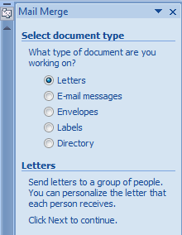

* The wizard will open in the task pane to the right. Select your document type.

**To create the letters**

**Step 1: Select Document Type**

1. Select **Letters** from the Mail Merge task pane and click on next to start the document.
2. Click Next: **Starting document**

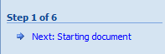

**Step 2: Starting Document**

1. Click Use the **Current Document** under Select starting document
2. Click Next**: Select recipients**

**Step 3: Select reciepents**

The recipients can come from either an existing Excel file, or Access table or you can create a new list.

**If Using an Existing List:**

1. Click Use an existing list under Select recipients
2. Click Browse
3. Select the file
4. Click Open Mail Merge Recipients opens showing the names and addresses from your file
5. Click OK

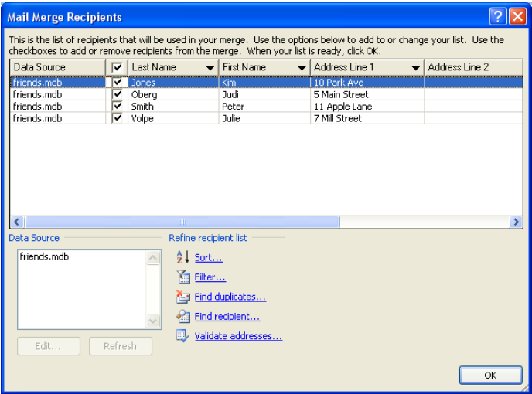

1. Click Next**: Write your letter**

**To Type a New List:**

* Click **Type a new list** under Select recipients
* 2) Click **Create**
* Click **Customize** **Columns** to modify the list of fields

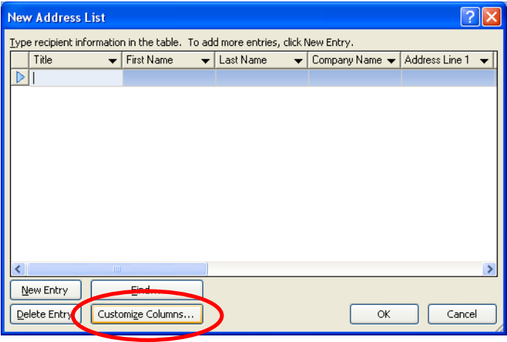

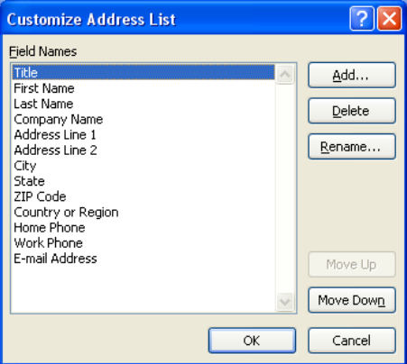

* Delete any unnecessary field names and/or add new ones
* Click OK
* Type records here hitting TAB to advance to the next field and to continue adding new records
* Click OK
* Click Save

The recipients list will be saved as a separate file as a Microsoft Access file type. It is saved in the My Data Sources folder. It is recommended to save the file in this folder.

* Click Next: **Write your letter**

**Step 4: Write your letter**

* 1. Click the location in your document where the data from the mail merge fields need to be inserted
  2. Insert the fields using **Insert** **Merge** **Field** from **Mailings** tab.

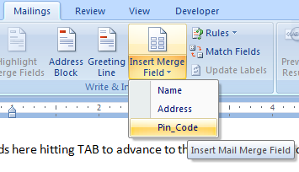

The field name will look like this**: <<Name>>**

* 1. Repeat this step until all fields have been inserted. Remember to put spaces and punctuation where needed.
  2. Click Next: Preview your letters

**Step 5: Preview your letters**

* Here is where you can preview the first page with the fields filled in.
* Click Next: Complete the merge

**Step 6: Complete the merge**

**To Complete the Merge:**

* Click Print to send directly to the printer
* Click Edit individual letters to create a new file

**OUTPUT:**

D:20/09/2022,

Hyderabad.

To,

Gopinath,

xxxxxxxxxx,

James Street,

Hyderabad.

Dear Gopinath,

Hai! How are you? Am fine here. How are your studies going on? What about the mid exams. Am happy to say that our college has conducted FRESHERS PARTY for us in the last week at our college premises. Many competitions such as sports, food competition and funny games were conducted before the Fresher’s Day. We enjoyed a lot up to the last second of the party and our college has provided food and transportation facility also. Ok bye and “ALL THE BEST” for your exams.

Yours Lovingly,

A.Ravi kumar.

D:20/09/2022

Hyderabad

To,

Shiva,

yyyyyyyyyy,

Geetha Bhavan,

Hyderabad

Dear Shiva,

Hai! How are you? Am fine here. How are your studies going on? What about the mid exams. Am happy to say that our college has conducted FRESHERS PARTY for us in the last week at our college premises. Many competitions such as sports, food competition and funny games were conducted before the Fresher’s Day. We enjoyed a lot up to the last second of the party and our college has provided food and transportation facility also. Ok bye and “ALL THE BEST” for your exams.

Yours Lovingly,

A.Ravi Kumar.

D:20/09/2022,

Hyderabad.

To,

Shilpa,

zzzzzzzzzzz,

Thimmapur,

Hyderabad.

Dear Shilpa,

Hai! How are you? Am fine here. How are your studies going on? What about the mid exams. Am happy to say that our college has conducted FRESHERS PARTY for us in the last week at our college premises. Many competitions such as sports, food competition and funny games were conducted before the Fresher’s Day. We enjoyed a lot up to the last second of the party and our college has provided food and transportation facility also. Ok bye and “ALL THE BEST” for your exams.

Yours lovingly,

* + 1. Ravi Kumar

**3) Create an electronic spread sheet which shows the sales of different products for 5 years. Create column chart for the following data**

|  |  |  |  |  |
| --- | --- | --- | --- | --- |
| **Year** | **Product_1** | **Product_2** | **Product_3** | **Product_4** |
| **2010** | 1000 | 800 | 900 | 1000 |
| **2011** | 800 | 80 | 500 | 900 |
| **2012** | 1200 | 190 | 400 | 800 |
| **2013** | 400 | 200 | 300 | 1000 |
| **2014** | 1800 | 400 | 400 | 1200 |

**Procedure :**

**Creating the spread with different products of 5 year**

Before you can make a chart, you must first enter data into a worksheet. To create the spread sheet with 5 years different products follow the below steps

**Step1:**

Click on the cell B1 and type “Product_1” and go to the next cell by clicking the Tab key on the keyboard.

**Step 2:**

In the cell C1 type “Product_2” and click on tab key to activate next cell. Repeat the above to steps to enter “Product_3”, “Product_4”

**Step3:**

Click on cell “A2” and type “2010” then press on tab key to activate the next cell.

**Step 4:**

Repeat the above procedure to enter the details of four products for five years. Finally we have the data of products as follows

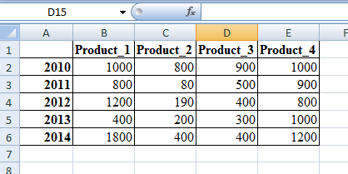

**Creating a Column chart for the above data**

**Definition of Chart:**

Charts allow you to present data entered into the worksheet in a visual format using a variety of graph types.

Following steps are given to draw a Chart

1. Enter data in the work sheet: Suppose you entered data as given in below



1. Now select data range: By using the mouse high light the range of data you want to take

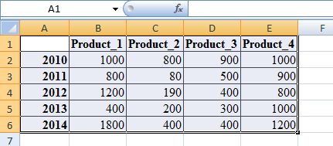

1. Click Insert Tab and select a chart type from the chart group and Select the sub type of chart ( In this example selected a 2D Column chart)

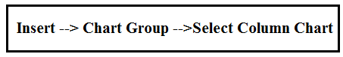

1. The Chart will be displayed as follows
2. Select the Title of the chart

* To give a title to a chart, click on the chart. Now you can see layout tab available. Click on Layout tab.
* Choose(click) on chart title option available in the Label group
* Click on the chart title and write a title “Product Analysis”.



1. Give a name to X-Axis

* Click on Layout tab.
* Then select Axis Titles from Labels Group.
* Select Primary Horizontal Axis Title, as shown below.
* Now, click on the Axis Title and write an X-axis title “Year”.
* Follow the same steps to give a title to Y-axis “Product Sales”.



1. Adding Data Labels to the chart

* Click on Layout tab.
* Then click on Data Label option available in Labels Group.
* Now choose a format to display data labels

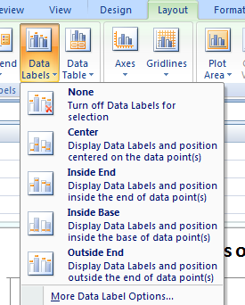

**Output:**

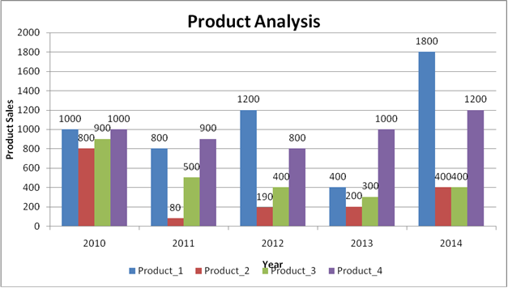

**4) Create a suitable examination data base and find the sum of the marks(total) of each Student and respective class secured by the student**

**Rules**

* **Pass if marks in each subject > = 35,**
* **Distinction if average>=70,**
* **First class if average>=60 but <70,**
* **Second class if average >=50 but <60,**
* **Third class if average>=35 and but <50 ,**
* **Fail if marks in any subject is <35 .**

**Display average marks of the class, subject wise and pass percentage.**

**Procedure:**

To find the grade of a student we need to follow the following steps

**Step 1: Typing Student database in Excel**

Type the student database with the required fields starts from A1 cell as follows

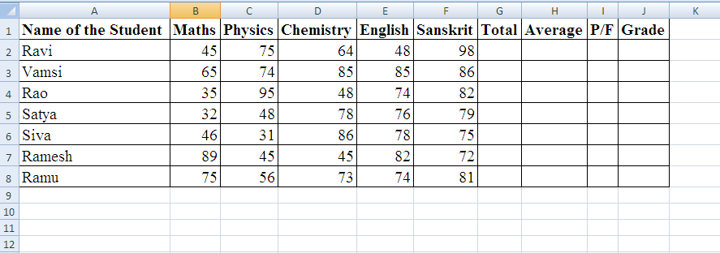

**Step 2: To find Total Marks of Student**

To find the total marks of a student click on the cell “G2” and type the following formula

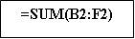

To find the total marks for the remaining students select “G2” cell and drag down to the remaining students.

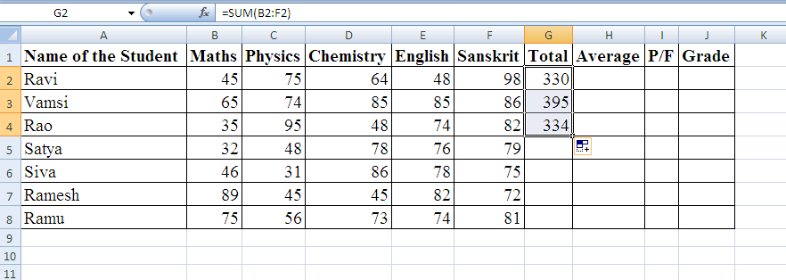

**Step 3: To find Average marks**

To find the average marks of the student click on the cell “H2” and type the following formula

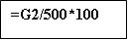

To find the average marks for the remaining students select “H2” cell and drag down to the all the students.

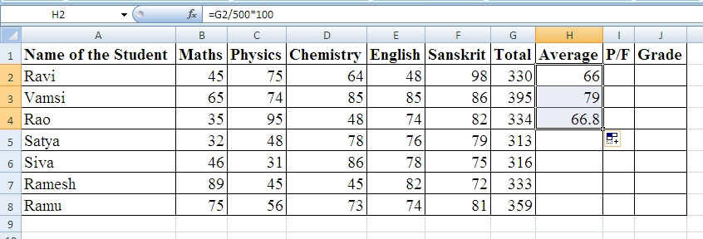

**Step4: To Check Pass or Fail**

To check whether the student is Pass or Fail select the cell “I2” and type the following formula

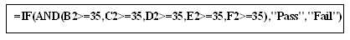

To check the remaining students are Pass/Fail select the cell “I2” and drag down to all the students

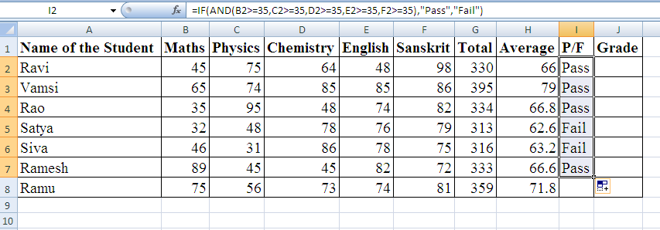

**Step 5: To find Grade**

To find the grade of a student click on the cell “J2” and type the following formula



To find the grade for the remaining students select “J2” cell and drag down to the all the students

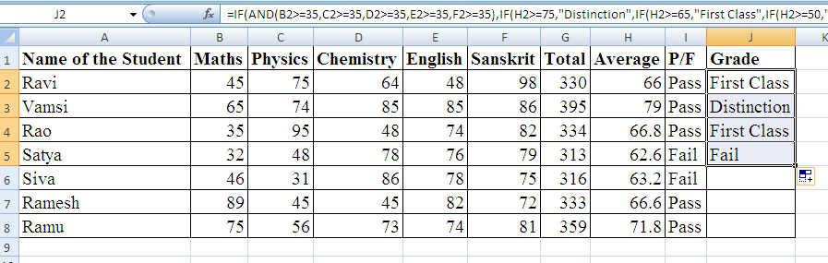

Finally, we get the following student database with total, average and grade.

**Output:**

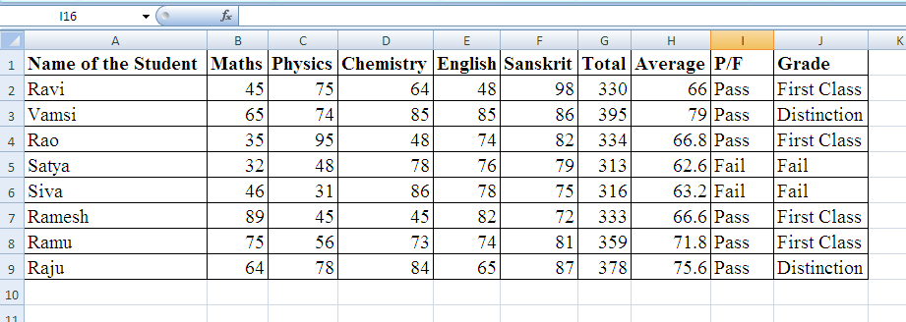

**5 ) Make a Power point presentation of all the details of the books that you had studied in B.com First sem.**

**Procedure:**

PowerPoint is presentation software that can be used to create slide shows for printing, on-screen projection, or Web-based display.

**Opening PowerPoint**

**NOTE: The procedure for opening PowerPoint may vary depending on the setup of your computer.**

To open PowerPoint in Windows, click on the

Start button --> Programs --> Microsoft PowerPoint

When **PowerPoint**  is opened, a blank *Title* slide appears by default as the first slide in your new presentation. You can start a new presentation when you first open PowerPoint or after PowerPoint is already open.

To change the **layout** of an open slide, click on the **Layout** button in the **Home tab**.

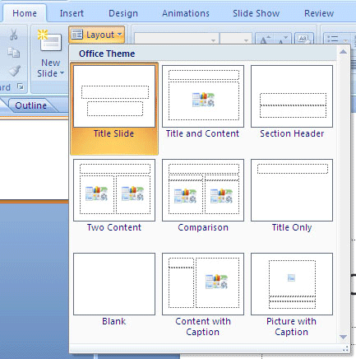

**Inserting Slides**

There are two ways to add new slides to your presentation.

* Quick Menu Option
* Ribbon Option

**Quick Menu Options**

To insert a new slide using the Quick Menu, in the Slides panel **right click** the slide after which you want a new slide inserted and select **New Slide**.

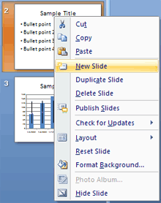

To change the layout of the slide, **right click** the new slide in the Slides panel, select **Layout** and select the desired theme.

**Ribbon Option**

From the **Home tab** in the Slides group, click on **New Slide**. A blank slide will be inserted after your active slide.

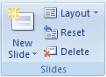

If you wish to choose the layout while creating your new slide, click the  on the **New Slide** button and choose a theme.

Select the new slide from Quick menu option or Ribbon Option:

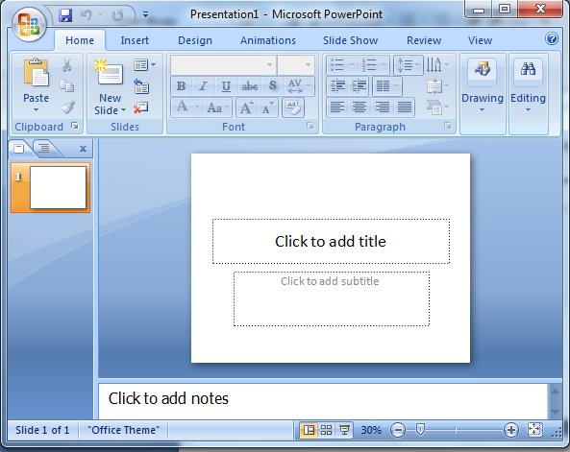

**Apply a new layout to a slide**

To change the layout of an existing slide, do the following:

1. On the **Slides** tab, click the slide that you want to apply a new layout to.
2. On the **Home** tab, in the **Slides** group, click **Layout**, and then click the new layout that you want.

**Copy a slide**

To copy a slide does the following

1. On the **Slides** tab, right-click the slide that you want to copy, and then click **Copy** on the shortcut menu.
2. Still on the **Slides** tab, right-click where you want to add the new copy of the slide, and then click **Paste** on the shortcut menu.

You can also insert a copy of a slide from one presentation into another presentation.

**Rearrange the order of slides**

* On the **Slides** tab, click the slide that you want to move, and then drag it to the location that you want.

To select multiple slides, click a slide that you want to move, and then press and hold CTRL while you click each of the other slides that you want to move.

**Delete a slide**

* On the **Slides** tab, right-click the slide that you want to delete, and then click **Delete Slide** on the shortcut menu.

**Adding text to a slide**   
The Title Slide layout contains text boxes for a title and a subtitle. Try typing text into these boxes.

1. Click in the Title text box. A dashed line border with a circle in each corner and a square box at each midpoint appears around the text box indicating that it is selected.

Adding list of subjects that studying in B.com First sem, into the slides:

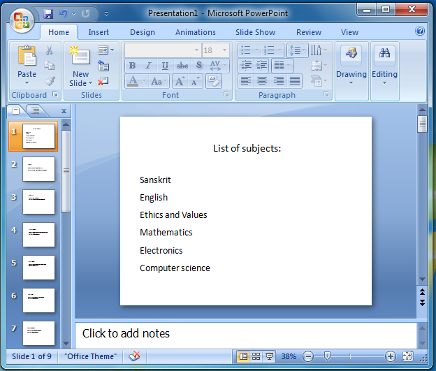

1. Click the Subtitle text box and type a subtitle.

**Selecting a Theme or Designing Slides**

Design themes are a convenient way to add a professional flair to your presentation. Themes include preset colors, fonts, backgrounds, and formatting effects. PowerPoint provides you with the option to customize one of their existing themes or to build your own.

**Selecting a Theme**

To choose a Theme for an open slide, use the **Theme group** under the **Design tab**. Use the arrows on the right of the Theme group to scroll through the themes, or to see all available themes at once. When you hold your mouse over any of the examples, PowerPoint will show you a preview of the slide.

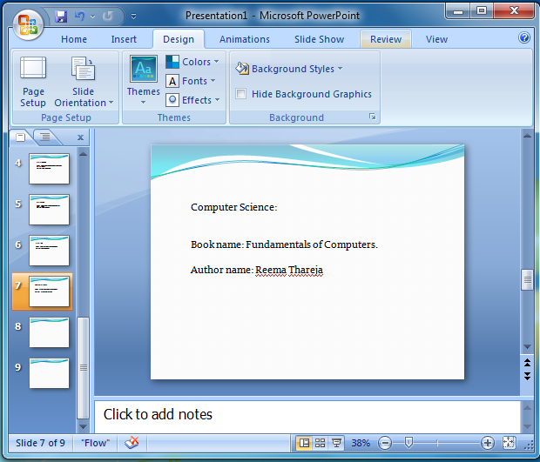

**Animating Text and Images**

**Adding Animation to Slides**

1. Click on the object or text box you wish to animate (hold down the Ctrl button while clicking to select more than one).
2. In the **Animations tab** under the **Animations group**, select an option from the **Animate** pull-down list. As you move your mouse over each choice PowerPoint will preview the effect on your slide.
3. Repeat for any other slides or objects you wish to animate.

**Run Your PowerPoint Slide Show**

After you create your slides, you can run your slide show:

* Press F5.
* Choose the Slide Show tab. Click the From Beginning button  in the Start Slide Show group.
* Click the Slide Show icon in the bottom-right corner of your screen.

**Saving your presentation**

If you are saving a document for the first time, you will need to use the **Save As** command; however, if you have already saved a presentation, you can use the **Save** command.

To use the Save As command:

* Click the **Microsoft Office button**.
* Select **Save As**. A menu will appear.
* Select the type of file you want to save the presentation as
* Enter a **name** for the document.
* Click the **Save** button.

To use the Save command:

* Click the **Microsoft Office button**.
* Select **Save** from the menu.

Using the Save command saves the document in its current location using the same file name.

**6) Write a program to Create a Bio – Data by using MS-Word**

**Procedure:**

**Step 1 :-** To open MS-Word, Go Start, Simply, Select All Programs, MS- Word.

**Step 2 :-** Just we have type the tile of Bio – Data in “Bold”.

**Step 3:-** Type Bio – Data like Name, Sex. Date of Birth, Father’s Name, Mother’s Name, Marital Status, Mother Tongue Nationality, Religion and Caste, Permanent Address, Phone or Mobile Number , Email ID, Qualifications, Computer, Languages Known Experience.

**Step 4:-** Bio - Data is a title, So we make it “Bold”. Other data in “Times New Roman”.

**Output:**

# 7) Write a program to create the following time table by using MS word?

# 

**Procedure:**

**Step 1 :-** First, Put the title of time table in “Bold”.

For eg:- Time table for B.Com., (CA) in “Bold” and centralized it to press the tab button on the keyboard.

**Step 2 :-** Go to Insert tab, click the table and select the Insert table, Now displayed Insert table box, that shows on table size, ie… Number of columns and Number of rows.

**Step 3:-** If we want 8 columns, type in that dialog box, if we 18 Rows , type in box, that click ok, Otherwise table is appears on the screen.

**Step 4:-** If you want to increase the size of the table, click the arrow mark in the right corner of the table and drag it down and release it.

**Step 5:-** If you want to merge the first row, select the row and right click; then, It shows merge cells and click it.

**Step 6:-** If you want to merge the fifth column, select the column right click, then it shows merge cells and click it.

**Step 7:-** Type the Day orders in that table in Time New Roman or any you liked.

**Step 8:-** Go to the design tab, different kinds of table are available, if you want to change the table design, they have many in build designs to choose

**8) Write a program to create a minutes by using MS-Word.**

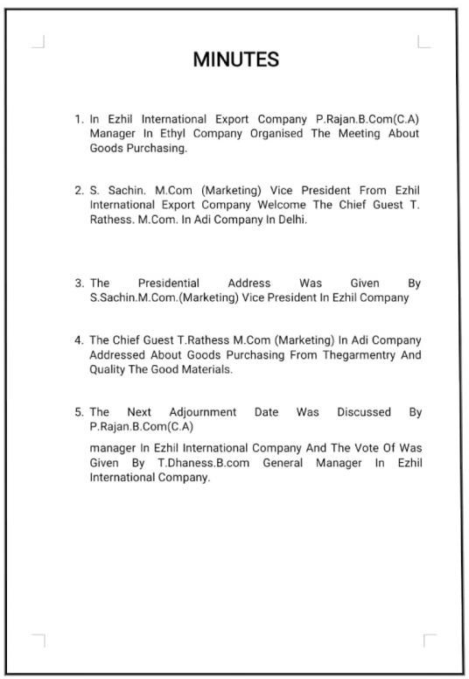

**Procedure:**

**Step 1 :-** Go to the page layout tab and click the page borders, Now displayed a box and then we want to choose the borders and click ok.

**Step 2 :-** Type the title of minutes in “Bold” and fix ot center position.

**Step 3:-** Select the whole typed words and align it.

**a)** Left align (ctrl+l)

**b)** Right align (ctrl+r) **c)** Center align (ctrl+e)

**Step 5:-** Otherwise, Go to the home tab, select the justify the given words is properly aligned.

**9) Write a program to Create the following Agenda by using MS-Word.**

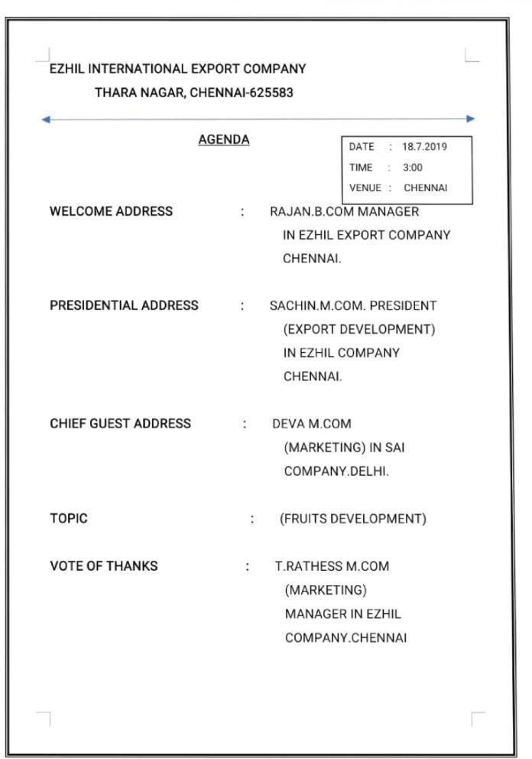

**Procedure:**

**Step 1 :-** Go to the page layout tab, click the page borders what we want to do.

**Step 2 :-** Type the title of Agenda in “Bold” and fix it centre position.

**Step 3:-** At the right top corner, we type the Date, time, venue in

Rectangle box.

**Step 4:-** Type the Agenda format given and align it properly.

**10) Write a program to Create an insert pictures by using MS-Word.**

**Procedure:**

**Step 1 :-** Use Curriculum Vitae formed for insert pictures.

**Step 2 :-** Go to the Insert tab, click pictures options and opened the dialog box and choose any pictures, click insert button, Then we fix the pictures.

**Step 3:-** Go to Format tab, On the right hand side, we see the position options, They shows a nine position, click any of them on using a mouse to drag it.

**Step 4:-** If you want to resize the pictures, Just pull down the corner using mouse.

**Step 5:-** If you want to change the shapes of the pictures, click on the picture styles.

**Output :**

**11) Write a program to insert shapes by using MS-Word.**

**Procedure:**

**Step 1 :-** Go to the Insert tab, click shapes. If you want to change colors of shapes, Go to the format tab, you can select any of them.

**Step 2 :-** Click the shape outline, Go to weight and select the outline for the shapes.

**Step 3:-** If you want to change the shapes, you go the edit shapes and then click change shapes, Then it shows all the shapes available.

**Step 4:-** If you want to add text in that shapes, select the drawn shapes and start typing.

**Step 5:-** If you want to increase the font size in that shapes, Go to the home tab, increase the size of font.

**Step 6:-** If you want to modifying text, Go to the format tab and you can choose word on styles.

**Step 7:-** Go to format tab, On the right hand side, we see the position, click it and choose any position that we want.

**Step 8:-** If you want to fix the shapes in between a text surrounding, keep the cursor in any position and paste it.

**Step 9:-** If you want to move shapes at anywhere, select the drawn shapes, then shows icon and click it. It shows types of layout we want.

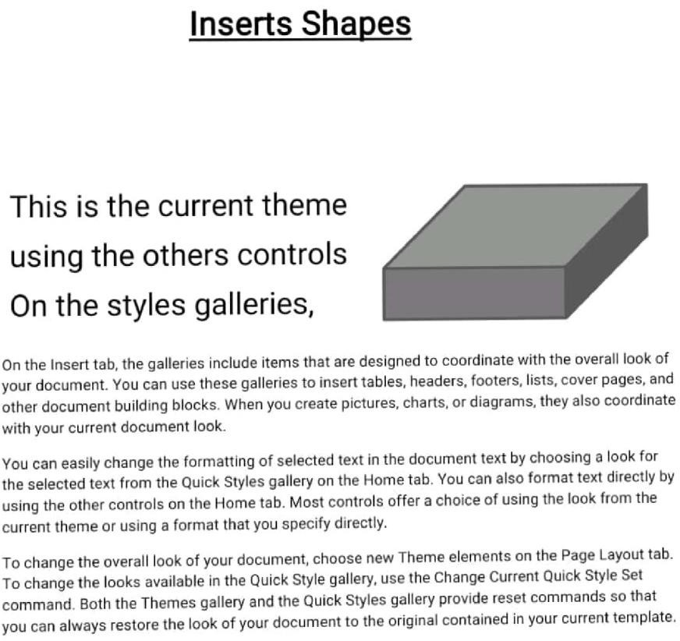**Output:**

**12) Write a program to create a Piechart by using MS-Word.**

**Procedure:**

**Step 1 :-** Go to the Insert tab, click the charts, select the Piecharts.

**Step 2 :-** Select the 3D Piechart, click OK. It appears the Excel data table, we change the subjects and Marks.

**Step 3:-** If you want to change the colurs of piechart, Go to the column changing options and select any color that we want.

**Output:**

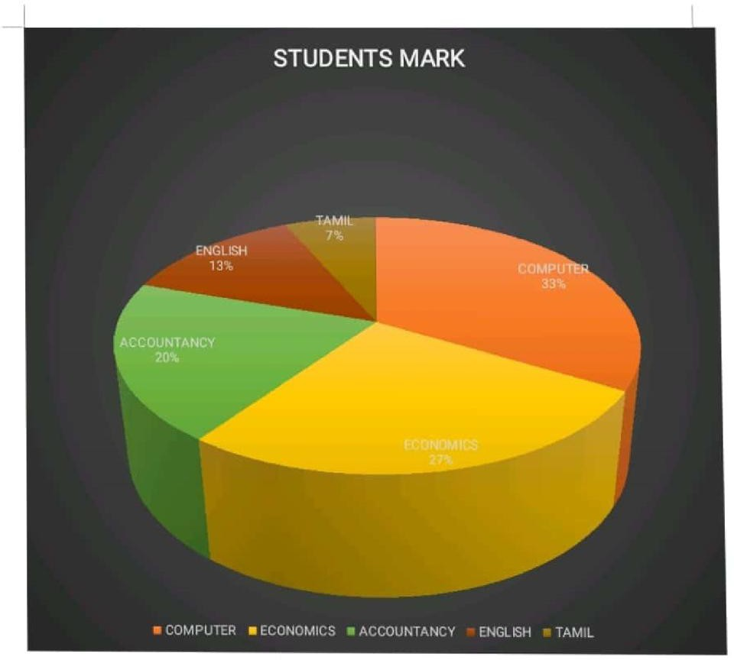

**13) Write a program to Create a paragraph formatting, line spacing and Sorting, Bullets and Numbering.**

**Procedure:**

**Step 1 :-** Click the justify alignment options on the top.

**Step 2 :-** Select the line spacing icon and select 1.5 spacing between the line.

**Step 3:-** If you want to coloring the first paragraph, keep the cursor on first paragraph and select the paragraph coloring options.

**Sorting, Bullets and Numbering:**

**Step 1:-** Select the text and click the sorting icon.

**Step 2:-** Select the text and click the Bullet icon.

**Step 3:-** Select the text and click the Numbering icon.

**Output:**

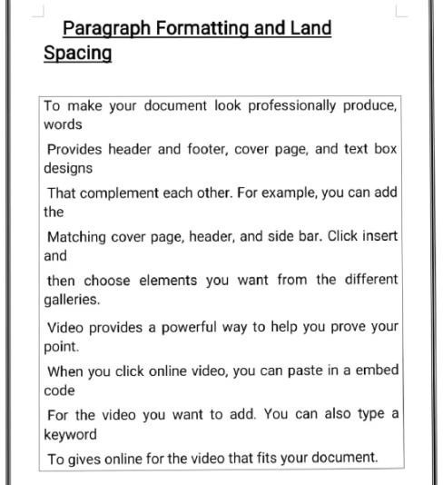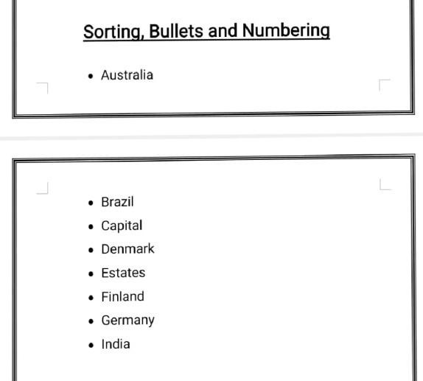

**14) Write a program to Create a formatting text by using MS-Word.**

**Procedure:**

**Step 1 :-** Select the text and change the font

**Step 2 :-** Select the text and click ctrl+B.

**Step 3:-** Select the text and press ctrl+I

**Step 4:-** Select the text and press ctrl+U

**Step 5:-** Select the text and change the font color.

**Step 6:-** Select the text and change the font size by using Ctrl+Shift+>.

**Step 7:-** Select the text and click highlighted icon.

**Step 8:-** Select the text, Go to the change case.

**Output:**

**15) Write a program to Create the following Interactive form in MS-Word.**

**procedure:**

**Step 1 :-** Go to the “File”, click “Options”, click Customize Ribbon, On the right hand side, Click the developer tab and click on OK.

**Step 2 :-** Click the developer tab, see the control category, click the Aa icon the type the name.

**Step 3:-** In the control category, click the “drop down list icon”, click the properties, you get the dialog box, Now we can see choose an item, click remove on it. Then click “Add” and type age.

**Step 4:-** If we want to create Today’s Date, In the control category, click the “Data picker content control” Icon and click date.

**Step 5:-** If you want to enter the sex (male or female), click the “legacy forms” Let we See “Active X Controls”, click the Radio button, click the properties, delete the option button and type female. Then close it.

**Step 6:-** Similarly, create one more radio button. Keep the cursor, click the properties, put the cursor in the option button, type male, then close it.

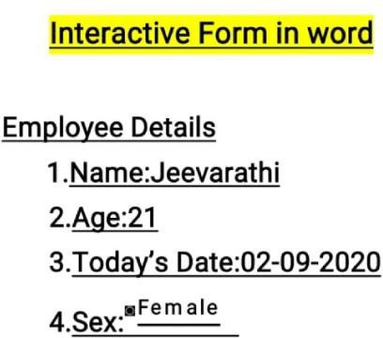**Output:**

**16) Write a program to Create a Business card by using MS-Word.**

**Procedure:**

**Step 1 :-** Open Microsoft Word.

**Step 2 :-** Go to the “file” tab, and select “New” from the left hand pane.

**Step 3:-** In the search box at the top of the window, search for “Business cards”. A large selection of templates will appear.

**Step 4:-** Scroll through the library of business and templates and choose the one you like best.

****Output:**

**17) Write a program to create resume in the following format by using MS WORD?**

**Procedure:**

**Step 1 :-** Open MS-Word.

**Step 2 :-** Go to the “file” and select “New”.

**Step 3:-** Type resume into the search box.

**Step 4:-** Click a resume template that you want to use.

**Step 5:-** Click “Create” to open the resume template in MS-Word.

**Step 6:-** Write an objective or Summary statements.

**Step 7:-** List your work history.

**Step 8:-** Include key skills and qualifications.

**Step 9:-** Fill out the education section.

**Step 10:-** List your all information.

**Output:**

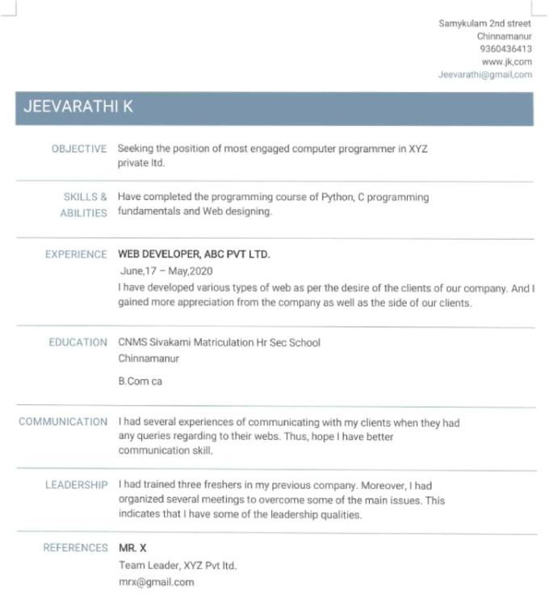

**18) Write a program to Create your college’s Annual day Invitation by using MS-Word**.

**Procedure:**

**Step 1 :-** Start -> Programs -> M.S. Office -> MS-Word.

**Step 2 :-** Go to the office button -> New file Open.

**Step 3:-** Type the Invitation.

**Step 4:-** And change the Alignment.

**Step 5:-** Save the document and exit from the MS-Word.

**Output:**



**19) Write a program to Create a Bill Voucher by using MS-Word.**

**Procedure:**

**Step 1 :-** Start -> Program -> MS Office-> MS Word

**Step 2 :-** Go to office button -> New file open.

**Step 3:-** Type the Gift Voucher on Bill Voucher.

**Step 4:-** And change the Alignment.

**Step 5:-** Save the document and exit from the MS-Word.

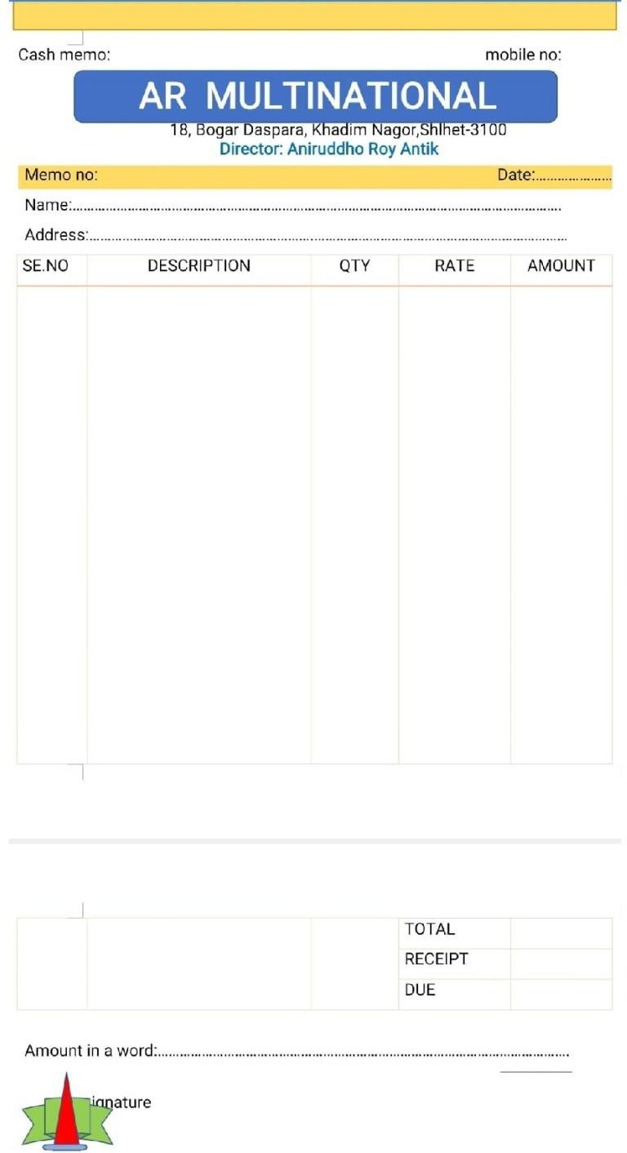**Output:**

**20) Write a program to create an employee work details list and prepare a salary sheet by using MS-Excel.**

**Procedure:**

**Step 1 :-** Start -> Program -> MS Office-> MS-Excel

**Step 2 :-** Go to office button -> New.

**Step 3:-** Go to home, auto sum one are mark formula in available.

**Step 4:-** A worksheet is a large area of 65,536 rows and 255 columns.

**Step 5:-** The columns are labled as A, B, C, .. IV.

**Step 6:-** the rows are labled 1, 2, 3, ….., 255.

**Step 7:-** Create a employee details using to format follow.

**Step 8:-** Save to document and exit.

**Note:**

DA = D4*20/100

HRA = D5*3/100

MA = D4*6/100 GRASS PAY = SUM (E4 :G4) TOTAL = SUM (I4 : K4)

NET PAY = H4 – L4

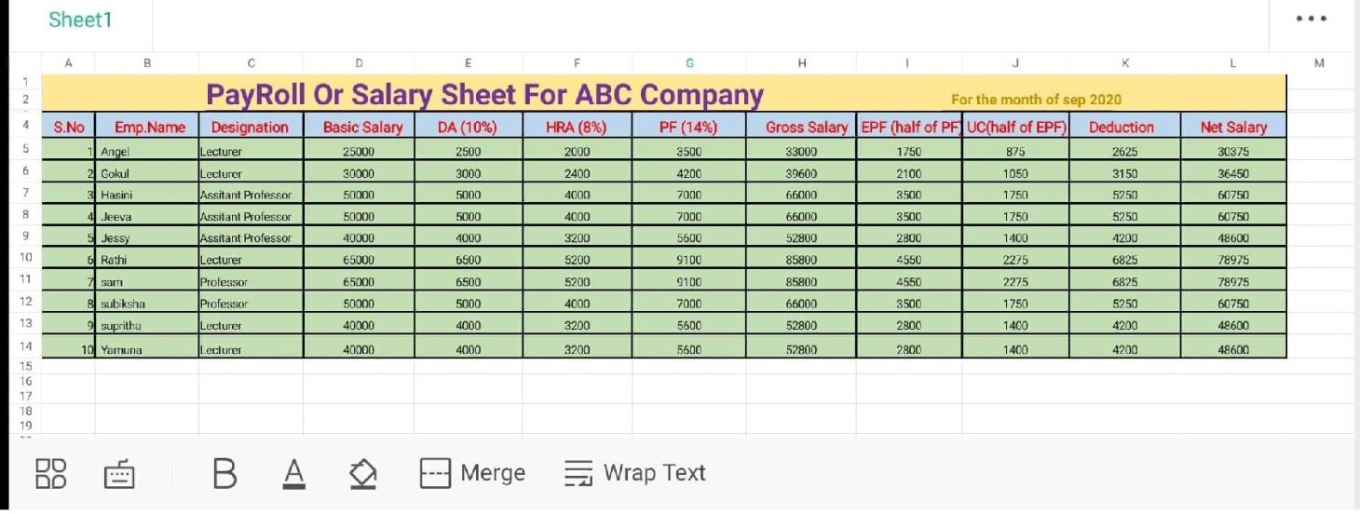**Output:**

**21) Write a program to create two types of charts by using MS-Excel.**

**Procedure:**

**Step 1 :-** Start -> Program -> MS-Office -> MS-Excel.

**Step 2 :-** Go to offices button, New

**Step 3:-** Enter the data on the excel sheet for which you want to draw chart.

**Step 4:-** Go to insert, chart one are more model in available.

**Step 5:-** Type of chart (column, pie, area, line, bar, … etc). Then click on the next button.

**Step 6:-** Change the option as necessary to the charts work in the way you it and then click the next button (axis, heading, chart heading,

etc…)

**Step 7:-** Select the option where you want to place the chart in the worksheet from the legend.

**Step 8:-** Then click the finish button.

**Step 9:-** Now the respective chart will be appeared for the given date.

**Step 10:-** Save the Worksheet using the file name.

**Output:**

**22) Write a program to creating a Power Point Presentation.**

**Procedure:**

**Step 1 :-** Open Microsoft Powerpoint.

**Step 2 :-** Go to the file at the top of the screen and click New.

**Step 3:-** In the “New Presentation” dialog box, click on “From Design Template”. You may then seen through design templates and choose one that you like .

**Step 4:-** Then Insert slide design.

**Step 5:-** Then Insert slide layouts.

**Step 6:-** Then adding text.

**Step 7:-** Then adding pictures from Insert -> pictures, choose one that you like.

**Step 8:-** Then, Insert audio.

**Step9:-** Finally, press F5 to run the slide of PowerPoint Presentation.

**Step 10:-** Save the Document and MS-> Powerpoint.

**Output:**

**23) Write a program to create an advertising of new model car by using Power Point Presentation.**

**Procedure:**

**Step 1 :-** Start -> All Program -> MS-Office -> MS-Powerpoint.

**Step 2 :-** Enter the car model name invented by you in blank slide.

**Step 3:-** Create a New slide, Insert the picture of the car.

**Step 4:-** Enter the New specifications in the third Slide.

**Step 5:-** In the fourth Slide, enter the features of a new car.

**Step 6:-** Select the picture with caption slide and enter the price details of a car.

**Step 7:-** Enter the further details of price and special offers in title and content slide.

**Step 8:-** Go to -> click to F5 and Play Button Play to effect.

**Step 9:-** Save the document and the MS-Power Point.

**Output:**



**24) Write a program to create an organization chart by using Power Point.**

**Procedure:**

**Step 1 :-** Go to the Insert tab and click Smart Art.

**Step 2 :-** Go to the Hierarchy group and choose the Org chart template you want to use.

**Step 3:-** Next, you will see a mean with shapes that represent people…

**Step 4:-** If you need to add shapes to your org chart template, click the Smart Art tools design tab, then click Add Shape.

**Step 5:-** Save the document and exit.

**Output:**

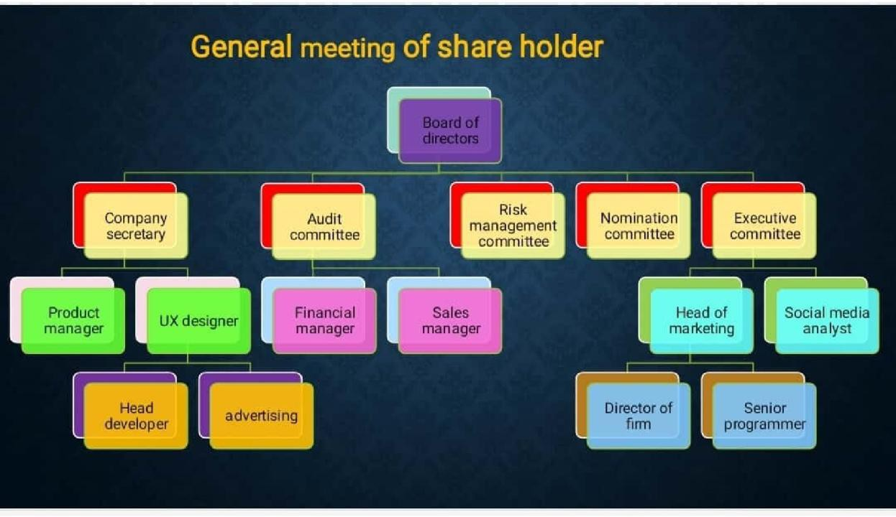

**25) Write a program to create an advertisement in TV channel by using Power Point.**

**Procedure:**

**Step 1 :-** Open Microsoft Power Point.

**Step 2 :-** Go to the file at the top of the screen and click New.

**Step 3:-** Then add some needed slides.

**Step 4:-** Then insert pictures from Insert -> Pictures, choose the advertisement image that you like.

**Step 5:-** Then Insert relating audio.

**Step 6:-** Similarly, we add the TV channel name in right bottom corner on every slide.

**Step 7:-** Finally, press F5 to play the TV advertisement.

**Step 8:-** Save the document and MS -> Power Point.

**Output:**



**26) Write a program to create a newspaper document with heading along with set of margins by using MSWORD.**

**Procedure**:

1. First set the margin as given there.
2. Type heading Gandhi jayanthi with its font size. Then type contents of it.
3. Use drop command.
4. Select the picture of Gandhi and paste it.
5. Then set the size of the picture.
6. Then drag the picture to the right portion of paragraph.
7. By right click at picture option go to text wrapping & then click at square option.
8. Now type computer basics at the center of next line & paste its content below it.
9. By using page layout option now you can make three columns.

**Output:**

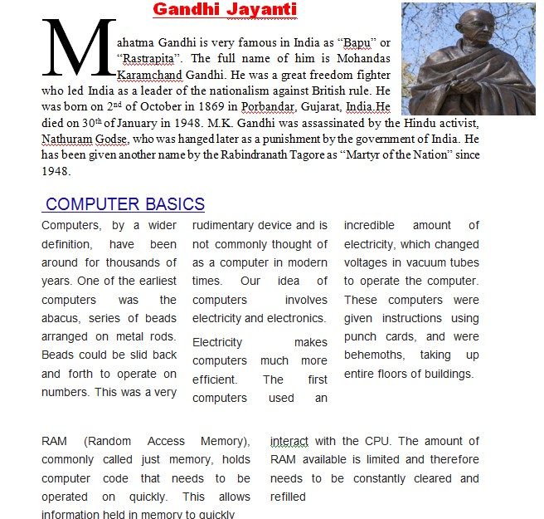

**27) Write a program to create following mathematical equations in word document.**



## **PROCEDURE:**

**Step 1:** start → program→MS-Office2007 → MS-Word.

**Step 2:** Go to office button → New.

**Step 3:** Type the name of the equation.

**Step 4:** Go to insert → Equation → insert new equation.

**Step 5:** Go to insert → object.

**Step 6:** From object submenu, select Microsoft equation 3.0and click ok.

**Step 7:** Then by using the equation tool, type the following mathematical equations.  
**Step 8:** Save the document**.**

**28) write a program to Create a flowchart using shapes like ellipse, arrows, rectangle & parallelogram & grouping them like as below.**

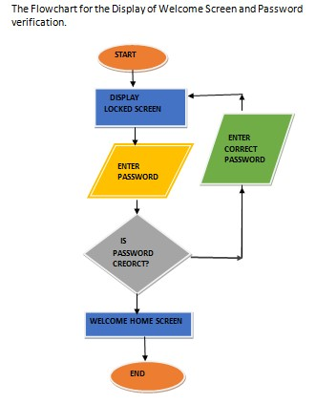

**PROCEDURE:**

a. Insert various shapes as given above one below another using insert tab .

b. Then use arrow shape to connect various shapes.

c. Now we can group various shapes by selecting them into one single object.

**29) Write a program to create a table using table menu with a given no of rows & columns.**

**PROCEDURE:**

1. First create a table using table menu with a given no rows & columns
2. Then fill the cells of table using data provided.
3. Then apply merge the first row into one cell.
4. Then merge the second row into one cell.
5. Apply border to the table.

**Output:**

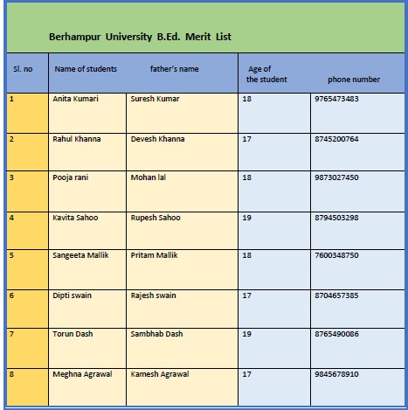

**30) Writing a program to create a letter to a friend using at least 100 words,two paragraphs.**

**PROCEDURE:**

1. Open a blank MS-word page.
2. Start writing a letter with proper salutation.
3. Complete first paragraph.
4. Start second paragraph & complete the letter with proper closing.

**Output:**

4 July, 2019 - 09:03

Dear Ava,

Thank you for writing me this letter. You were asking which day of the week is my favorite. So, my favorite day of the week is Thursday because I could relax after school not worry about anything or go out with my family to eat dinner but if we don’t have any plans. I would finish my homework so in Friday it’s much smoother or study for a test that I’m having the following week or also make summaries for the new lessons and file them in a folder. So, for me, Thursdays are the most memorable, amazing, marvelous, spectacular day of the week. When Thursdays come near I feel all my worries and stress have vanished until Sunday’s are near the stress, all the worries in the universe come back.

I go to bed at 11pm cause Friday is our holiday. So we have no school and I can stay awake till the midnight. And the best thing is I watch movies at night with my family. I love Thursday......!!

Tell me your favorite meal of the day?

With best regards,

Lama

**31) Write a program to Create a letter document using mail merge to send multiple recipients.**

**Procedure:**

a. Click at start mail merge & then step mail by mail wizard

b. Click at starting document in current letter

c. Now click at select recipients

d. Click new list to create a new one & save it at desktop

e. Then click at write your letter

f. By clicking more item add fields on the letter

g. Then we have to type the complete message

h. Click at preview your letter & then complete the merge

i. Now click at “edit individual letters & then click at ALL

**Output:**

To,

RAVI

BGH

123456

Dear RAVI,

I am fine here. How are you? I will be there on holidays. We will meet there too. Thank you for writing me this letter. You were asking which day of the week is my favorite. So, my favorite day of the week is Thursday because I could relax after school not worry about anything or go out with my family to eat dinner but if we don’t have any plans. I would finish my homework so in Friday it’s much smoother or study for a test that I’m having the following week or also make summaries for the new lessons and file them in a folder. So, for me, Thursdays are the most memorable, amazing, marvelous, spectacular day of the week. When Thursdays come near I feel all my worries and stress have vanished until Sunday’s are near the stress, all the worries in the universe come back.

Thanking you ,

Prasant

To,

AKASH

SBP

625478

Dear AKASH,

I am fine here. How are you? I will be there on holidays. We will meet there too. Thank you for writing me this letter. You were asking which day of the week is my favorite. So, my favorite day of the week is Thursday because I could relax after school not worry about anything or go out with my family to eat dinner but if we don’t have any plans. I would finish my homework so in Friday it’s much smoother or study for a test that I’m having the following week or also make summaries for the new lessons and file them in a folder. So, for me, Thursdays are the most memorable, amazing, marvelous, spectacular day of the week. When Thursdays come near I feel all my worries and stress have vanished until Sunday’s are near the stress, all the worries in the universe come back.

Thanking you ,

Prasant

To,

MILAN

RGDA

954732

Dear MILAN,

I am fine here. How are you? I will be there on holidays. We will meet there too. Thank you for writing me this letter. You were asking which day of the week is my favorite. So, my favorite day of the week is Thursday because I could relax after school not worry about anything or go out with my family to eat dinner but if we don’t have any plans. I would finish my homework so in Friday it’s much smoother or study for a test that I’m having the following week or also make summaries for the new lessons and file them in a folder. So, for me, Thursdays are the most memorable, amazing, marvelous, spectacular day of the week. When Thursdays come near I feel all my worries and stress have vanished until Sunday’s are near the stress, all the worries in the universe come back.

Thanking you,

Prasant

**32) Write a program to create a table “Student Result” with some conditions by using MS.EXCEL.**

**Procedure:**

a.First insert a table in the Excel Sheet by the insert tab so that you can write the student’s information.

b. Now, give the headings – SL NO, Name, Mark 1, Mark 2, Mark 3, Total etc.

c. Fill up the data in the columns you have to enter.

d. Calculate the sum of the marks of each student via ‘Auto sum’ option.

e. Highlight the highest total mark in green color and lowest one in red color.

f. Find the average of the marks of each student in an individual cell.

**Output:**

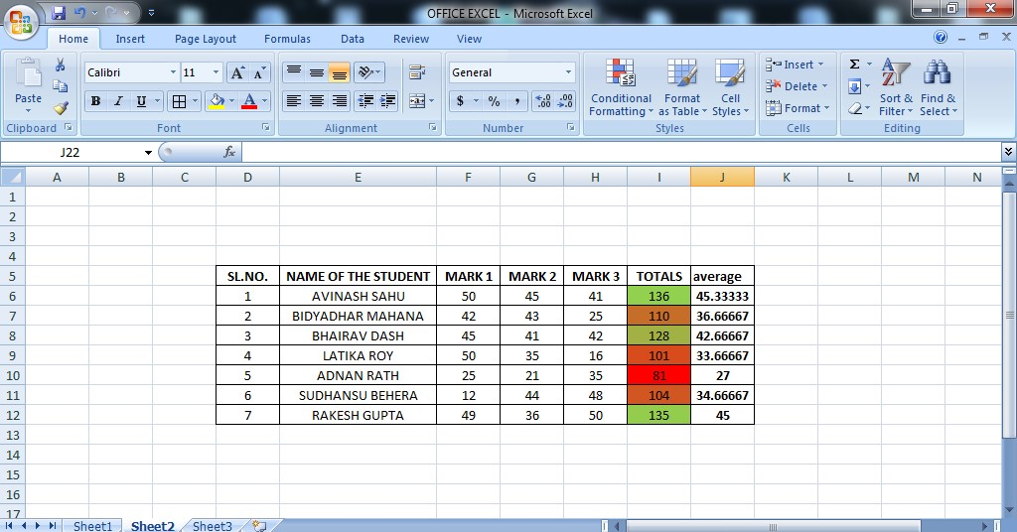

**33) Write a program to create a table “Sales” with some data provided and create different charts in MS.EXCEL**

**Procedure:**

1. Create a table using five columns & four rows.
2. Enter the data given as provided
3. Go to insert tab, in charts groups, you just have to select the specified charts as given in no. a, b, and c.
4. Set a new rule for highlighting the sales which are greater than or equal to 1000
5. To do so, go to conditional tab. There, click more rules option. There you can change all the necessary options.

**Output:**

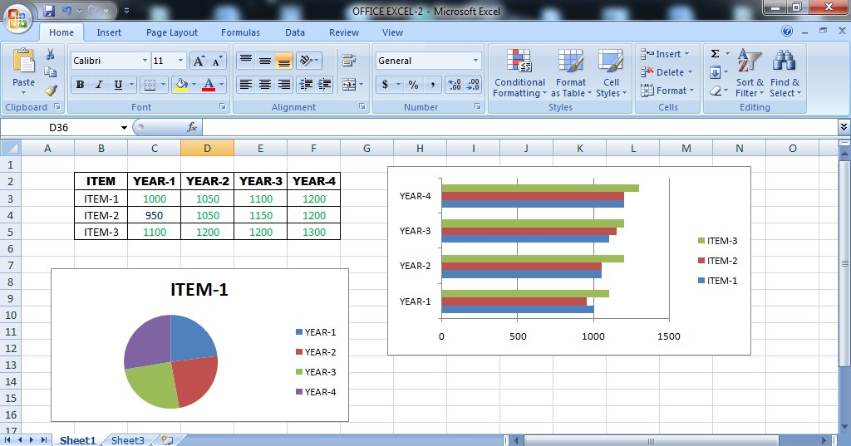

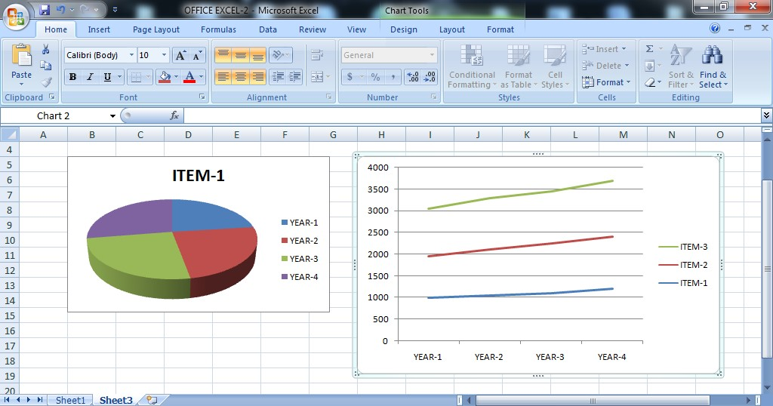

**34) Write a program to create a power-point presentation with 5 slides about COVID-19.**

**Procedure:**

1. First set the titles and subtitles based the topics with the suitable font style, size, and color in first slide.
2. As given you must choose a topic of your own which must cover up 5 slides.
3. Write and design all your slides perfectly and make it ready to show.
4. At last place a ‘thank you’ slide so as to end your presentation

**Output:**

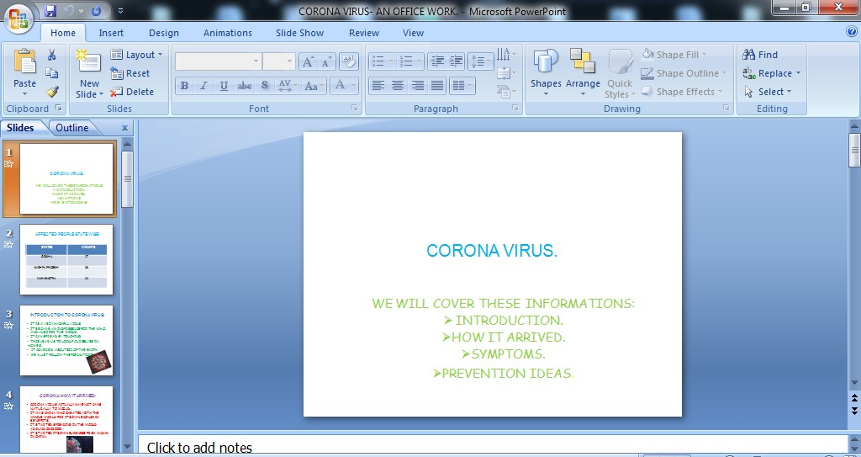

AFFECTED PEOPLE STATE WISE:

|  |  |
| --- | --- |
| **STATES** | **COUNTS** |
| ODISHA | 17 |
| ANDHRA PRADESH | 33 |
| MAHARASTRA | 24 |

INTRODUCTION TO CORONA VIRUS:

* IT IS A VERY HARMFUL VIRUS.
* IT BECAME A MIND PRESSURE FOR THE W.H.O. AND ALSO FOR THE WORLD.
* IT CAN SPREAD BY TOUCHING.
* THIS LEAD US TO LOCKUP OURSELVES IN HOMES.
* IT COVERED ABOUT 80% OF THE EARTH.
* WE MUST FOLLOW THE PRECAUTIONS.

CORONA: HOW IT ARRIVED:

* CORONA VIRUS ACTUALLY HAVE NOT CAME NATURALLY TO WORLD.
* IT WAS CHINA WHO CHEATED WITH THE WHOLE WORLD FOR ITS OWN ECONOMIC BENEFITS.
* IT STARTED SPREADING IN THE WORLD AROUND 02.02.2020
* IT STARTED ITS OWN BUISNESS FROM WUHAN IN CHINA.

## 

## CORONA: IT’S SYMPTOMS

THE FOLLOWING ARE THE SYMPTOMS OF CORONA VIRUS:

1. COUGHING.
2. SNEEZING.
3. TIREDNESS.
4. DIFFICULTY IN TAKING BREATH.

THESE ARE THE MAIN SYMPTOMS. IF SEEN,

PEOPLE SHOULD TAKE APPOINTMENT WITH DOCTOR.



**35) Write a program to create a power-point presentation with 10 slides using word art.**

**Procedure:**

1. First set the titles and subtitles based on any topic
2. Set titles by ‘word art’ in insert tab
3. choose any topic to create 10 slides
4. insert one picture from ‘clip art’ option.
5. Similarly insert audio & videos as required
6. For hiding a slide, just right click it and click ‘hide slide’ option
7. Write and design all your slides to perfectly and make it ready to show

**Output:**

**36) Write a program to create a power-point presentation with 5 slides using animations.**

**Procedure:**

1. set the titles and subtitles based on your topic of 5 slides
2. Use ‘custom animation’ present in animation tab in the animations tab. Give the instruction for moving the word from left to right.
3. Use proper transition for slides.
4. Write and design all your slides to perfectly and make it ready to show

**Output:**

**37) Create a word document to generate the following output:**

**(a+b)2=a2+2ab+b 2**

**H2SO4, H2O, CO2, MNO2**

**N2+H2 🡪 NH3**

**Procedure:**

1. Go to Start -> All Programs -> Microsoft Office -> Microsoft Word.

2. To apply the given formats in font group: in Home Tab-> select Font Group and use subscript and superscript

option to the write the below formula as shown:

a. (a+b)2=a2+2ab+b2

(here I used Superscript button)

b. H2SO4 , H2O , CO2 , MNO3 (HERE I used subscript button)

c. N2 + H2 →NH3 ( To add the arrow mark , click on arrow mark for twice and then click this symbol ‘>’)

**38) Create a news paper model with multi columns.**

Procedure:

1. Go to Start ->All Programs -> Microosft Office -> Microsoft Word.

2. To insert multiple columns like a newspaper then goto PageLayout -> Page Setup section, select the columns menu and then select the number of columns you require.



**39) Type a paragraph and perform the following task.**

1. **Make five lists of numbering which contains details of the courses offered in your college.**
2. **Make the five list of bullets having hand symbol which describes about facilities in your**

**college.**

1. **Keep a footnote to any one of the word of the first paragraph.**
2. **Center the heading of your document**.

**Procedure:**

1. Go to Start ->All Programs -> Microosft Office -> Microsoft Word.
2. The below is a paragraph to perform various actions on it.

**Output:**



(A) To insert 5 numbering list options : Home Tab ->Paragraph ,then select numbering list menu

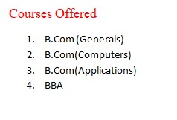

(B) To insert 5 bullets options : Home Tab ->Paragraph ,then select bullets list menu

**College Facilities**

* + Library
  + Canteen
  + Sports
  + Cultural Activities
  + Scholarships

( C ) To include a foot note: Goto Reference Tab →insert footnote.

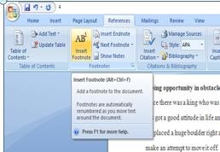

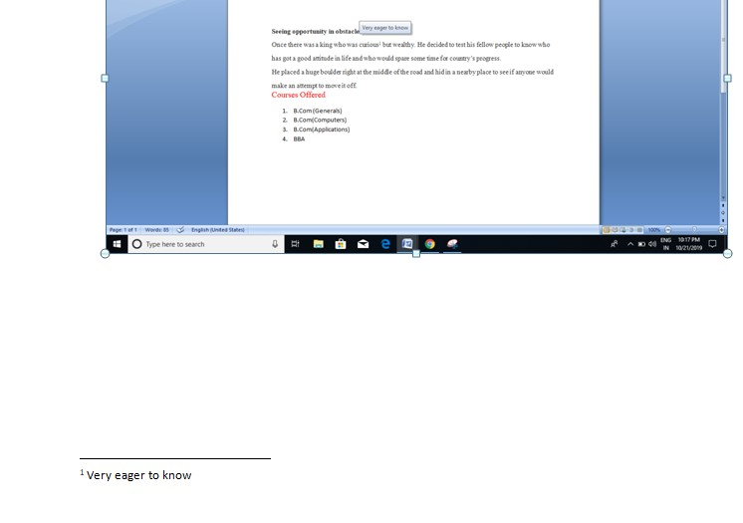

(D ) To Center the heading of your Document:

Home Tab → Paragraph → select Alignment option as Centered

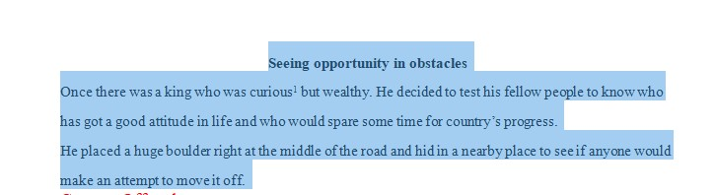

**40) Create a word document to display the Time Table of your class. Use all the features of Table Formatting.**

**Procedure:**

1) Go to Start → All Programs → Microsoft Office → Microsoft Word.

2) To Create a Table, goto Insert Tab → Click on Table Option.

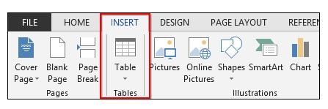

1. To quickly spec out a table but you can also insert, draw, or pick from some predefined “Quick Tables”.

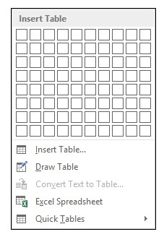

1. On the Ribbon, the “Table Tools” tabs are contextual tabs that appears whenever you create or click on a

table. 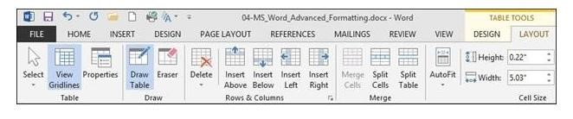

1. The “Design” tab by contrast is all about how your table(s) appear.

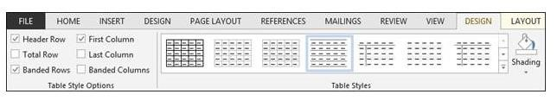

1. when you click on the scrollbar in “Table Styles” a larger menu appears granting you greater built-in options.

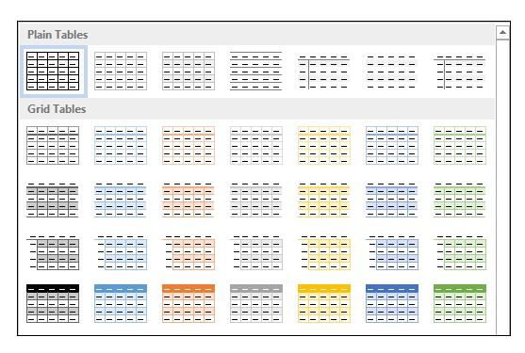

**Output:**

**I B.COM. TIME TABLE FOR THE ACADEMIC YEAR 2022-25**

|  |  |  |  |  |  |  |  |  |
| --- | --- | --- | --- | --- | --- | --- | --- | --- |
| **DAY** | **YEAR** | **I**  **9.00 to**  **9.50** | **II**  **9.50 to**  **10.40** | **III**  **10.40 to**  **11.30** | **IV**  **11.30 to**  **12.20** | **Break**  **12.20 to**  **12.50** | **V**  **12.50 to**  **1.40** | **VI**  **1.40 to**  **2.30** |
| **MON** | **I.A (303)** | **BOM** | **FA** | **FIT** | **ENG** |  | **SL** | **-** |
| **I.B (304)** | **ENG** | **BOM** | **FA** | **FIT/FT** |  | **EVS** | **-** |
| **I.G (201)** | **FA** | **ENG** | **BOM** | **EVS(H)** |  | **FIT** | **-** |
| **TUE** | **I.A (303)** | **BOM** | **FA** | **FIT** | **ENG** |  | **EVS** | **-** |
| **I.B (304)** | **ENG** | **BOM** | **FA** | **FIT/FT** |  | **SL** | **-** |
| **I.G (201)** | **FA** | **ENG** | **BOM** | **EVS(H)** |  | **FIT** | **-** |
| **WED** | **I.A (303)** | **BOM** | **FA** | **FIT** | **ENG** |  | **--** | **-** |
| **I.B (304)** | **ENG** | **BOM** | **FA** | **FIT/FT** |  | **--** | **-** |
| **I.G (201)** | **FA** | **ENG** | **BOM** | **EVS(H)** |  | **FIT** | **-** |
| **THU** | **I.A (303)** | **BOM** | **FA** | **FIT** | **ENG** |  | **--** | **-** |
| **I.B (304)** | **ENG** | **BOM** | **FA** | **FIT/FT** |  | **--** | **-** |
| **I.G (201)** | **FA** | **ENG** | **BOM** | **EVS(H)** |  | **SL** | **-** |
| **FRI** | **I.A (303)** | **BOM** | **FA** | **FIT** | **ENG** |  | **--** | **-** |
| **I.B (304)** | **ENG** | **BOM** | **FA** | **FIT/FT** |  | **--** | **-** |
| **I.G (201)** | **FA** | **ENG** | **BOM** | **EVS(H)** |  | **FIT** | **-** |
| **SAT** | **I.A (303)** | **BOM** | **FA** | **FIT** | **ENG** |  | **--** | **-** |
| **I.B (304)** | **ENG** | **BOM** | **FA** | **FIT/FT** |  | **--** | **-** |
| **I.G (201)** | **FA** | **ENG** | **BOM** | **EVS(H)** |  | **FIT** | **-** |

**41) Use Mail Merge feature to send invitation letters to ex-students of your college inviting them to attend the Alumni meet in your college.**

**Procedure:**

1. In a blank Microsoft Word document, click on the **Mailings** tab, and in the **Start Mail Merge** group, click **Start Mail Merge**.

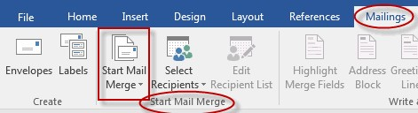

Click **Step-by-Step Mail Merge Wizard**.

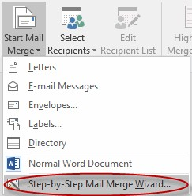

1. Select your document type. In this demo we will select **Letters**. Click **Next: Starting document**.

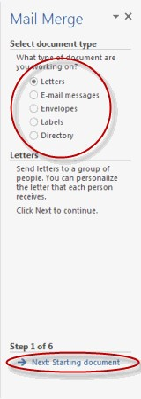

1. Select the starting document. In this demo we will use the current (blank) document. Select **Use the current document** and then click **Next: Select recipients**.

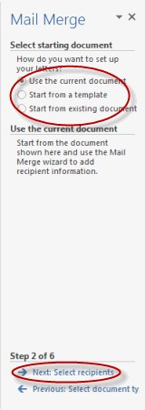

* + Note that selecting **Start from existing document** (which we are not doing in this demo) changes the view and gives you the option to choose your document. After you choose it, the Mail Merge Wizard reverts to **Use the current document**.

1. Select recipients. In this demo we will create a new list, so select **Type a new list** and then click **Create**.

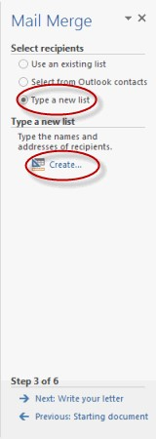

Create a list by adding data in the **New Address List** dialog box and clicking **OK**.

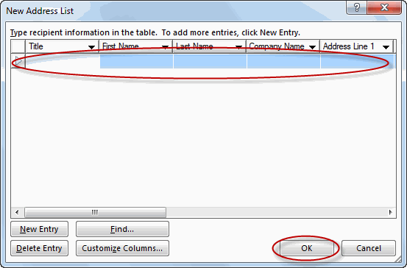

Save the list.

Note that now that a list has been created, the Mail Merge Wizard reverts to **Use an existing list** and you have the option to edit the recipient list.

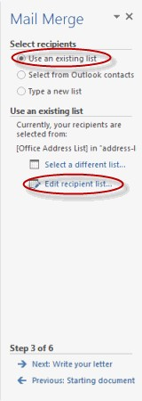

Selecting **Edit recipient list** opens up the **Mail Merge Recipients** dialog box, where you can edit the list and select or unselect records. Click **OK** to accept the list as is.

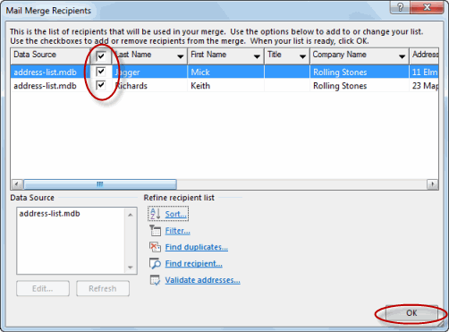

o Click **Next: Write your letter**.

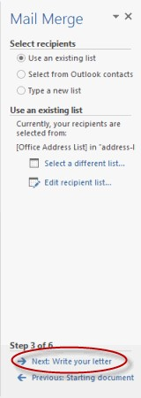

1. Write the letter and add custom fields.

Click **Address block** to add the recipients' addresses at the top of the document.

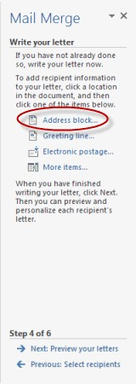

In the **Insert Address Block** dialog box, check or uncheck boxes and select options on the left until the address appears the way you want it to.

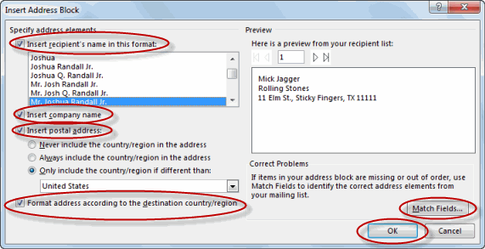

o Note that you can use **Match Fields** to correct any problems. Clicking **Match Fields** opens up the **Match Fields** dialog box, in which you can associate the fields from your list with the fields required by the wizard.

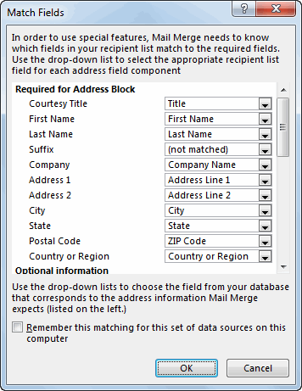

1. Press on your keyboard and click **Greeting line...** to enter a greeting.

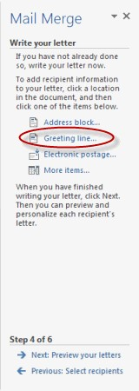

7. In the **Insert Greeting Line** dialog box, choose the greeting line format by clicking the dropdown arrows and selecting the options of your choice, and then click **OK**.

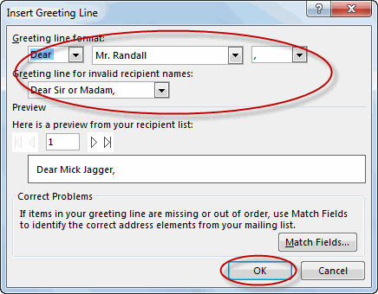

8. Note that the address block and greeting line are surrounded by chevrons (« »). Write a short letter and click **Next: Preview your letters**.

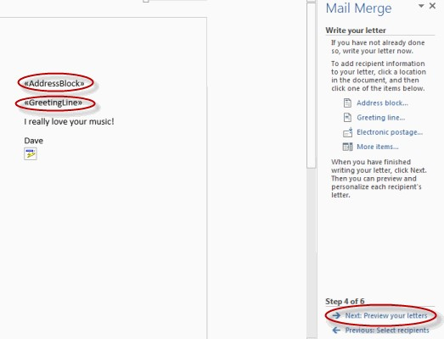

* Preview your letter and click **Next: Complete the merge**.

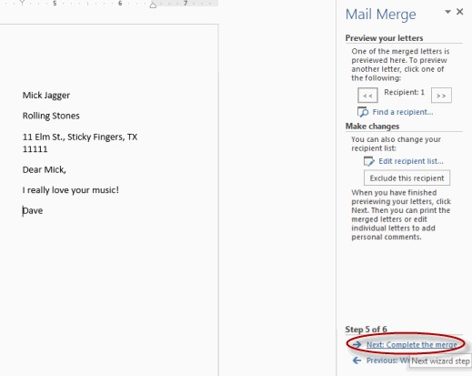

* Click **Print** to print your letters or **Edit individual letters** to further personalize some or all of the letters.

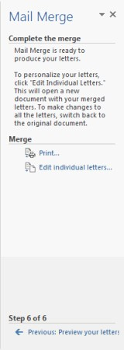

**42) Create letterhead of any company or institution that you got and insert the Watermark with that company name in the document.**

**Procedure:**

* 1. Go to Start ->All Programs -> Microosft Office -> Microsoft Word.
  2. Go to **Design** > **Watermark** > **Custom Watermark**.
  3. Choose **Picture Watermark** and select a picture, or choose **Text watermark** and type your watermark text in the **Text** box.
  4. Select **OK**.

**Output:**

**43) Create a MACRO taking your own data and run it.**

**Procedure:**

A macro is a series of commands and instructions that you group together as a single command to accomplish a task automatically.

To save time on tasks you do often, bundle the steps into a macro. First, you record the macro. Then you can run the macro by clicking a button on the Quick Access Toolbar or pressing a combination of keys. It depends on how you set it up.

Record a macro with a button

Click **View** > **Macros** > **Record Macro**.

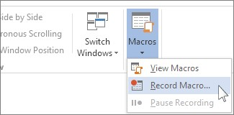

1. Type a name for the macro.

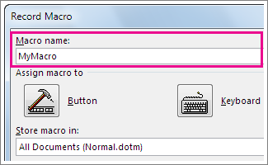

1. To use this macro in any new documents you make, be sure the **Store macro in** box says **All Documents (Normal.dotm)**.

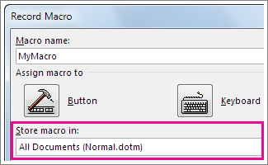

1. To run your macro when you click a button, click **Button**.

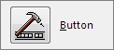

1. Click the new macro (it’s named something like Normal.NewMacros.<your macro name>), and click **Add**.

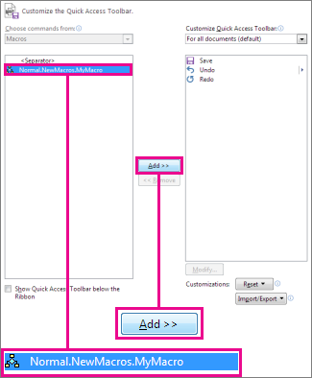

1. Click **Modify**.

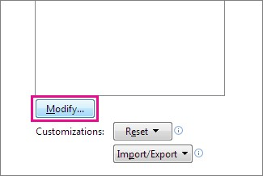

1. Choose a button image, type the name you want, and click **OK** twice.

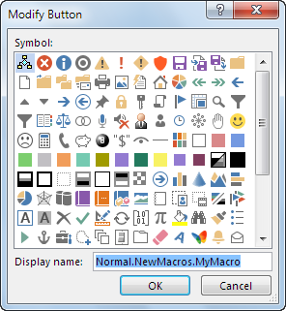

1. Now it’s time to record the steps. Click the commands or press the keys for each step in the task. Word records your clicks and keystrokes.

**Note:** Use the keyboard to select text while you’re recording your macro. Macros don’t record selections made with a mouse.

1. To stop recording, click **View** > **Macros** > **Stop Recording**.

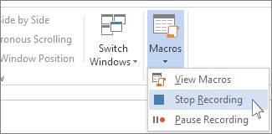

The button for your macro appears on the Quick Access Toolbar.



To run the macro, click the button.

To run a macro, click the button on the Quick Access Toolbar, press the keyboard shortcut, or you can run the macro from the **Macros** list.

1. Click **View** > **Macros** > **View Macros**.

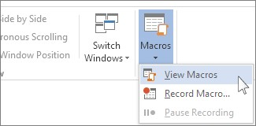

1. In the list under **Macro name**, click the macro you want to run.
2. Click **Run**.

**44) Create a document on Features of computers and apply different themes.**

**Procedure:**

Apply a document theme

To change the document theme that is applied by default in Word, select another predefined document theme or a custom document theme. Document themes that you apply affect the styles that you can use in your document.

* 1. If you are using Word, on the **Design** tab, in the **Document Formatting** group, click **Themes**.
  2. Do one of the following:

o To apply a predefined document theme, click the document theme that you want to use.

o To apply a custom document theme, under **Custom**, click the document theme that you want to use.

* 1. If a document theme that you want to use is not listed, click **Browse for Themes** to find it on your computer or network. To apply a theme from one Office document to another, in the **Choose Theme or Themed Document** dialog box, select the Office document that contains the theme that you want to apply, and then click **Open.**
  2. In Office 2007 applications, you can search for other document themes on Office Online. Click **Search Office Online**.

**45) Create Super Script at Subscript as Co2; x2.**

**Procedure:**

* 1. Go to Start ->All Programs -> Microosft Office -> Microsoft Word.
  2. To Create a Superscript at Subscript as
  3. To apply the given formats in font group: in Home Tab-> select Font Group and use subscript and superscript option to the write the below formula as shown:

Co2 ; x2.

**46) Create a word document consisting of 5 pages describing about your college. Insert headers and footers and page numbers in all the pages.**

**Procedure:**

* 1. Go to Start ->All Programs -> Microosft Office -> Microsoft Word.
  2. Now create a document of 5 pages describing your college using paragraph and other options on paragraphs:
     1. Bullets: Numeric and Symbolic bullets (In Home Tab)
     2. Formatting Tools such as Fonts, Styles, Alignments (In Home tab)
     3. Headers and Footers ( In insert Tab)
     4. Page numbers ( in Insert Tab)

**Output:**

**47) Enter the Student details with the following columns: Sno, Sname, Subjects marks in first semester.**

**Calculate the Total Marks, Average and Result.**

**Result should be displayed as “Pass/Fail”. Take your own criteria for result.**

**Procedure:**

* 1. Go to → Start → All Programs → Microsoft Office → Microsoft Excel
  2. Click on Insert Tab → Select Tables and enter the columns of the tables as shown in outputs.
  3. Insert the data of the students as needed
  4. Then use the formaula, to find total as =SUM(C4:G4)
  5. To find th average use the formaula as =Table1[[#This Row],[Average]]
  6. Finally get the result based on the average scored by the student.

=IF(I7>= 60, "Pass", "Fail")

* 1. Save the file with the filename as student details.xls

**Output:**

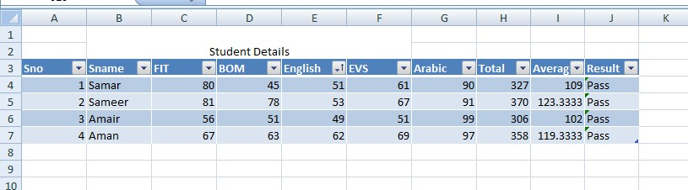

**48) Enter the Student details with the following columns:**

**Sno, Sname, Subjects marks in first semester.**

* 1. **Calculate the Total Marks, Average.**
  2. **Find the maximum and minimum of marks in Total Marks column.**
  3. **Count the number of students whose Average score is > 70.**

**Procedure:**

1. Go to → Start → All Programs → Microsoft Office → Microsoft Excel
2. Click on Insert Tab → Select Tables and enter the columns of the tables as shown in outputs.
3. Insert the data of the students as needed
4. Then use the formaula, to find total as =SUM(C4:G4)
5. To find th average use the formaula as =Table1[[#This Row],[Average]]
6. Finally
   * 1. to find the Max of Total Marks scored by the students is : =MAX(H4:H9)
     2. to find the Min of Total Marks scored by the students is : =MIN(H4:H9)
     3. to count the number of students whose average score is > 70 is : =COUNTIF(I4:I7,">70")

1. Save the file with the filename as student details.xls

**Output:**

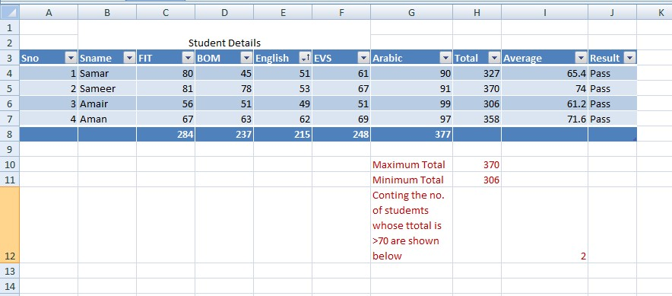

**49) Enter the Student details with the following columns:**

**Sno, Sname, Subject marks in first semester.**

**a) Calculate the Total Marks, Average.**

* 1. **Use conditional formatting to display the students marks whose score in a particularl subject is greater than 90.**

**Use conditional formatting to display the students whose marks are greater than 90 in all the subjects.**

**Procedure:**

1. Go to → Start → All Programs → Microsoft Office → Microsoft Excel
2. Click on Insert Tab → Select Tables and enter the columns of the tables as shown in outputs.
3. Insert the data of the students as needed
4. Then use the formaula, to find total as =SUM(C4:G4)
5. To find th average use the formaula as =Table1[[#This Row],[Average]]
6. To apply the conditional Formatting:

Goto Home Tab → Conditional Formatting → Highlight Cell Rules → Greater THan

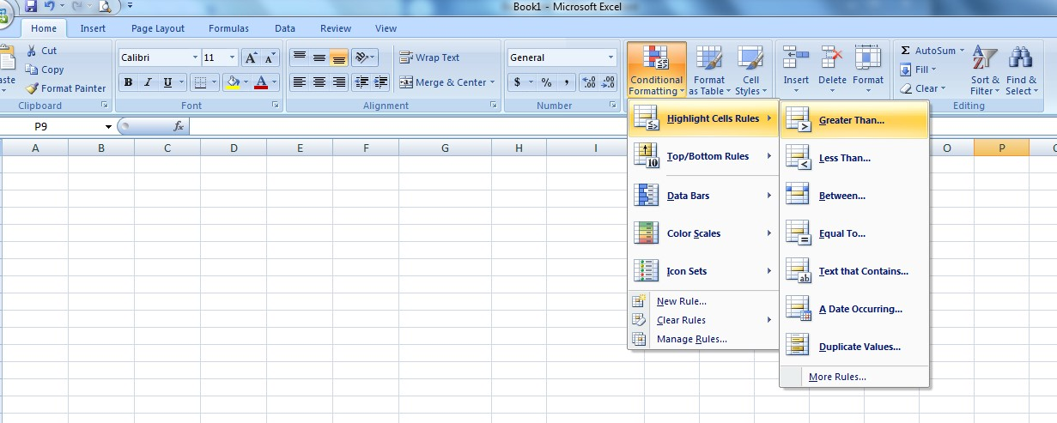

7. To display the students marks whose score in a particular subject ( FIT ) is greater than 90 then Output1

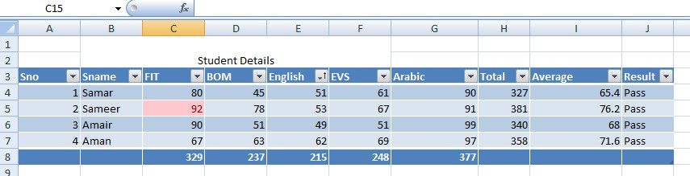

8. To display the students marks whose score in all subject is greater than 90 then Output2:

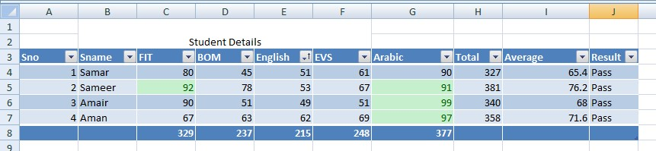

**50) Consider the following columns:**

**Sno, Sname, Total marks obtained in first semester. Represent this data using a Bar diagram.**

**Procedure:**

* 1. Go to → Start → All Programs → Microsoft Office → Microsoft Excel
  2. Click on Insert Tab → Select Tables and enter the columns of the tables as shown in outputs.
  3. Insert the data of the students as needed
  4. Then use the formaula, to find total as =SUM(C4:G4)
  5. To find th average use the formaula as =Table1[[#This Row],[Average]]
  6. To represent the data using a Bar Diagram: Insert tab → Charts → Select Bar Chart option
  7. Finally save the file using the filename as student details in chart.xls

**Output:**

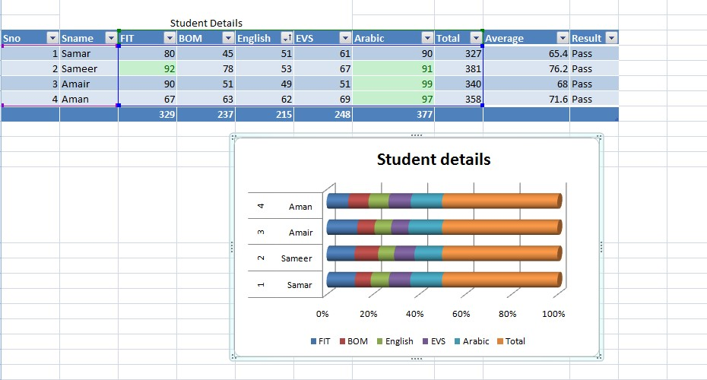

**51) Consider the following columns:**

**Month, Sales(Rs.). Plot the data using a line chart.**

**Procedure:**

1. Go to → Start → All Programs → Microsoft Office → Microsoft Excel
2. Click on Insert Tab → Select Tables and enter the columns of the tables as shown in outputs.
3. Insert the data with respect to Months and Sales in Rs.
4. Then finally the output is as displayed below:
5. Save the file as monthlysales.xls

**Output:**

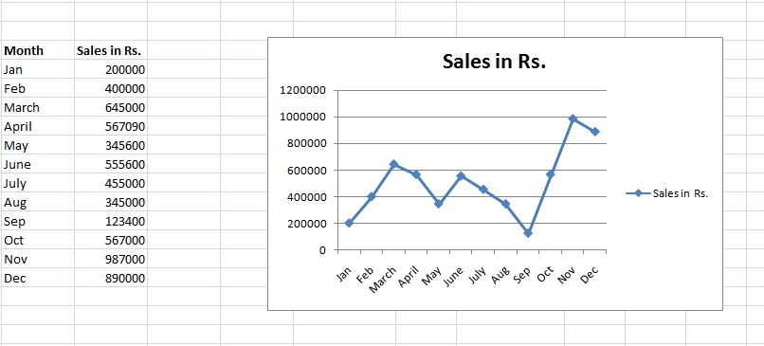

**52) Consider the following student data with columns:**

**a) Firstname, Lastname, Score(out of 100)**

**b) Sort the above data on Firstname column.**

**c) Sort the above data on Fistname and then by Lastname (use multilevel sorting)**

**Procedure:**

1. Go to → Start → All Programs → Microsoft Office → Microsoft Excel

2. Click on Insert Tab → Select Tables and enter the columns of the tables as shown in outputs.

3. Enter the column headers as First Name, Last Name and Score

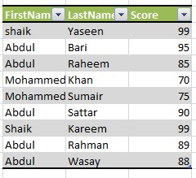

1. To Sort the above data on Firstname After Sorting the result is as shown below

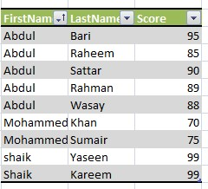

1. To Sort the above data on Firstname and by LAstName using Multilevel Sorting

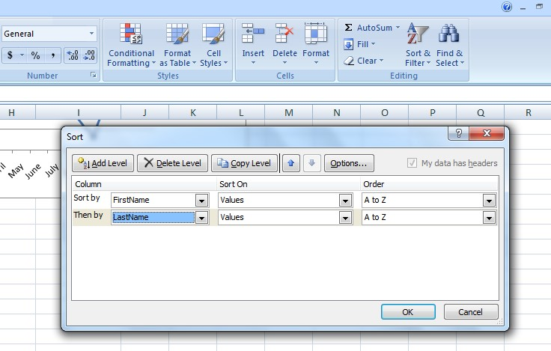

6. Final Sorted output after applying multi level sorting

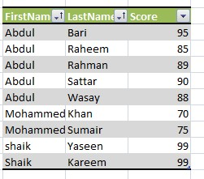

**53) Consider the following student data with columns:**

**a) Firstname, Lastname, Score(out of 100)**

**b) Filter the above data by displaying the student details where score > 70.**

**c) Filter the above data by displaying the student details where score between 50 and 70.**

**Procedure:**

1. Go to → Start → All Programs → Microsoft Office → Microsoft Excel

2. Click on Insert Tab → Select Tables and enter the columns of the tables as shown in outputs.

3. Enter the column headers as First Name, Last Name and Score



1. To apply Filter the above data by displaying the student details where score >70.

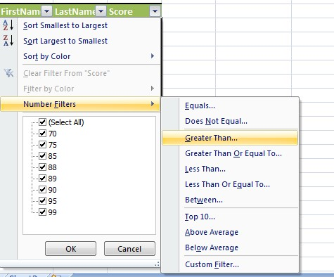

5 . Apply the criteria as >70.

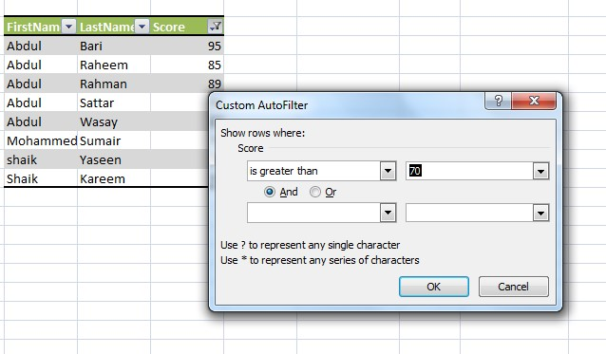

6. After applying the criteria as > 70.

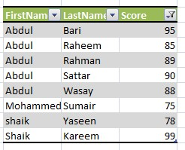

7. To apply Filter the above data by displaying the student details where score between 50 and 70.

8. Number Filters → Between

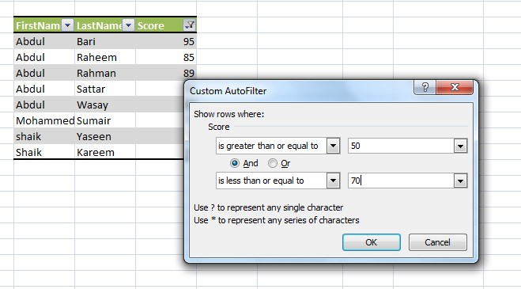

* 1. After applying the condition , the following result is displayed

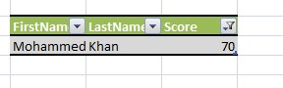

10. Finally save the Excel File.

**54) Consider Employee details data with the columns:**

**Emp. ID, Employee name, Department and Salary.**

**Generate Department wide sub-totals.**

**Procedure:**

1. Go to → Start → All Programs → Microsoft Office → Microsoft Excel

2. Click on Insert Tab → Select Tables and enter the columns of the tables as shown in outputs.

3. Create the table with the Employee details:

4. To generate the department wise subtotals: use the formulas as below:

* + - 1. SUBTOTAL of Finance=SUBTOTAL(9,E57,E63)
      2. SUBTOTAL of Computers =SUBTOTAL(9,E58,E62)
      3. SUBTOTAL of Doctors =SUBTOTAL(9,E59,E61)
      4. SUBTOTAL of engineers =SUBTOTAL(9,E60,E64)

**Output:**

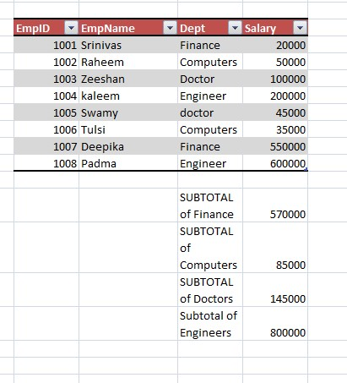

**55) Following are the scores of 10 students in an exam: 44, 56, 89, 94, 43, 32, 11, 55, 99, 44.**

**Use functions to calculate Mean, Median and Mode.**

**Procedure:**

* 1. Go to → Start → All Programs → Microsoft Office → Microsoft Excel 2. Enter the scores of 10 students in an exam as given below
  2. To find the Mean, Median ,Mode from the given values:
  3. Mean =SUM(D74:D83)/10
  4. Median =MEDIAN(D74:D83)
  5. Mode =(3*49.4)+(2*D85)
  6. Finally save the excel file with the extension.xls

**Output:**

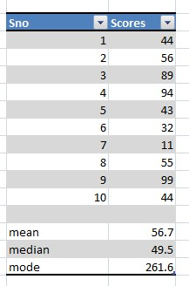

**56) Consider the following Sales data with columns:**

**Date, Salesman Name, Region(North/South/East/West), Sales in Rs.**

**Generate a pivot table to calculate the Total Sales Region wise. Also calculate the average sales made region wise.**

**Procedure:**

Step 1:- Click on start button* All Programs* MS-Office🡪 MS-Excel.

Step 2:- Now new work book will open. In sheet I type the data as given in the above question.

Step 3:- first select the data then click on Insert tab*Pivot table

Then Create Pivot table window will open , and then select new work sheet, click on OK button

Step 4: Drag and drop salesman option in Row Labels

Step 5: Drag and drop Region option in Column Labels

Step 6: Drag and drop Sales option in values Labels

Step6: From OPTIONS contextual tab* deselect the "Field Headers"

Step 7: Select Design contextual  on Grand Totals dropdown For Column only"

Step8: To calculate Average, Right click on Grand total cell select "summarize data by" option then select Average from Sub menu.

Step 9:Save it by selecting office button *save or save as

**57) Create a presentation of 5 slides to describe the facilities available to students in your college.**

**Procedure:**

1. Goto Start → All Programs → Microsoft Offfice → Microsoft Powerpoint.
2. Create a powerpoint presentation by including different slides about the facilities provided by the college to their students.
3. List out various facilities and then insert an image of the college. 4. Finally, save your file by using an extension as student.pptx

**58) Create a presentation of 5 slides to describe the benefits of Yoga in human life. Apply different slide transitions.**

**Procedure:**

1. Goto Start → All Programs → Microsoft Offfice → Microsoft Powerpoint.
2. Create a powerpoint presentation by including different slides about the benefits of Yoga Practice.
3. Create different slides describing the need and importance of yoga in our life.
4. 4. Finally save the file with the filename as yoga.pptx

**Output:**



**59) Create a presentation of 5 slides using different slide layouts to describe about Global Warming.**

**Procedure:**

1. Goto Start → All Programs → Microsoft Offfice → Microsoft Powerpoint.
2. Create a powerpoint presentation by including different slides about the Global Warming.
3. Create different slides describing the causes and effects of global warming. 4. Finally save the filewith the filename as yoga.pptx

**Output:**



**60) Create a presentation of 5 slides describing the side effects of overuse of Smart Phones and apply design templates.**

**Procedure:**

Stepl: open power point application window

Start button all programs Microsoft office Microsoft PowerPoint.

Step2: Take new slide: go to Home tab slides select new slide

Step3: write the content regarding to topic i.e. about Effects of overuse of Smart Phone.

Step4: Repeat Step2 and step3 until 5 slides

Step5: to apply design templates, go to Design Tab themes group click on the required Design Template.

Step6: save the file.

**61)Create a presentation of 5 slides describing about the Side effects of smoking using custom animations**

**Procedure:**

Step1: open power point application window

Start button 🡪 all programs 🡪Microsoft office 🡪Microsoft PowerPoint.

Step2: Take new slide: go to Home tab slides 🡪select new slide

Step3: write the content regarding to topic i.e. about Side effects of smoking.

Repeat Step2 and step3 until 5 slides

Step4: To apply the custom animation, go to animations tab animations group then select custom animations.

Custom animations window will be opened.

Step5: select text or content in slide to which you want to apply custom animation.

Step6: choose required custom animation

Step7: repeat step 5 and 6 until to apply custom animations to all slides.

Step8: save the file.

**62) Create a MS-Excel worksheet to illustrate sorting.**

**Procedure:**

1. Select data on list to be sorted. For example salary in the above figure.
2. Click the Data Menu and select the sort option. The sort dialog box appears.
3. Select the ascending and descending option in the Sort by section.

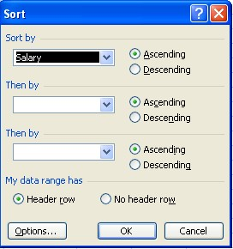

4. Click the OK button.

**Output**:

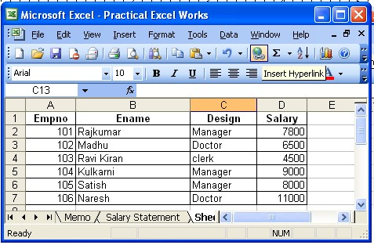

**63) Create worksheet with following fields Empno, Ename, Basic Pay(BP), Travelling Allowance(TA), Dearness Allowance(DA), House Rent Allowance(HRA), Income Tax(IT), Provident Fund(PF), Net Pay(NP)**

**Given: DA= 30% of BP, HRA=20% of BP, TA=17.5% of BP, IT=15% of BP, PF=12.5% of BP.**

**Procedure:**

1. Create an Excel Worksheet for an employee pay roll system.
2. Enter the details of Employee as given and calculate the DA, TA, HRA, IT, PF as a percentage on the basis of Basic Pay.
3. Calculate the Net Pay by using the formulae

**Gross Pay**= DA+TA+HRA+BP

**Deductions**=IT+PF

**Net Pay**= Gross Pay-Deductions

**Output:**

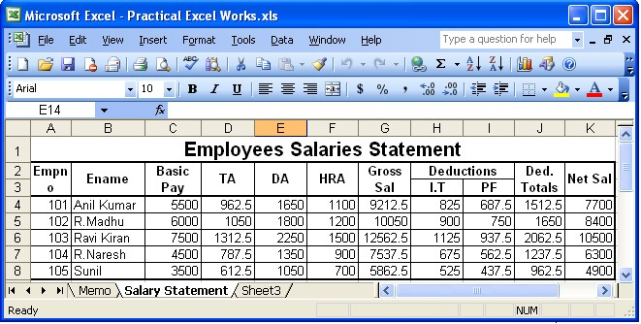

**64) Create an Excel Worksheet with fields as Roll No, Name, Marks and percentage.**

**Procedure:**

1. Create an Excel Worksheet by inserting field names
2. Calculate total marks, Averages, Results and Divisions.(By using Mathematical and Logical Functions)
3. Represent the Data by inserting the Pie Chart.

**Output:**

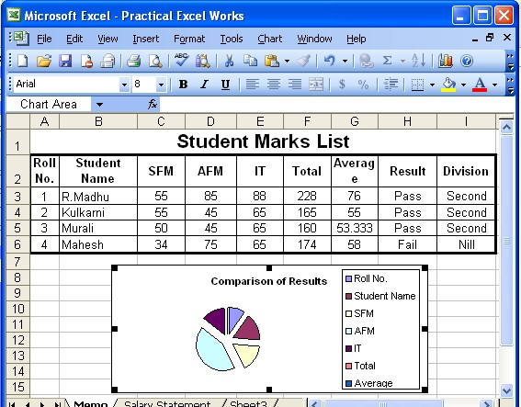

**65) Create an Excel Worksheet for the monthly sales of a product and also represent the data by using bar chart?**

**Procedure:**

1. Create an Excel sheet with the given Data
2. Assuming sales of a product for different months can be represented by using bar chart.

**Output:**

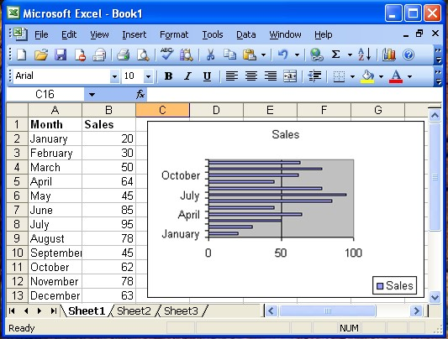

**66) Write a program to add new row and new column to already existing table.**

**Procedure:**

To Add a Row:

1. Select the entire row below where you want to add the new row

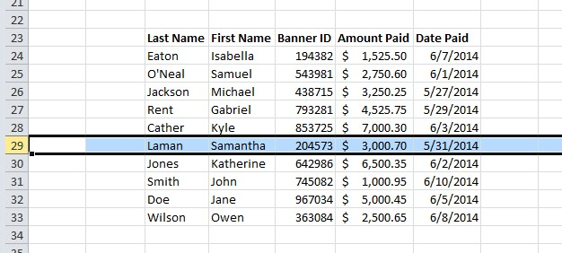

2. Right click, select Insert.

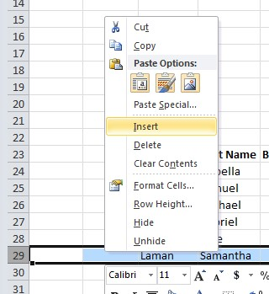

To Add a Column:

1. Select the column to the right of where you want to add the new column

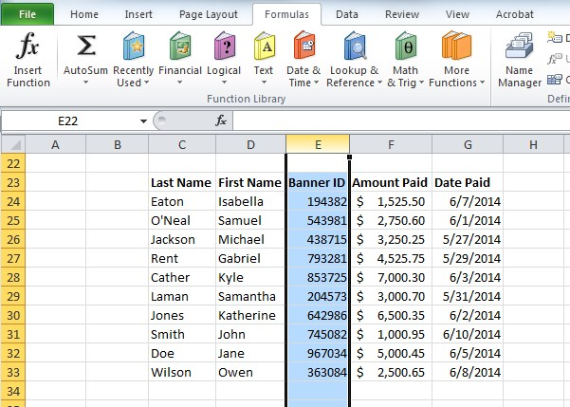

2. Right click, select Insert.

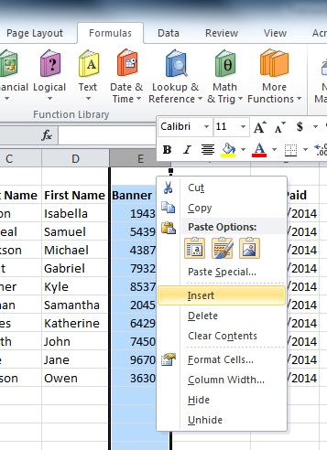

**67) Write a program to convert from numerical value in to accounting value.**

**Procedure:**

1.

S

elect the cell or cells to forma

t

2.

Right click

and

select

*Format Cells*

.

The Format Cells dialogue box will appear

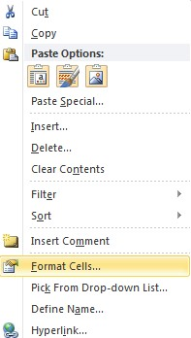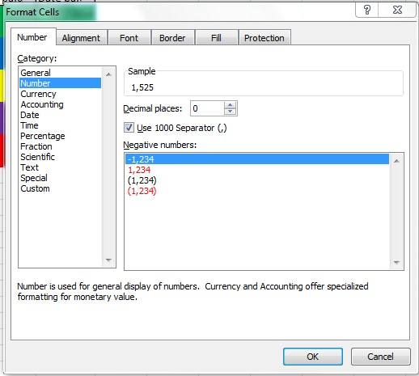

3.To convert a numeric value into an accounting value: Select Accounting from the list of Categories.

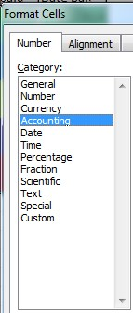

4. Click Ok.

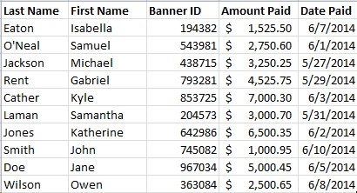

**68) Write a program to Creating or Deleting a Custom Table Style.**

**Procedure:**

To Create a Custom Table:

1. Select your data
2. Choose Format as Table.

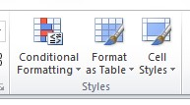

3 .Select New Table Style at the bottom of the dropdown menu.

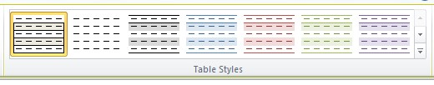

The New Table Quick Style dialogue box will appear

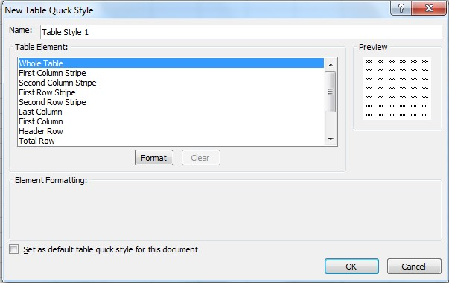

4. Select any of the table elements to format the table as desired.

The Preview box allows you to view the table before completing formatting changes. Select OK to apply the table to your data.

To Set this Table as a Default Table:

1. Select the Set as default table quick style for this document option

To Delete a Custom Style:

1. Select Format as Table.
2. Find the custom style located within the Custom section
3. Right click on the style, select Delete.

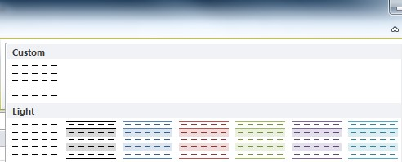

**69) Write a program to removing a table style.**

**Procedure:**

To Remove a Table Style from and Existing Table:

1.

Select the

contents of the

table

.

2.

Choose the

More

button

.

3.

Choose

Clear

.





This will clear the table style but the data will still remain in a table format.

**70) Write a program to Converting a Table to a Range of Data .**

**Procedure:**

To Convert an Existing Table to a Range of Data:

1. Select the table.

2.

Select

Convert to Range

.

3.

Select

Yes

.

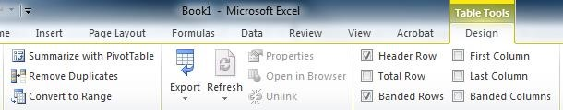

**71) Write a program to Formatting Table Elements?**

**Procedure:**

To Format the Elements of a Table Style:

1. Select the contents of the table.
2. *Table Style Options* contains various table formatting options.

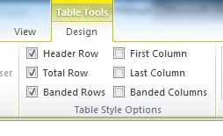

3. Select the desired checkboxes to change the format of the table.

*Header Row* – Creates a row at the top of the table for headers.

*Total Row* – Creates a row at the bottom of the table populates a total sum for each column.

*Banded Rows* – Shades every other row in the table.

*First Column* – Shades the entire first column the same color as the header row.

*Last Column* – Shades the entire last column the same color as the header row.

*Banded Columns* – Shades every other column in the table.

**72) Write a program to insert a pivot table.**

**Procedure:**

1.

S

elect any cell in you

r

data range.

2.

Select Pivot Table located on the Insert tab.

The Create PivotTable

dialogue box

will appear.

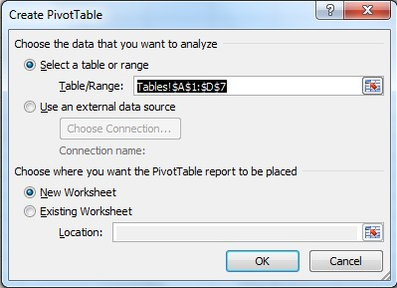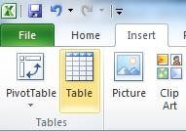

Excel will automatically select the data for the pivot table.

Excel will also automatically select New Worksheet as the destination for the pivot table.

Click *Ok*.

A new worksheet will be added for the pivot table.

Initially, the spreadsheet will appear blank.

The PivotTable Field List is located to the right.

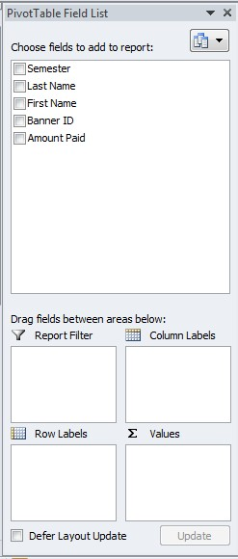

1. Choose the fields to see by selecting column headers within *Choose Field to Add to Report*.

You can also drag and drop a field into a Pivot table Area within the dialogue box.

Pivot Table Areas:

*Report Filter* – Filters the entire pivot table based on fields in that area

*Column Labels* – Adds columns to the table based on fields in that area;

*Row Labels* – Adds rows to the table based on fields in that area;

*Values* – Performs an Auto Sum action in the table based on the fields in that area.

In a pivot table, you can sort and filter like you can with any other data range.

To Change the Summary Calculation Value:

1. Click on any cell in the *Grand Total* row

2. Select *Value Field Settings* from the menu.

This will open the Value Field Settings dialogue box:

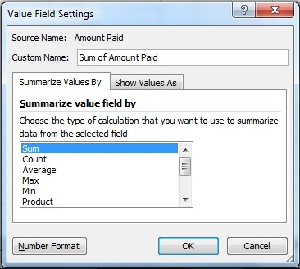

1. Choose the calculation you want to summarize.
2. Click *Ok*.

The *Values* field will change to the selected calculation.

**73) Write a program to create a date occurring?**

**Procedure:**

To highlight cells that contain a certain date or date range:

1. Highlight the data range.

2.

S

elect

*Conditional Formatting*

.

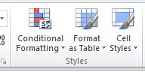

1. Hover over the *Highlight Cells Rules*.
2. Select *A Date Occurring* to open the Date Occurring dialogue box.

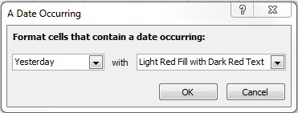

5. Select the date or date range that you’re looking for.

6. Select the type of cell formatting.

7. Select *Ok*.

The cells which contain the specified date or date range will now appear with the cell formatting which you selected.

**74) Write a program to create duplicate values?**

**Procedure:**

To highlight cells that contain either duplicate or unique values:

1. Highlight the data range.

2.

S

elect

*Conditional Formatting*

.



1. Hover over *Highlight Cells Rules*.
2. Select *Duplicate Values* to open the Duplicate Values dialogue box.

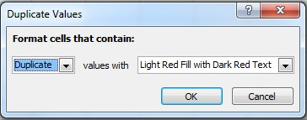

1. Select either *Duplicate* or *Unique* from the drop down menu.
2. Select the type of cell formatting you wish to use.
3. Select *Ok*.

The cells which contain either duplicate or unique values will now appear with the cell formatting which you selected.

**75) Write a program to highlight the top ten items.**

**Procedure:**

To highlight cells that are the top 10 items in your data:

1. Highlight your entire data range.

2.

S

elect

*Conditional Formatting*

.



1. Hover over *Top/Bottom Rules*.
2. Select *Top 10 Items* to open the Top 10 Items dialogue box.

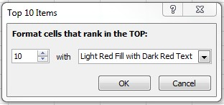

1. Enter the number of items to identify.
2. Select the type of cell formatting you wish to use.
3. Select *Ok*.
4. The cells which are in the top selected number will now appear with the cell formatting which you selected.
5. To identify the bottom 10 items select *Bottom 10 Items* instead of Top 10 Items.

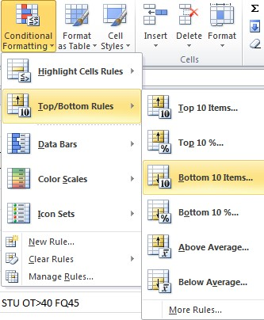

**76) Write a program to highlight cells that are in the top ten percentage of items in your data?**

**Procedure:**

To highlight cells that are in the top percentage of items in your data:

1. Highlight the data range.

2.

S

elect

*Conditional Formatting*

.



1. Hover over *Top/Bottom Rules*.
2. Select *Top 10%* to open the Top 10% dialogue box.

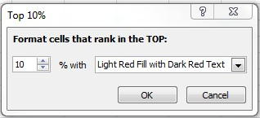

1. Enter the number of items to identify.
2. Select the type of cell formatting you wish to use.
3. Select *Ok*.

The cells which are in the top selected percentage will now appear with the cell formatting which you selected.

To identify the bottom 10 percent select *Bottom 10 Percent* instead of Top 10 Percent.

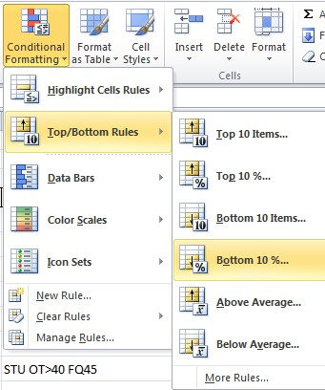

**77) Write a program to highlight cells that are above the average value of your data?**

**Procedure:**

To highlight cells that are above the average value of your data:

1. Highlight the data range.

2.

S

elect

*Conditional Formatting*

.



1. Hover over *Top/Bottom Rules*.
2. Select *Above Average* to open the Above Average dialogue box:

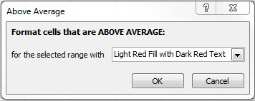

Select the type of cell formatting you wish to use. Select *Ok*. The cells which are above the average value of your data will now appear with the cell formatting which you selected.

To identify items below the average value select *Below Average* instead of Above Average.

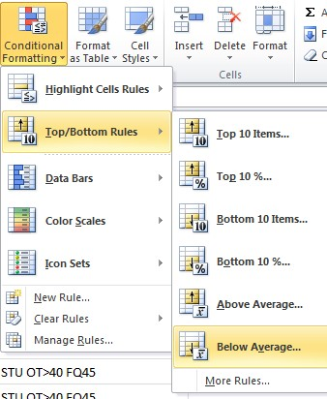

**78) Write a program to convert data into a bar graph?**

**Procedure:**

To convert data into a bar graph:

1.

H

ighlight your entire data range.

2.

S

elect

*Conditiona*

*l Formatting*

.

3.

Hover over

*Data Bars*

.

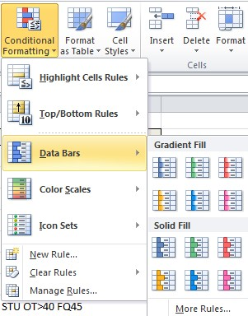

4. Choose either Gradient or Solid and select a color for the bar graph.

The data cells will now be filled with a gradient color based on the value in the cell.

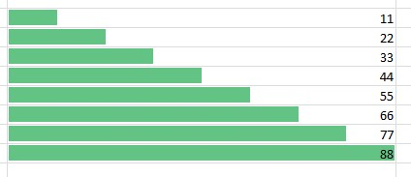

**79) Write a program to add a color scale to your data?**

**Procedure:**

To add a color scale to data:

1.

Highlight the

data range.

2.

S

elect

*Conditional Formatting*

.

3.

Hover over

*Color Scales*

.

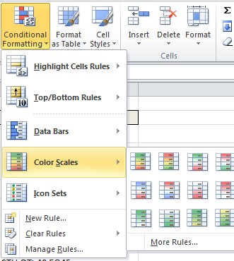

4. Select a color scale.

The data cells will now be displayed as a color scale based on the value of the cell.

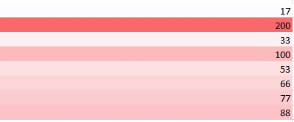

**80) Write a program to create your own rule?**

**Procedure:**

To create your own rule:

1. Highlight the cells in your data range.
2. Select the *Conditional Formatting* tool.

3.

Select

*New Rul*

e

.

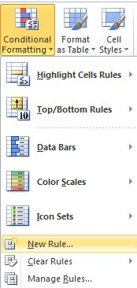

The New Rule dialogue box will open.

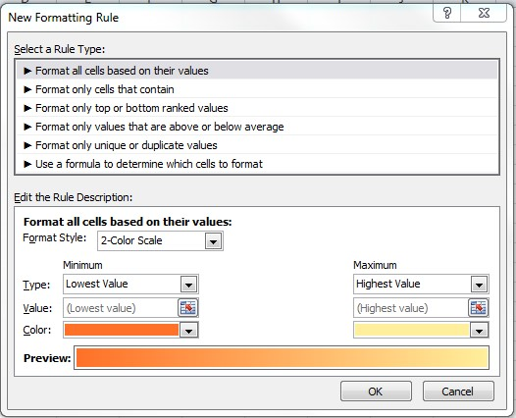

4. Select the Rule Type.

Each rule type will change the appearance of the dialogue box, as it changes the rule description.

**81) Write a program to clear conditional formatting of your data?**

**Procedure:**

To

clear c

onditional formatting:

S

elect

*Conditional Formatting*

.



1. Hover over *Clear Rules*.

2. Select the range for which to clear conditional formatting

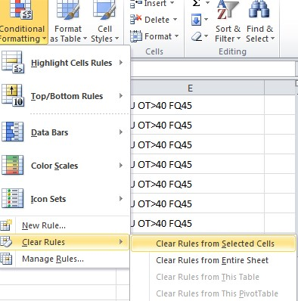

**82) Write a program to manage conditional formatting rules?**

**Procedure:**

To manage conditional formatting rules:

1.

Select

*Conditional Formatting*

.

2.

Select

*Manage Rules*

.

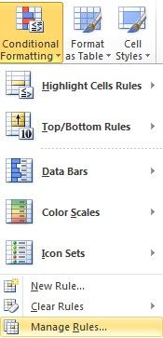

This will open the Conditional Formatting Rules Manager dialogue box:

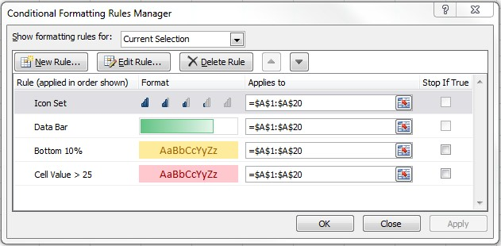

Select the formatting rules for dropdown to view rules for the current selection or any other worksheet or table within the workbook. You may add, edit or delete a rule from the Conditional Formatting Rules Manager.

**83) Write a program to separate data within a cell?**

**Procedure:**

To separate data within a cell:

1. Insert a blank column to the right of the column containing the merged data.
2. Highlight the column of full names.

3.

Select the

*Data*

tab

.

4.

Select

*Text to Columns*

.

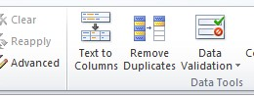

The Convert Text to Columns Wizard dialogue box will.

1. Choose the appropriate data type.

To separate a column based on punctuation characters, select *Delimited*.

To separate a column based on spaces between each field, select *Fixed Width*.

For this example we will select *Delimited*.

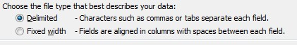

1. Select *Next*.

1. Choose your delimiters for the text separation.

For this example select *Space*.

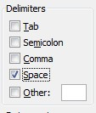

1. Select *Next*.

1. Select the data format for each column.

For this example select *General*.

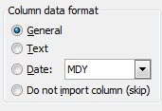

10. Select *Finish*.

Data will be displayed as separate columns

.

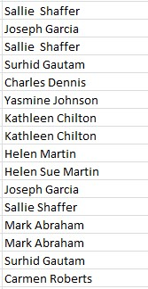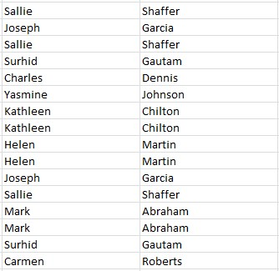

**84) Write a program to sort data alphabetically?**

**Procedure:**

To sort the data alphabetically:

1. Select the column to sort.

For this example we will sort by last name.

1. Highlight the column.

1. Select the *Data* tab.

Sorting options are located in the *Sort & Filter* section.

The Sort action, circled in blue below is used to alphabetically organize data.

The A-Z descending button is used to sort data from the lowest to highest values.

The Z-A descending button is used to sort data from the highest to lowest values.

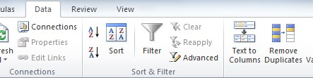

4. Select the *A-Z* to alphabetize the data within the column.

A Sort Warning dialogue box will appear. This will ask if you want to expand the selection or continue with the current selection.

5. Select *Expand the Selection*. This will sort the entire data sheet based on the column instead of just sorting the column selected.

The data

will be displayed alphabetically

.

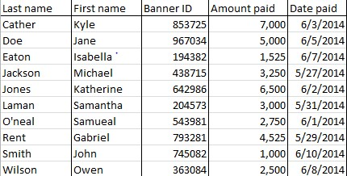

**85) Write a program to apply multi level sorting to the following table?**

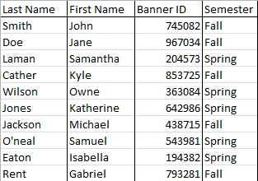

**Procedure:**

1. Select the first column to sort.

2.

Select the

*Sort*

button, circled

in red.

The Sort dialogue box will appear:

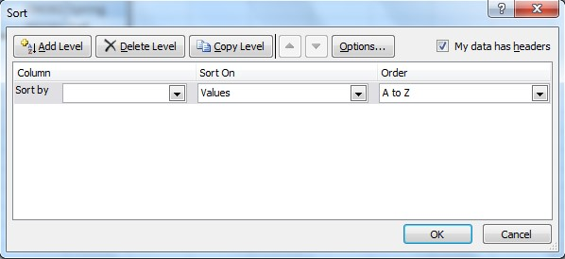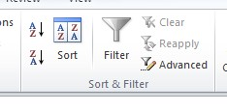

1. Open the *Sort By* dropdown.
2. Select the appropriate name of the column to sort first. For this example we will use *Semester*.
3. The *Sort On* dropdown should remain as *Values*.
4. To alphabetically sort data, select *A-Z*.
5. Ensure the *My Data Has Headers* option is selected to differentiate between column headers and data.
6. Select *Add Level* to add additional criteria to sort by. The *Then By* criteria will appear.

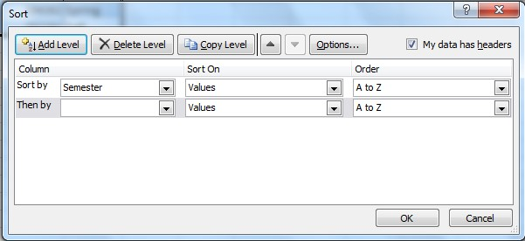

1. Select *Last Name* from the *Then By* dropdown box.

1. The *Sort On* dropdown should remain as *Values*.

1. The Order dropdown should be *A-Z*.

1. Click *Ok*.

The table will now be sorted alphabetically by semester and then by last name.

**Output:**

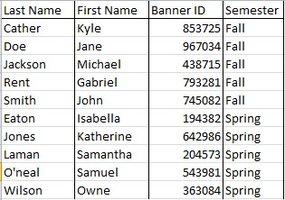

**86) Write a program to sort a following color coded data table?**

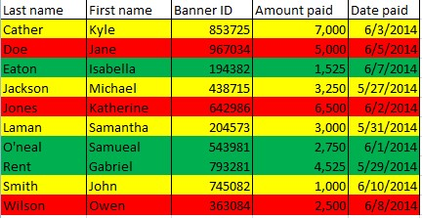

**Procedure:**

For this example we will organize the table with green at the top, yellow in the middle, and red on the bottom.

1.

H

ighlight the column of cells to sort.

2.

Select

*Sort*

.

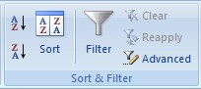

The Sort dialogue box will appear.

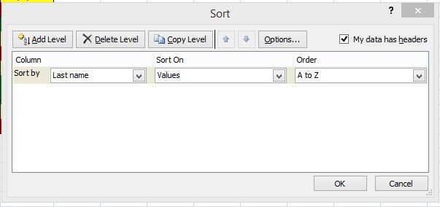

1. Open the *Sort By* dropdown.
2. Select the name of the column to sort.
3. Select *Cell Color* from the *Sort On* dropdown.
4. Select the color to be displayed at the top of the data sheet from the *Order* dropdown.
5. Ensure *On Top* is selected.
6. Select *Add Level* to add another sort criteria.
7. Select the same column from the *Then By* dropdown.
8. Select *Cell Color* from the *Sort On* dropdown
9. Select the color to be displayed at the bottom of the data sheet.

For this example we will use the color red. Your dialog box should now look like this:

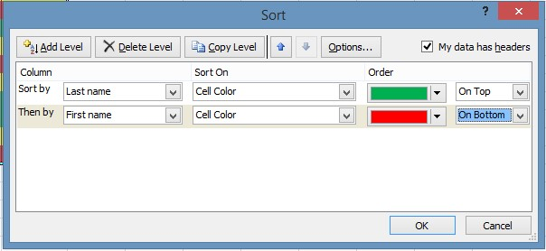

10. Select *Ok*.

The data table will now be sorted by color.

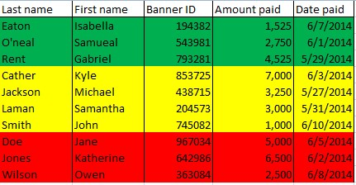

If there are more than three colors in the data sheet:

Follow the same process, but for each additional sort level added in the Sort dialogue box, select for each color to be displayed on top.

For example, data that contains five different colors would look like this:

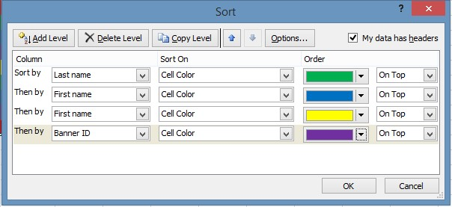

Once sorted, the data table will appear like this:

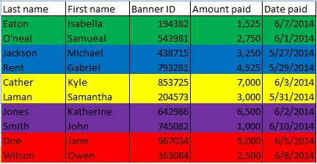

**87) Write a program to apply the filter to your data?**

**Procedure:**

To apply a filter:

1. Select the range of data to filter
2. Highlight the headers of each column of data to filter.

To highlight all header columns select the entire first row.

1. Select *Filter*.

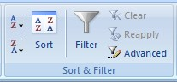

A dropdown arrow will appear to the right of each column header.



Filters may be applied to each column of data. To apply a filter, open the dropdown menu and select the criteria to display.

For example: to view all items that were paid in May:

1. Select the arrow to open the dropdown menu to filter.
2. Unselect the *Select All* checkbox.
3. Select the checkboxes you wish to display.

To filter further than the options that are made available:

1. Hover over the *Date Filters* option. (This may also be displayed as column, text or number filters, depending on the contents of the column).

2. Select the appropriate filter option to filter the data

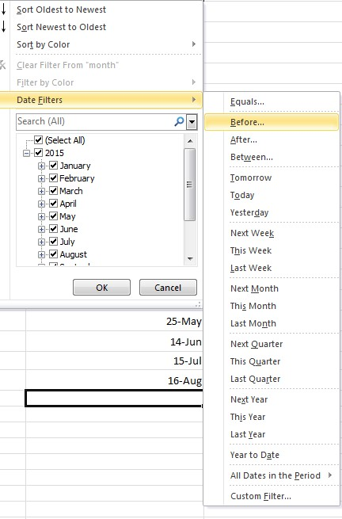

In this example, we will select *Before*

A dialog box titled

*Custom AutoFilter*

will open.

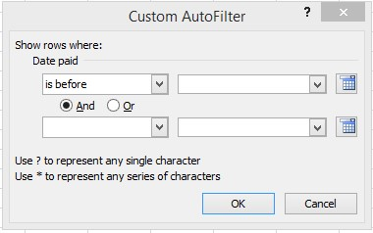

Enter the parameters for the filter in the Custom AutoFilter dialog box.

Select 6/1/2014 from the calendar dropdown menu to the right of the *Is Before* dropdown. Click *Ok*.

The result will look like this:

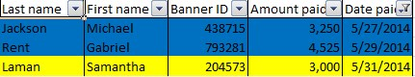

This process may be used to filter any column.

*All sort and filter functions can also be found from the dropdown *Sort & Filter* menu in the *Editing* section

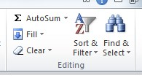

**88) Write a program to add numbers in a column of the following table.**

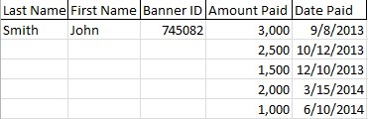

**Procedure:**

1.

S

elect the cell directly

beneath

the last entry.

2.

S

elect

*Auto Sum*

locat

ed on the

*Formulas*

tab.

3.

Select the

*AutoSum*

button

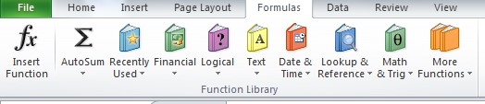

1. This will select all items within the column
2. Click the *Enter* key on your keyboard to calculate the sum of all fields.

Other functions are available by selecting the AutoSum dropdown

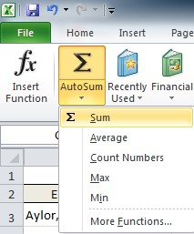

Other functions include: averaging the numbers in a column, counting the numbers in a column and finding the minimum and/or maximum numbers in the column.

Additionally, there is an *AutoSum* button and dropdown menu also located on the Home toolbar.

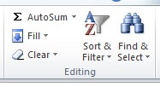

**89) Below is a sample data sheet for which we need to calculate the total amount paid for each semester by using one level sub totals.**

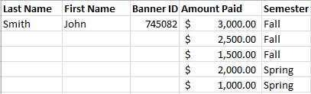

**Procedure:**

To Subtotal a data sheet:

1. Select the *Subtotal* button located on the Data toolbar.

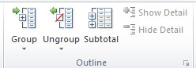

The Subtotal dialogue box will open

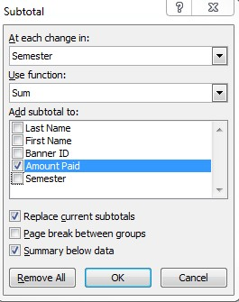

To subtotal this data sheet by semester:

1. Choose *Semester* for the *At Each Change* In dropdown.
2. Select *Sum* for the *Use Function* dropdown.
3. Choose *Amount Paid* for the *Add Subtotal To* field.
4. Click *Ok*.

Subtotals will automatically be added to your data.

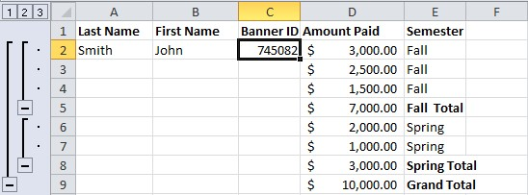

The subtotal hierarchy located to the left of the spreadsheet can be used to hide some of the data within the spreadsheet.

To view only the grand total, select column 1

To view the total for each subsection, select column 2 To view all data, select column 3.

**90) Write a program to calculate the nested level sub totals for the below table?**

**Procedure:**

1. Select any cell within your range of data
2. Select *Subtotal* on the Data tab.

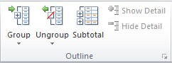

The Subtotal dialogue box will open.

3. For the *At Each Change* in dropdown menu, select *Semester*.

4. Choose to *Use Function*, *Sum*.

5. Choose to *Add Subtotal To*, *Amount Paid*.

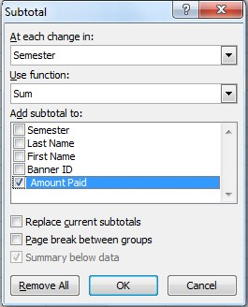

6. Click *Ok*.

The first level of subtotal will be added to the data.

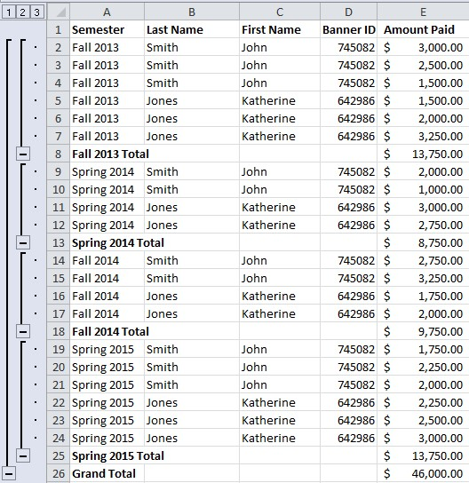

To add an additional level of subtotals:

1. Select *Subtotal*
2. For the *At Each Change* in dropdown menu, select *Last Name*.
3. Choose to *Use Function*, *Sum*.
4. Choose to *Add Subtotal To*, *Amount Paid*.
5. Ensure the checkbox *Replace Current Subtotals* is unchecked.

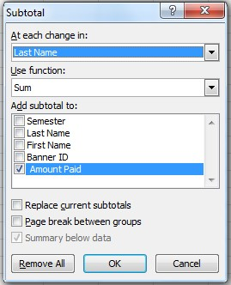

1. Click *Ok*.

The second level of subtotals will be added to the data range:

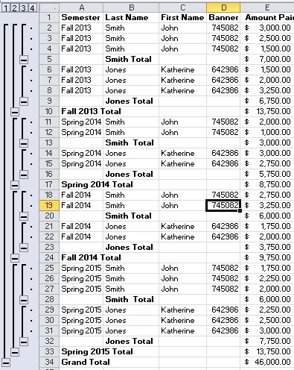

**91) Write a program to removing the sub totals?**

**Procedure:** To remove subtotals from a data sheet:

1. Select the *Subtotal t*ool

The Subtotal Dialogue box will appear.

1. Select *Remove All* to remove all subtotals.

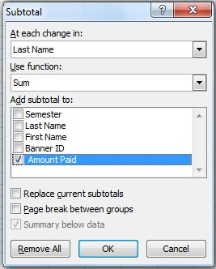

**92) Write a program to calculate the average for a table?**

**Procedure:**

To find the average of a select range of data:

1.Select the cell directly beneath the range of data 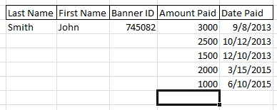

2.

Select the

*Auto Sum*

dropdown on the Formulas tab.

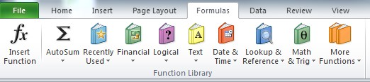

3. Choose *Average* from the Auto Sum dropdown

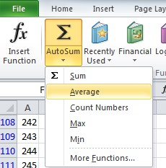

4.

Select the range of cells to calculate

5.

Click

*Enter*

on your keyboard

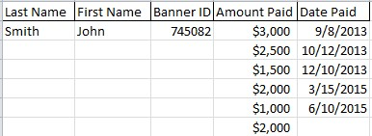

**93) Write a program to count the number of items in a range of data?**

**Procedure:**

To count the number of items in a range of data:

1. Select the cell directly beneath the range of data.



1. Select the *Auto Sum* dropdown.
2. Select *Count Numbers*.

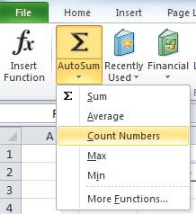

1. Select the range of cells to calculate.
2. Click *Enter* on your keyboard.

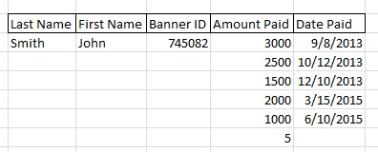

**94) Write a program to calculate the Maximum or Minimum for a range of data?**

**Procedure:**

To calculate the Maximum or Minimum for a range of data:

1. Select the cell directly beneath the range of data.



1. Select the *Auto Sum* dropdown.
2. Select *Max* or *Min* to calculate the maximum or minimum values

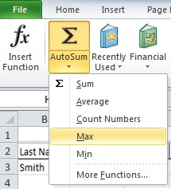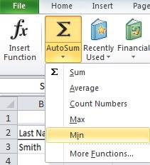

4. Select the range of cells to calculate.

5. Click *Enter* on your keyboard to calculate the value.

**95) Write a program to aligning text in a word document?**

**Procedure:**

1. Select the text for which you want to align to the center of the line.
2. Click the ‘Center’ button as shown in Fig.

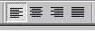

Left

Ri

g

ht

Center

Justif

y

1. Select the text you want to align to the right of the line.
2. Click on the ‘Align right’ button as shown in Fig.
3. Select the text you want to align to the left of the line.
4. Click on the ‘Align left’ , button as shown in Fig.

To take care that the text written is always aligned properly with the margins specified and to get perfect justification of the text on the either side of the line.

1. Click on the ‘Justify’; button as shown in Fig.

**Note :** It is recommended that whenever working with a new document always keep the alignment in the ‘Justify’ mode for proper alignment of text.

**96) Write a program for Indenting Paragraphs and modifying line spacing?**

**Procedure:**

1. Select the paragraph for which you want to set the indenting.
2. Click ‘Increase Indent’ as shown in Fig.



1. Click ‘Decrease Indent’ as shown in Fig used to remove the indenting.
2. Select the paragraph you want to set the line spacing.
3. Select the ‘Format’ option from Main Menu.
4. Click ‘Paragraph’ option , a dialogueue box as shown in Fig appears.

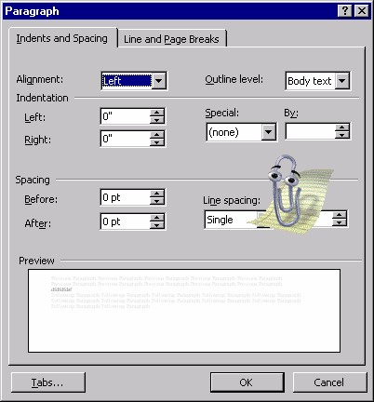

1. Select ‘Line Spacing’ list box from the dialogue box.
2. Click on ‘Double’ option from the list box.

# 97) Write a program for Setting and Modifying existing Tabs ?

# Procedure:

To modify the existing tabs do the following steps:

1. Select ‘Format’ option from Main menu.
2. Click ‘Tabs’ option, screen as shown in Fig will be displayed.

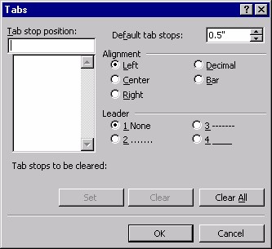

1. Enter ‘1’ in the text box for ‘Tab’ stop position.
2. Click ‘Set’ button. The new tab position is set.
3. To remove any unwanted tab stop select the tab from the list.
4. Click ‘Clear’ button. The tab is removed.
5. Click ‘Clear All’ button to remove all the tabs set currently by you.
6. Click ‘OK’ button to reflect the changes made now on to the document.

# 98) Write a program to Inserting Numbers in the word document.

# Procedure:

1. Type the following text in the document currently open.

Ceat Cricket Ratings:

Sachin Tendulkar.

Brain Lara.

Steve Waugh.

Alec Stewart.

Nathan Astle.

1. Select only the name from the text you have typed.
2. Select the ‘Format’ option from the Main menu.
3. Click ‘Bullets and Numbering’ option.
4. Screen as shown in fig will appear.

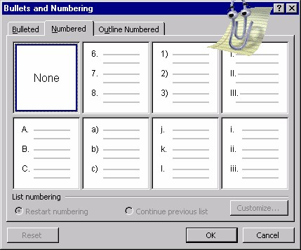

1. Click the bordered box.
2. Click ‘OK’ button. Names will be numbered accordingly.

# 99) Write a program to Inserting Bullets in the word document.

# Procedure:

1. After giving the number to the players, continue the document with the following text.

**Rules & Regulations:**

Batsmen gets 2 points after 50 runs and 3 addition points for a hundred.

Bowler gets 1 point for every 2 wicket and 3 additional point for a haul of 5 wickets.

Fielder gets 1 point for every catch.

1. Select the text after the ‘Rules & Regulation’ line.
2. Select ‘Format’ option from the Main menu.
3. Click ‘Bullets and Numbering’ option.
4. Click the ‘Bulleted’ tab page, as shown in Fig.

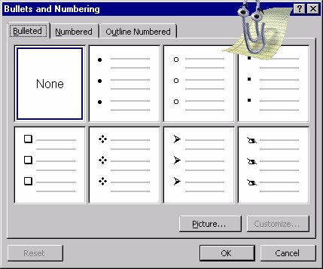

6. Select the ‘Arrow Mark’ bullets . Refer the Fig.

7. Click ‘OK’ button.

The rules are bulleted now.

# 100) Write a program to Inserting Header and Footer to the document.

# Procedure:

While preparing a report, you may want some information to appear on every page, for example college name, report title or page number. This information would normally appear either in the top or bottom of the page. You can insert this using Header and Footer option. To do so follow these steps.

1. Select on the ‘View’ option of the Main Menu.
2. Click on the ‘Header and Footer’ option. The screen as shown in Fig will be displayed.
3. Click on ‘Insert Date’ icon on the ‘Header Footer Toolbar’ to insert date on the header.
4. Press a ‘Tab key’ on the key board.
5. Write ‘SIVA SIVANI DEGREE COLLEGE’

This is the header of your document.

After adding a header to the document we move ahead to insert a footer.

1. Click on ‘Switch between header and footer icon’ on the toolbar.

Footer screen is displayed.

1. Click on ‘Insert page number’ icon on the toolbar.
2. Press ‘Tab key’ twice on the keyboard.
3. Write ‘FIT’.
4. Click ‘Close Header and Footer’ icon on the header/footer toolbar.

# 101) Write a program for Creating Page Breaks in a word document.

# Procedure:

For creating Page Breaks, do the following steps:

1. Select ‘Insert’ option from the Main menu.
2. Click ‘Break’ option. Screen as shown in Fig will be displayed.

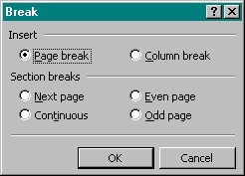

1. Click on the ‘Page Break’ button.
2. Click on the ‘OK’ button.

# 102)Write a program for Using of AutoCorrect option in a word document?

# Procedure:

Word 2000 allows us to check any grammatical error while you are typing any document . To use this feature do the following steps:

1. Select ‘Tools’ option from the Main menu.
2. Click ‘AutoCorrect’ option. Screen as shown in Fig will appear.
3. Click all the Check Boxes as shown in Fig.
4. Click on ‘OK’ button.
5. Open the ‘AutoCorrect’ dialogue.
6. Place the cursor in ‘Replace’ text box.
7. Type ‘Radian’
8. Place the cursor in ‘With’ text box.
9. Type ‘Radiant’
10. Click on ‘OK’ button.

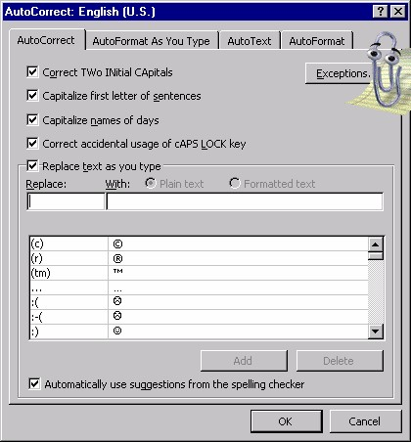

# 103) Write a program for Setting Auto Text.

# Procedure:

1. Select ‘Insert’ option from the Main Menu.
2. Click ‘Auto Text’ option.
3. A cascade menu is displayed.
4. Click ‘Auto Text’ option. Screen as shown in Fig will be displayed.
5. Enter ‘your data’ in the text box ‘Enter Auto Text Entries’
6. Click on ‘Add’ button, to add the auto text.
7. Now instead of writing the entire line just press <Enter>key.

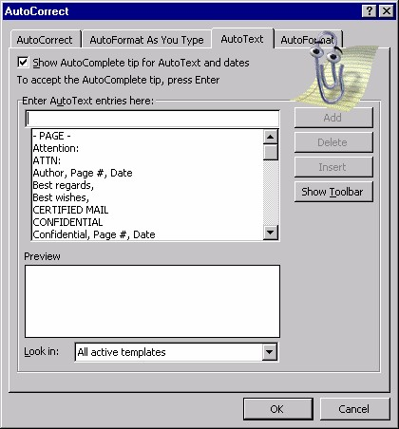

# 104) Write a program of applying Spelling Check and Grammar Tool.

# Procedure:

After the entire document is typed you can check the spelling mistakes and the grammatical mistakes with the help of ‘Spelling & Grammar check tool’. Perform the following steps to do so:

1. Type the following line in a doc.

This is a tes for spell checking.

1. Select ‘Tools’ option from the Main Menu.
2. Click ‘Spelling and Grammar’ option. The screen will look like this.

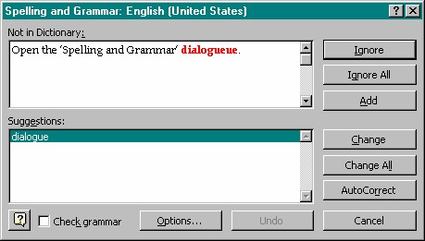

This will start the Spell and Grammar check. Spell checker will provide certain suggestions if there are any errors.

1. If you want the text according to the suggestion then, click on ‘Change’ button.
2. Else click on ‘Ignore’ button. The right suggestion is as follows.

This is a test for spell checking.

# 105) Write a program for applying Thesaurus to your data.

# Procedure:

Thesaurus is used to find a more precise expression for a given word. To make use of thesaurus perform the following.

1. Select the word for which you want an expression.
2. Select the ‘Tools’ option from the Main menu.
3. Select the ‘Language’ option from the menu.
4. Click on ‘ Thesaurus’ option. The screen as shown in Fig will be displayed.

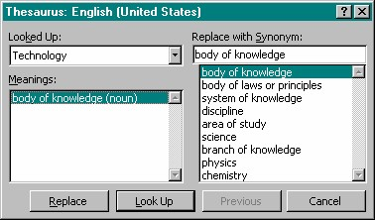

5. If you want to replace the word with the given expression then

Click on ‘Replace’ button. The word will be replaced. Instead of selecting a word and then activating thesaurus, you can activate thesaurus first and then enter word for which you require an expression. Step for this way are as follows.

6. Activate ‘Thesaurus’ as explained earlier. The Screen as shown in Fig will be displayed.

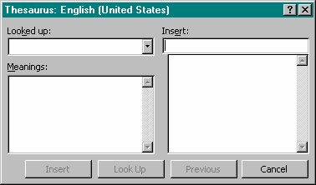

7. Write the word in the ‘Insert’ text box.

8. Click ‘Look Up’ button.

9. Meanings will be displayed.

10. Select the appropriate meaning and click ‘Insert’ button to place the expression in the document.

# 106) Write a program for Find a specific Text in a word document.

# Procedure:

To find a particular word throughout the document, we use the feature of Find. Perform the following steps:

1. Select ‘Edit’ option from Main menu.
2. Click on ‘Find’. The screen as shown in Fig appear.

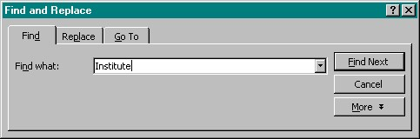

1. Type the text you want to find in the ‘Find What’ text box.
2. Click on ‘Find Next’ button.
3. Cursor will be placed at the first occurrence of the text.
4. Click on ‘Find Next’ again button to get the next occurrence.

You can continue till the end-of-document is reached.

# 107) Write a program for Find and Replace Text in a word document.

# Procedure:

After a specified word is found you may want to replace it with some other word, which is possible using the replace feature. Perform the following step to find and replace text:

1. Activate ‘Find’ dialogueue as given above.

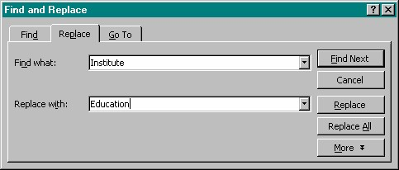

1. Click on ‘Replace’ tab. The screen as shown in Fig will appear.
2. Type the word in the ‘Replace with’ text box.
3. Click on ‘Replace’ button, if you want to replace only the first instance.

Or

Click on ‘Replace All’ button if you want to replace all the instances of the found word.

All your word ‘Institute’ will be replaced by ‘Education’.

# 108) Write a program to Splitting a Window?

# Procedure:

1. Open any document created earlier as learnt previously.
2. Select ‘Window’ option from the Main menu.
3. Click on ‘Split’ option.

A horizontal line appears on the screen, which moves along with the mouse movement.

4. Click the mouse button where you want the window to split .See the Fig.

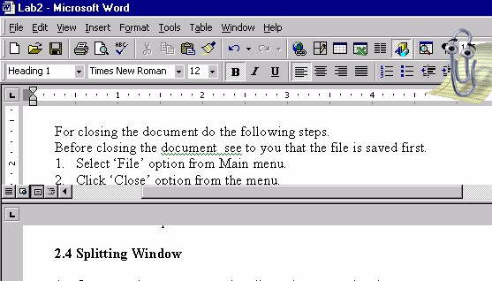

The Window will be split as shown in the above Fig.

# 109) Write a program for Arranging Windows.

# Procedure:

By splitting a window you can only work with a single document. But if you want to work with two documents simultaneously then you have to arrange the windows . Do the following steps to arrange windows.

1. Open any two documents you want to work with at the same time.
2. Select ‘Window’ option from the Main Menu.
3. Click ‘Arrange All’ option. Screen as shown in Fig will appear.

Now you can see both documents opened in two separate windows and you can modify either of them at the same time.

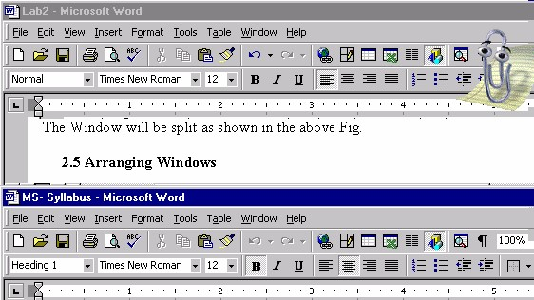

After modifying individual documents save the files one by one, both the windows get their own menu bar.

# 110) Write a program of Protecting documents with Password.

# Procedure:

While saving a document you should also take care that when the document is protected form illegal access from any source. For such kind of security we can give password while we are saving the document. For specifying the password to a file do the following steps.

1. Select ‘File’ option from the Main Menu.
2. Click on ‘Save as’ option.
3. Click on ‘Tools’ drop down.
4. Click on ‘General Option’ . Screen as shown in Fig will be displayed.
5. Enter the password in the ‘Password to open’ text box.

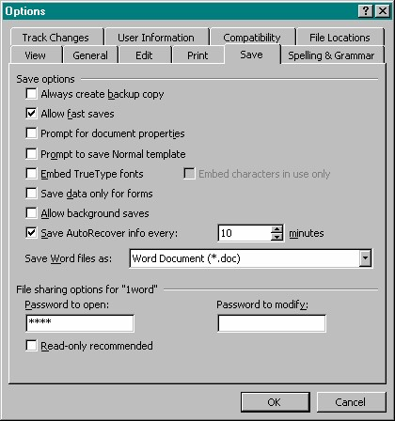

Asterisk ‘*’ mark will displayed when the password is typed.

1. Click ‘OK’ button.

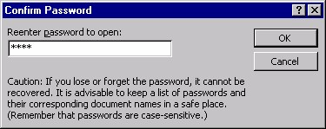

Word will ask a confirmation for the password entered. In the above steps we had given password for just opening the document i.e. when anybody tries to open the file afterwards, Word 2000 will prompt the user for the password, screen as shown in Fig will appear.

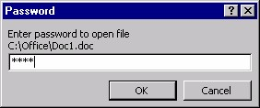

Do the following steps to find out whether the file is password protected.

1. Close the file for which you have assigned the password.
2. Open the same file. Before the file is opened. Word 2000 prompt for the password, screen will be displayed .
3. Enter the password you have assigned.
4. Click ‘OK’ button.

If the user enters the proper password then the file will be opened and he can modify the file.

Now you want that the user should not be able to modify the contents if he is not knowing the password. For giving the password for not allowing unauthorized persons to modify the file do the following steps:

1. Perform the step from 1 to 4 given above.
2. Enter the password in ‘Password to modify’ text box.
3. Click ‘OK’ button.

Do the following steps to find out whether the file is password protected.

Close the file for which you have assigned the password.

1. Open the same file.
2. Enter the assigned password to modify the file.
3. Click ‘OK’ button.

If the user enters the proper password then the file will be opened and he can modify the file.

1. Click on ‘Read-Only’ button to open the file for reading purpose. If open in read-only mode the contents of the file cannot be appended or changed.

# 111)Write a program for Protecting document without password.

# Procedure:

1. Select ‘Tools’ option from the Main Menu.
2. Click ‘Protect Document’ option. Screen as shown in fig will appear.

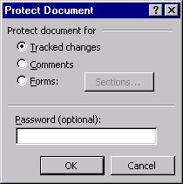

1. Click ‘Track Changes’ option.
2. Click ‘OK’ button.

This will keep a track of all the changes made to the file by any other user. If you click on ‘Comments’ option then the user can only insert comments and cannot modify the contents of the file.

The password is optional while protecting the document this way.

# 112)Write a program for a Creating Table in a word document?

# Procedure:

In a document you may want to enter some data, which is in tabular format. For entering such kind of data you require a table. Following the given steps to do so:

1. Select ‘Table’ option from Main Menu.
2. Select ‘Insert’ option from the list.
3. Click on ‘Table’ option. Screen as shown in Fig will appear.

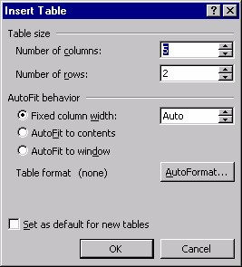

1. Click on ‘OK’ button.

* A table with 5 columns and 2 rows will be inserted into the document.
* You can change the number of columns or the rows by making the changes in the number of column and number of rows text box respectively.
* The table created above will have column cells of same width, as we have selected the ‘Fixed column width’ radio button. Select ‘AutoFit to contents’ option if you want the column width to variable width depending on what we enter into the cell.
* The difference between the two types of behavior is shown in Fig.



If you don’t want the table of fixed width as well as AutoFit style , then you can go for some predefined style. Perform following steps to AutoFormat the table.

Repeat the steps 1,2,3 as given above.

1. Click on ‘AutoFormat’ button . Fig as shown will appear.
2. Select ‘Classic4’ from the formats list box.
3. Click ‘OK’ button.

Table with a classic4 layout will be inserted.

Click the check box ‘Set as default for new tables’ if you want the same format for all the new tables created hereafter.

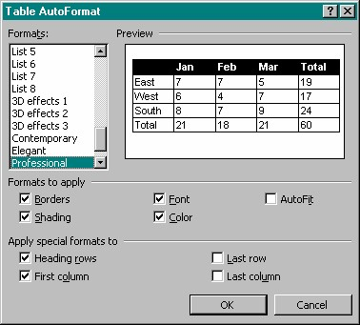

|  |  |  |  |  |
| --- | --- | --- | --- | --- |
| ***Name*** | ***Age*** | ***Marks*** | ***Rank*** | ***Paper*** |
| John | 24 | 84 | First | Office Automation |

Instead of working with fixed column width and AutoFit width column, now suppose you want to have the width according to your choice. To do so follow the given steps:

1. Insert a table using any of the way discussed above.
2. Select the column for which you want to change the width.
3. Select ‘Table’ option from the Main Menu.
4. Click ‘Table Properties’ option.
5. Click ‘Column Tab’ .
6. Enter ‘4’ in the preferred width textbox.
7. Select ‘Measure in’ option as ‘Inches’.
8. Click ‘OK’ button.

The selected column will now have the width as 4”. The properties can be changed for all the columns by using the ‘Previous column’ and ‘Next column’ buttons.

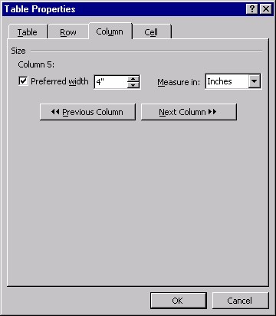

**113) Write a program for Adding Columns and Rows to the table.**

**Procedure:**

As data keeps on changing, new data is bound to come in. For that we require to add either columns or rows afterwards. So these are the steps for adding columns or rows.

1. Select the table in which you want to insert a column.
2. Select ‘Table’ option from Main Menu.
3. Select ‘Insert’ option.
4. Click ‘Column to the left’ or ‘Column to the right’

A blank column gets inserted either to the left of the existing column.

1. To insert a row repeat the first 3 steps given above.
2. Click either ‘Row above’ or ‘Row below’

A blank row gets inserted either above or below the existing row.

**114) Write a program for Deleting columns or rows from the table.**

**Procedure:**

To delete the columns or rows from the table do the following steps:

1. Select ‘Table’ option from the Main Menu.
2. Select ‘Delete’ option.
3. Click ‘Row’ to delete the entire row or click ‘Column’ to delete the entire column or click ‘Cell’ to delete the specified cell .

The specified column, row or the cells gets deleted.

1. If you want to delete the entire table then click ‘Table’ option.

The entire table gets deleted.

**115) Write a program for Splitting and merging cells.**

**Procedure:**

After the table is inserted you may want to enter two values in a single cell or else you want to use the space of two cells to enter a single value for doing so you have to split or merge the cells respectively. Perform the following steps to do so:

1. Select the cell, which you want to split.
2. Select ‘Table’ option from Main Menu.
3. Click ‘Split Cell’ option. Screen as shown in Fig will appear.

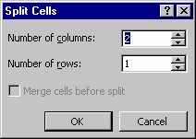

1. Enter ‘2’ in the number of columns text box.
2. Click ‘OK’ button.

The cell gets split into two parts. For Merging two or more cell do the following steps:

1. Select the cells you want to merge together.
2. Select ‘Table’ option from Main Menu.
3. Click ‘Merge Cells’ option.

The selected cells get merged together.

**116) Write a program for Text alignment within Tables.**

**Procedure:**

The text is always left justified and starts from top most corner of the cell. You can change this alignment with the help of table properties. Perform the following steps to do so.

1. Select the cell for which you want to change the alignment.
2. Increase the cell height.
3. Select the ‘Table’ option from the Main Menu.
4. Click on ‘Table Properties’ option.
5. Click on ‘Cell’ tab. Screen as shown in fig will appear.
6. Click ‘Center’ from the vertical alignment group box.
7. Click ‘OK’ button.

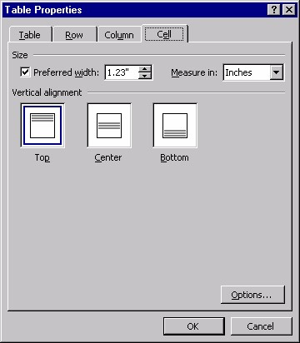

Now whatever you type it will be displayed in the middle of the cell.

**117) Write a program for Changing text orientation.**

**Procedure:**

You can also change the direction of the text displayed in the cell. Usually it is horizontal and from left to right . Perform the following steps to do so:

1. Select the cell for which you want to change the direction.
2. Select ‘Format’ option from Main Menu.
3. Click on ‘Text Direction’ option . Screen as shown in fig will be displayed.

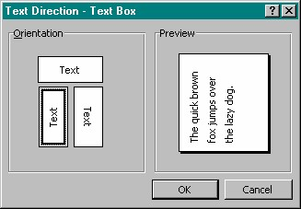

1. Click the vertical style of orientation as shown in Fig.
2. Click ‘OK’ button.

|  |  |  |  |  |
| --- | --- | --- | --- | --- |
| ***Na me*** | ***Age*** | ***Mark s*** | ***Ra***  ***nk*** | ***Paper*** |
| John | 24 | 84 | First | Office  Auto  matio  n |

The text typed hence will be displayed vertically in the cell.

**118) Write a program for Adding Calculations in word document.**

**Procedure:**

You may want to show some output by calculating the values from the other cells. You can do this with the help of formula. Perform the following steps to do so.

1. Select the cell in which you want to display the output.
2. Select ‘Table’ option from Main Menu.
3. Click on ‘Formula’ Option.

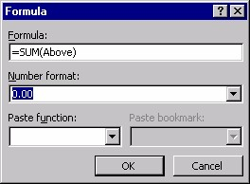

1. Enter ‘=Sum(ABOVE)’ if the values for which you want the sum are above the cell where you want to display the sum. OR Enter ‘=Sum(LEFT)’ if the values are at the cell where you want to display the sum.

1. Click ‘OK’ button to get the sum.

You can change the format of the output by changing the ‘Number format’ option.

You can also choose the functions with the help of ‘Paste Function’ option.

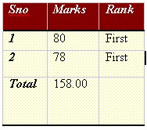

# 119) Write a program for Writing Complex Formula in work sheet.

# Procedure:

• Create Columns for HRA, Bonus ,PF, Total Years and Net Pay as shown in Fig

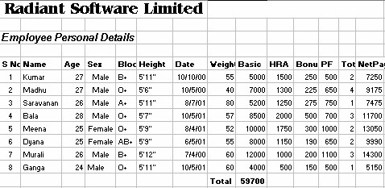

1. Click on the Cell , where the formula is to be Utilized , Here Cell J6.
2. Click on.
3. Click on the drop down button of the Function and Select More Functions>Logical -> If clause.
4. In the If dialogue box which appears, fill the text boxes with the conditions

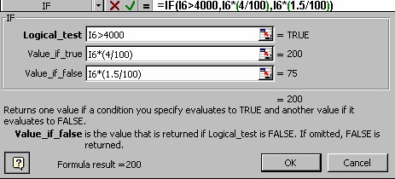

as shown in Fig.

* This is to get Bonus =4% of Basic, for a Basic >=4000 and Bonus = 1.5% of Basic , for basic<4000.

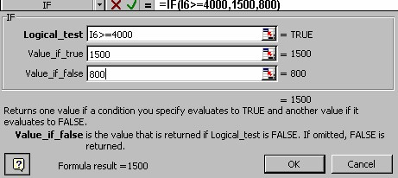

* This is to get HRA of Rs 1500 if the Basic is more than or equal to Rs.

4000 or Rs 800 , if HRA is less than 4000.

Complete the Worksheet as given in the First Fig. Apply the formula below:

The Formulas are as follows:

* P.F> = (12% of Basic) if Basic >= 4000 else P.F. = 0.
* Total years = 1999 – YEAR(H6)
* Net Pay = I6+I7+K7-L7

# 120) Write a program for Applying Formatting features to numbers.

# Procedure:

Suppose you are required to add **Rs.** to all the amount related cells, follow the steps.

1. Select the cells to which the special formatting is to be applied .
2. Click on Format option on the Main Menu bar and Select Cells. A dialogue box appears as shown in Fig.

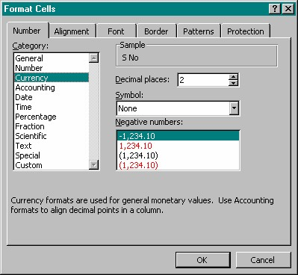

1. Click on Currency option in the category section of the Number tab page. The Format cell dialogue box will look like the above Fig.Click on
2. Click on OK to select the Currency settings to the selected Cells.
   * This will place the ‘$ sign’ in the Cells which were selected.

* + Perform the same steps for all the columns which are related to amount i.e Columns I,J,K,L and column N. The Final worksheet should look like in the Fig.

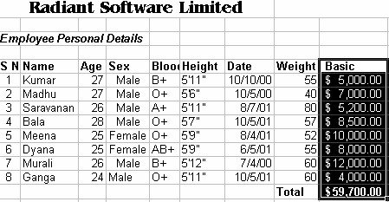

# To change the ‘$ sign’ to Rs. follow the steps

1. Click the Start Button.

1. Select Settings-> Control panel. The Control Panel window appears.

1. Double click on Regional setting icon. The Regional Property dialogue box appears.

1. Click on Currency tab page in the Regional Settings Property dialogue box.

1. Delete the ‘$ sign’ in the Currency symbol and type Rs. as shown in Fig.

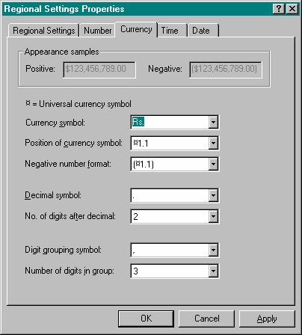

1. Click Apply and then click on OK. The ‘$’ sign in your worksheet will now be replaced by ‘Rs’. Now the Worksheet will look as shown in Fig.

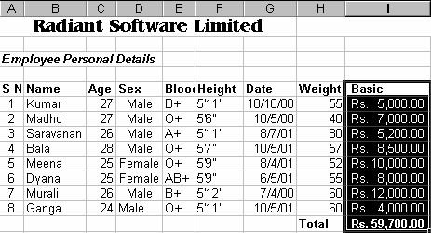

**121) Write a program for Changing the Column width.**

**Procedure:**

To change the width of the columns according to the text written in the cell, perform the following steps:

1. Click on the Column Heading Bar at column A.
2. Drag the cursor to the right by keeping the left mouse button pressed to fit the characters in the box.
3. In Column A make sure that “Product Name” should be visible.
4. Similarly arrange all the other columns according to the text in the corresponding columns

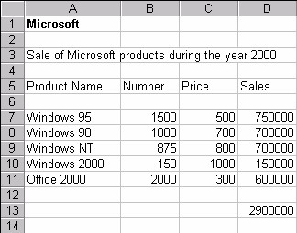

**122) Write a program for Changing Row Height?**

**Procedure:**

1. Select any cell of the row, the height of which has to be increased. Here select row 3.
2. Click on Format option from the main menu.
3. Select Row option and then click on Height option. Refer the Fig.

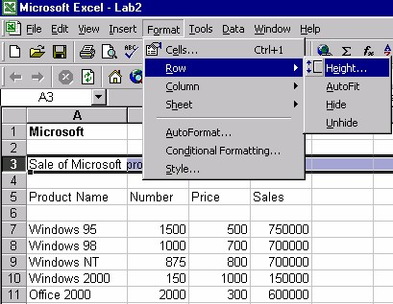

1. Enter the value of row height and click on OK. Here the value entered is

24.

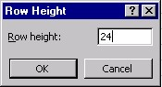

1. It can also be increased by right clicking on row 3 when you get the pop up menu as shown in Fig.

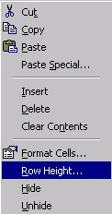

1. Select Row height and increase the value of the row height as done in step 3 & 4

**123) Write a program for Inserting and Deleting Rows.**

**Procedure:**

Suppose you wish to enter a new row before the row which contains

Windows NT. To insert a new row for Office 97, perform the following steps.

1. Click on the Windows 98 .i.e. Cell A8.
2. Click on Insert and Select row.

 A row will be added above Cell A8. The Windows 98 Cell will now become Cell A9.

1. Enter the Remaining Entries as shown in Fig.

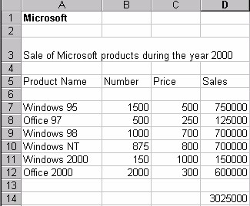

# Deleting Rows

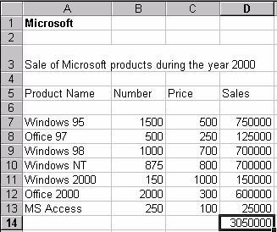

1. To delete a row, Click on the row, which is to be deleted. Here click row

13.

1. Select Edit option on the Main menu.
2. Select the Delete Option.
3. Now the Work Sheet will look like this.

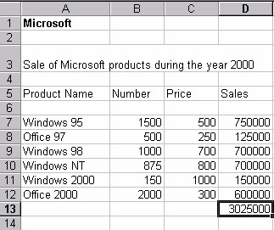

124) Write a program for Inserting and deleting Columns.

Procedure:

Suppose a new Column is to be inserted for a Manufacturer field before Sales.

Follow the steps given below.

1. Click On Cell for Sales i.e. Cell D5.
2. Click on “Insert” option on the Main menu and then select the “Columns” option.

* + A new column will be inserted before the column Sales as shown in

Fig.

* + Type “Manufacturer” as the heading for this column in Cell D5.

* + Enter some data in the cells for column D under “Manufacturer” as shown in Fig.

* + Insert a column for City after the Manufacturer Column, and give it a heading called as “City” i.e. in Cell E5 . Enter some city names in the cells from Cell E7 to E12.

* + If you want to delete any column, click on any cell on that column.

* + Here we select a cell say Cell E5 of the newly created column E for City.

* + Click on Edit option on the Main Menu->delete-> entire column and click on OK.

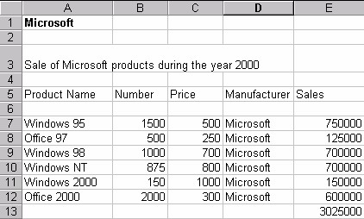

**125) Write a program for Moving and Copying Cell Contents.**

**Procedure:**

To copy contents of a cell to some other cell other than the adjacent cells.

Insert a new row for City and type some cities in that column as shown in Fig.

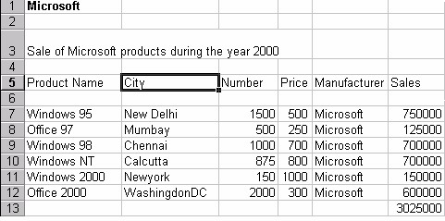

1. Click on the Cell B5 whose contents are to be copied.
2. Click on Edit option on the Main Menu and select Copy option.
3. To copy the contents to the other cell , Click on that particular cell.
4. Click on Edit option on the Main Menu and Select Paste option.

To copy contents into adjacent cells follow the steps given below.

1. Click on the cell whose contents are to be copied. Here click on cell B6.
2. Keep the left mouse button pressed on the right bottom corner of the cell when you see a bold ‘plus sign’.
3. While keeping the left mouse button pressed, drag the cell down to cell B12 .
4. Now click outside the selected area to view the copied contents.

**126) Write a program for Transferring Data between Worksheets.**

**Procedure:**

1. Select the cells A1 to A13 whose data is to be copied to another worksheet.
2. Copy the contents by clicking on Edit->Copy or Right click on the mouse and select copy.
3. Move to the other workbook by clicking on Sheet 2.



1. Click on the cell from where the contents are to be pasted. Here click on cell A1.
2. Click on Edit->Paste Special and follow the Fig and click OK.

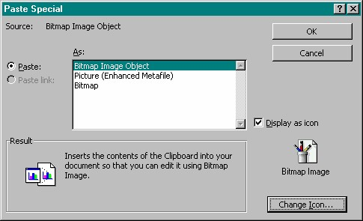

**127) Write a program for Transferring Data between Workbooks.**

**Procedure:**

1. Open a new workbook.
2. Go to the old workbook. Select all the cells from Cell A1 to F13, of the workbook just created.
3. Copy the contents by Clicking on Edit option->Copy or you may ever Right Click on the mouse and select copy.
4. Now move to the new workbook and click to Cell A1.
5. Click on Edit->Paste Special. Click OK on the dialogue box opened.

# 128) Write a program for relative reference?

# Procedure:

1. Open a new workbook.
2. Enter the following values as shown in Fig. to the worksheet which is newly opened.
3. The final worksheet must look as shown in Fig.

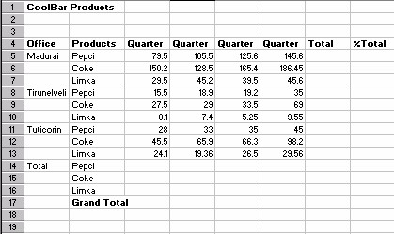

**Relative Reference:**

To calculate formula for a cell, perform the following steps:

1. Click on Cell C14.
2. Type the following formula at the formula bar as shown in Fig.

=C5+C8+C11

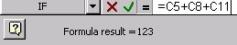

1. Click on the ‘+ Sign’ on the right bottom corner of Cell C14 and select the cells up to cell C17 by dragging the mouse while keeping the left mouse button pressed.
2. Again click on Cell C14.
3. Click on the ‘+ sign’ and select the Cells to the right up to Cell F14.
4. Now Click on Cell C15 .
5. Click on the ‘+ sign’ and select the cells to the right up to cell F15.
6. Now click on Cell C16.
7. Click on the ‘+ sign’ and select the cells to the right up to cell F16.
8. Now Your Cool Bar Work Sheet will look like this.

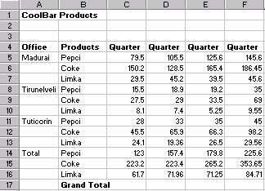

**129) Write a program for calculating total for the following table?**



**Procedure:**

1. Click on Cell G5.
2. Type the following formula in the Formula bar

=C5+D5+E5+F5

1. Press Enter.
2. Click on Cell G5.
3. Click on the ‘+sign’ at the right bottom of the selected cell and drag the cursor downward till cell G16.

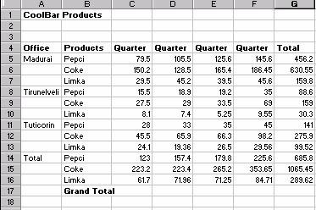

1. Now the Fig will look like this.

**130) Write a program to calculate the Grand total for the following table.**



**Procedure:**

1. Click on Cell C14 and select the Cells till Cell C17.

1. Click on the summation icon  on the Format Menu bar. This will produce the result of the summation in Cell C17.

1. Similarly calculate the summation for cells D17 to G17.

1. Now the Fig will look like this.

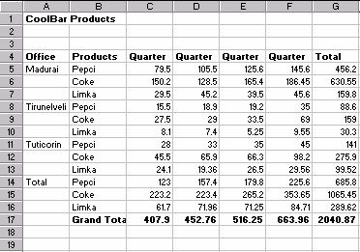

**131) Write a program for Absolute reference to the following table.**



**Procedure:**

To give Absolute reference to a cell, follow the steps given below.

1. Click on Cell H5.
2. Type the formula given below.

=G5/G17

1. Press Enter. The Cell H5 will now have the result of the formula.
2. The Work Sheet will look like this.

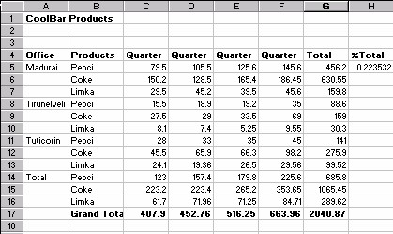

**132) Write a program for creating Names from a row or column.**

**Procedure:**

1. Click on Cell C4.
2. Select cells till Cell F7.
3. Click on Insert->Name->Create
4. Select Top Row and Left Row in the Create Names Dialogue Box as shown in Fig.
5. Click OK.
6. Select Insert->Name->Define… 7. Select Quarter 1 as shown in Fig.

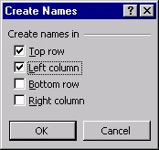

 This means that the top row and left column provide names for the range. Thus Five named ranges are created. Thus 5 named ranges are created (3 row labels and 2 column labels).

**133) Write a program for Using Excel Financial Function.**

**Procedure:**

1. Open a new Worksheet and enter the values as shown in Fig.

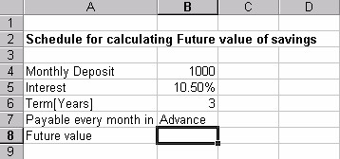

1. Click on Cell B8.
2. Click on the equal to icon .

1. In the Formula Box, Select More Options…..->Financials->FV.

1. Insert the formula as shown in Fig FV dialogue box which appears.

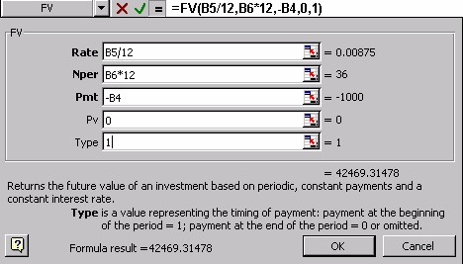

**134) Write a program for calculating Goal Seek?**

**Procedure:**

In the above example you will yield a future value of $42,469.31 if you save a value of $1000 per month. Suppose you wish to obtain a round sum of $40000 in the period of 3 years. To know the monthly deposit to seek this round sum you require to use the Goal Seek option in the Tool menu bar.

1. Click on Cell B8.
2. Select Tools->Goal Seek.
3. Enter the values in the text boxes as given in Fig.

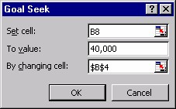

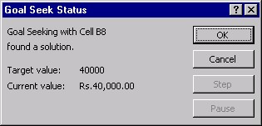

1. You may even select the Cells for the textbox “Set Cell” and for “By changing cell”. This can be done by click on the Collapse dialogue box icon .

1. Then click on Cell B8, Again Click on the collapse dialogue box icon to come back to the Goal Seek dialogue box.

1. After the entry is complete , Click on OK.

• When you Click OK, you will get the monthly deposit to yield the value of $40,000 in 3 years which comes to $ 941.85.

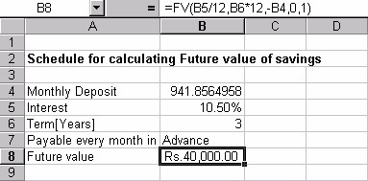

**135) Write a program for Using Common Statistical Functions.**

**Procedure:**

Let us take the detailed report of Survey conducted to Sell a certain Product.

1. Create a simple Worksheet as shown in Fig.

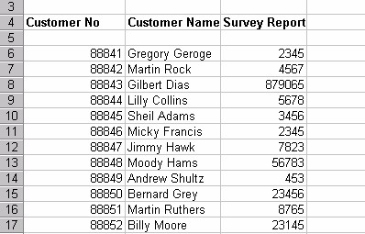

1. To make the Customer no. center aligned, Select the Cells from Cell A6 to Cell A17 and click on the align center button on the Format menu bar.

You are now required to find the survey conducted on how many persons, the average amount Quoted by the persons, to find what is the best price that can be paid for the product, to find the mean of the total amount quoted.

Follow the steps given below:

1. Click on Cell A19 and type “Number of Persons Surveyed”. Similarly type “Mean Average”, “Median” , “Mode” in Cells A20,A21,A22.

1. The Complete Worksheet must now look as shown in Fig.

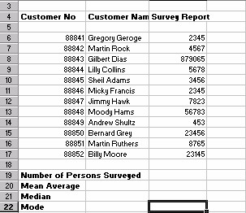

Now to apply the Formula to these, perform the steps shown below.

1. Click on Cell C17.
2. Click on the “=sign” or the edit-formula on the Formula Bar, the function button is displayed.

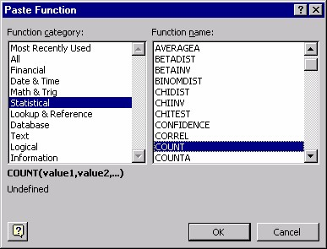

1. Click on More Functions.
2. In the Function Category , Select Statistical ->Count (in Function name).
3. Click OK.
4. In the Dialogue box, which appears , type “C6:C15” in the first text box.
5. Click OK to get the number of Surveys conducted. And the Fig will look

like this.

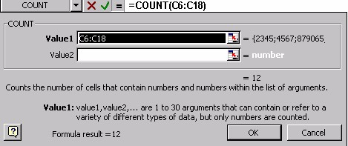

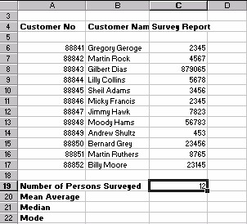

After completing this, try entering “B6:B15” in the text box for Value 1 where you entered “C6:C15” , just now.

Did you get the answer? What was it, Zero! But you had 10 entries for the survey conducted. So the answer is wrong. This is because the Function COUNT only recognizes numerical entries. To correct the mistake, use the function COUNTA instead of the function COUNT. You can access COUNTA in the same way More Functions->Statistical->COUNTA.

You are required to fill in the remaining cells for Mean Average, Median, Mode using the steps shown above. The changes that you will have to bring are in the selection of the items inside Statistical Function. For “Mean Average”, select the Average Function.

For “Median” select Median function and for “Mode”, select the Mode function.

The final Work sheet should now look like Fig.

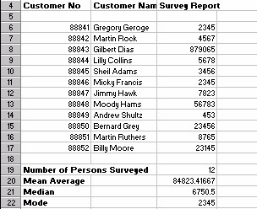

**136) Write a program to create Stock Charts?**

**Procedure:**

These charts are used for presenting Scientific, Statistical and Financial data.

These charts need a minimum of three values.

1. Select Sheet2, You are now in a new worksheet.
2. Create a database as shown in Fig.

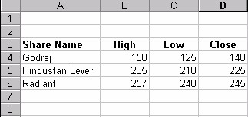

1. Select the cells from Cell A3 to Cell D6.
2. Click on the chart icon  on the Tool Menu Bar. The Chart Wizard appears.

1. Select the Stock Chart option and click on the first chart option as shown in Fig.

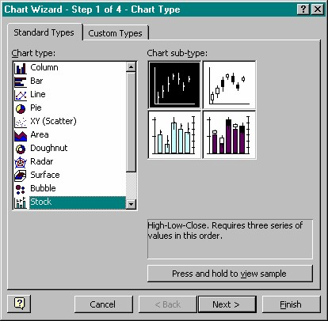

1. Click on Next.
2. In the dialogue box which appears as shown in Fig. Select Next.

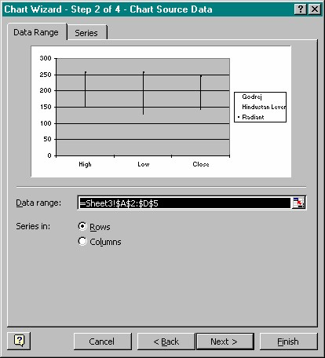

1. In the Chart option Dialogue box which appears give the Chart title and the X-axis and the Y-axis titles as shown in Fig.

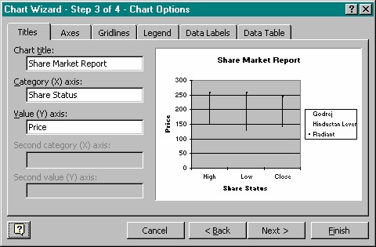

1. Select the sheet where you wish the chart to be created. Here we select –As new sheet
2. Click on Finish in the Step 4 of 4 Chart Wizard dialogue box.

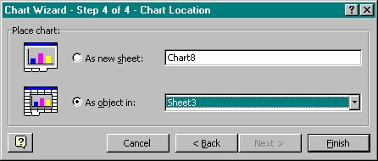

1. The Final Chart will look like the chart as shown in Fig.

|  |  |
| --- | --- |
| **Share Market Report**  300 | |
| 0  100  200  High  Low  Close  **Price**  **Share Status** | Godrej  Hindustan Lever  Radiant |
|  |

**137) Write a program for Creating a Presentation using AutoContent Wizard to 5 slides?**

**Procedure:**

1. Select ‘File’ option from Main menu.
2. Click ‘New’ option, as shown.
3. Click ‘AutoContent Wizard’ option.

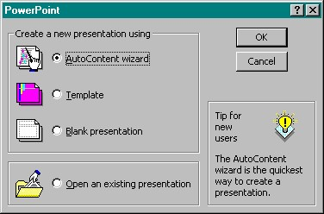

1. Select ‘AutoContent Wizard’ option.

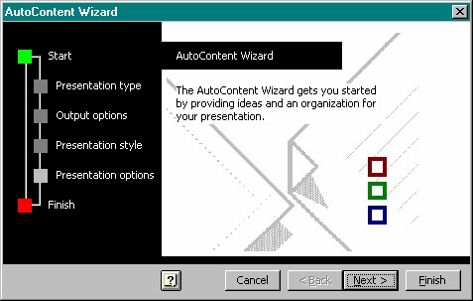

1. Click ‘OK’ button .

1. Click ‘Next’ button.

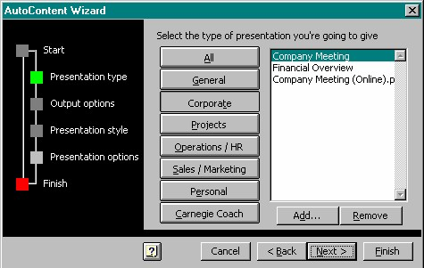

1. Click ‘Next’ button ,screen as shown in Fig.
2. Click ‘Corporate’ button.
3. Select ‘Company Meeting’ from the list.
4. Click ‘Next’ button.

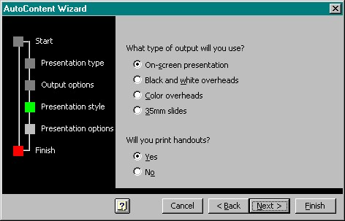

1. Click ‘On-Screen Presentation’ option.
2. Click ‘Next’ button.

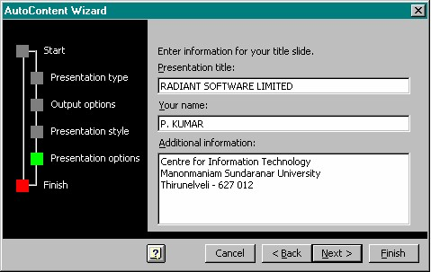

1. Give the title to the presentation and footer if required.
2. Click ‘Next’ button.

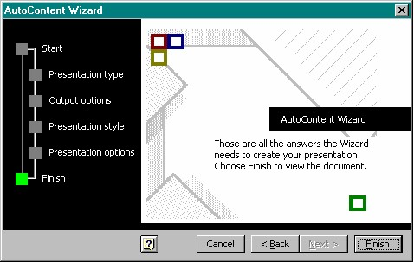

1. Click ‘Finish’ button.

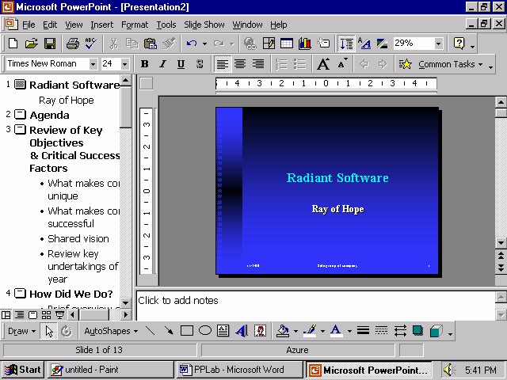

The presentation format is ready for you, which has to be modified to prepare the presentation the way you please.

1. Close the Presentation.

**138) Write a program for Using Design Templates.**

**Procedure:**

To work with the design template do the following steps:

1. Select ‘File’ option from Main menu.
2. Click ‘New’ option, screen as shown in Fig.
3. Select ‘Design template’ tab.
4. Click ‘Radar’ template.
5. Click ‘OK’ button.

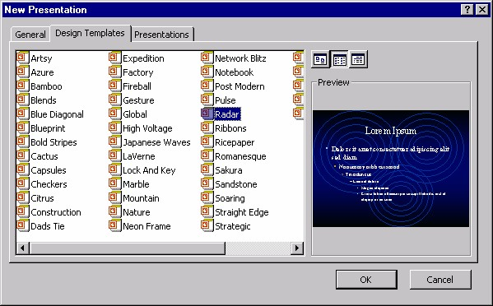

Now rest of the steps remains the same as working with blank presentation slides.

**139) Write a program for different views of Slides.**

**Procedure:**

When you start working with any presentation in PowerPoint you are working with a normal mode. But you can view the slides in different modes . For changing the mode you have to work with the icon given on the status bar. The icon are shown in Fig.

Slide Sorter

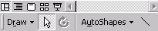

Normal

Outline

Slide

Show

1. To view the presentation in outline mode click the outline view icon.
2. To view one slide at a time click the slide view icon. Refer Fig.

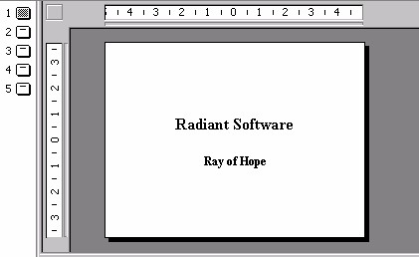

The slide sorter view is shown in Fig.

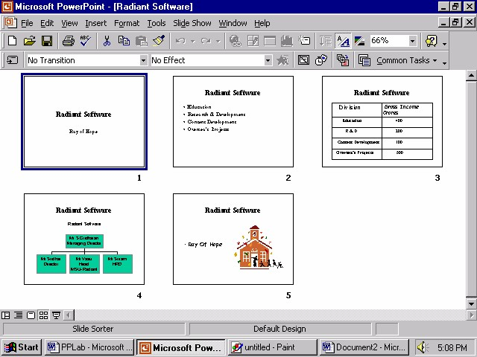

1. Close the presentation by selecting ‘File’ option from Main menu and click ‘Close’ option.
2. Exit PowerPoint by selecting ‘File’ option from Main menu and click ‘Exit’ option.

**140) Write a program for viewing Slide Master.**

**Procedure:**

To view the Slide Master, do the following steps.

1. Select the ‘File’ option from Main Menu.
2. Click ‘Open’ option.
3. Select the presentation saved in the last lab session.
4. Click ‘OK’ button.
5. Select the ‘View’ option from Main Menu.
6. Select ‘Master’ option.
7. Select ‘Slide Master’ option, screen as shown in Fig.

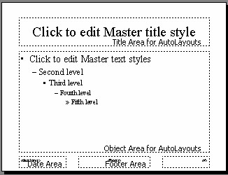

**141) Write a program for Customizing background of Slide Master.**

**Procedure:**

1. Click the Master title text to change the background.
2. Right click and select ‘Format Placeholder’ option screen as shown in Fig will be displayed.
3. Select any color in ‘Fill Color’ list box.
4. Click ‘Semi transparent’ check box.
5. Click ‘OK’ button.

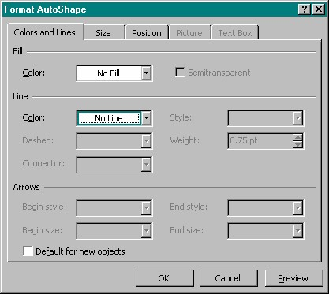

The Background of the slide master gets changed thus changing the background of all the slides.

**142) Write a program for adding footer to a Slide.**

**Procedure:**

1. Select ‘View’ option from Main menu.
2. Click ‘Header & Footer’ option screen as shown in Fig.

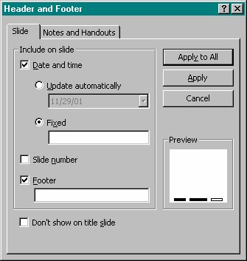

1. Click ‘Date and Time’ check box.
2. Click ‘Apply to all’ button.

The footer is inserted in the slide master reflecting the effect on all the other slides.

**143) Write a program for Making Handouts.**

**Procedure:**

For creating and viewing handouts do the following steps.

1. Select ‘View’ option from Main Menu.
2. Select ‘Master’ option.
3. Click ‘Handout Master’ option, screen as shown in Fig.

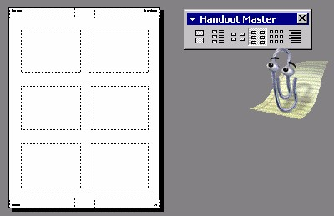

For inserting date, header, footer and the page number do the following steps.

1. Select ‘View’ option from Main Menu.
2. Click ‘Header and Footer’.
3. Select ‘Notes and Handout’ tab, as shown in Fig.

**144) Write a program for Making Notes in slide?**

**Procedure:**

For creating and viewing notes perform the following steps.

1. Select ‘View’ option from Main Menu.
2. Select ‘Master’ option.
3. Click ‘Notes Master’ option, screen as shown in Fig.
4. Click ‘Update automatically’ option.
5. Enter text in ‘Header’ textbox.
6. Enter text in ‘Footer’ textbox.
7. Click ‘Page number’ check box to display page number on the handouts.
8. Click ‘Apply to All’ button.

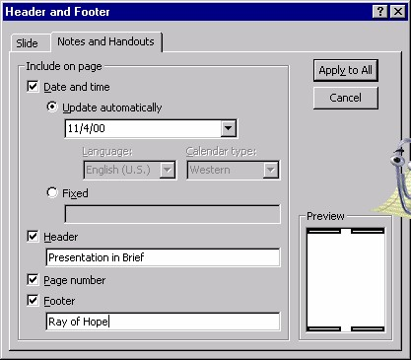

**145) Write a program for Setting the Slide Timings.**

**Procedure:**

For setting time gab between every slide you have to set the slide timings.

Perform the following steps to do so:

1. Select ‘Slide Show’ option from Main Menu.
2. Click ‘Rehearse Timing’ option.
3. The slide with the Rehearse toolbar will be displayed as shown in Fig.

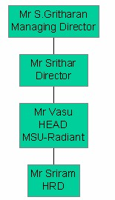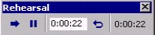



1. The clock shows the time for every slide to be displayed.

1. Click ‘Next’ button from the Rehearse Toolbar to set the time for the next slide.

1. After the last slides time is set, a dialogue box as shown in Fig is prompted which show the total time for the entire presentation.

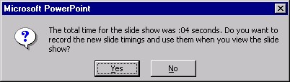

1. Click on Yes button.

**146) Write a program for Drawing on Slides.**

**Procedure:**

You can also draw on the slides when you are viewing the slide show as you can highlights the important points when the presentation is on. Perform the following steps to do so.

1. Start the Slide Show.
2. Right click anywhere on the slide.
3. Select ‘Pointer Options’ from the popup menu.
4. Click ‘Pen’ option.

You will see that the pointer changes from an arrow to a pen. You can use this pen pointer to highlight any important points, during the slide show. You will also notice that the slide show will not proceed ahead according to the rehearse time. It will only continue when you again set the pointer to automatic.

**147) Write a program for Customizing a Presentation.**

**Procedure:**

To customize a presentation do the following steps:

1. Select ‘Slide Show’ option from Main Menu.
2. Click ‘Custom Shows’ option, screen in Fig.

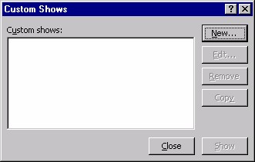

1. Click ‘New’ button, to create a new custom show.
2. When you click on new button, a dialogue box as shown in Fig will appear.

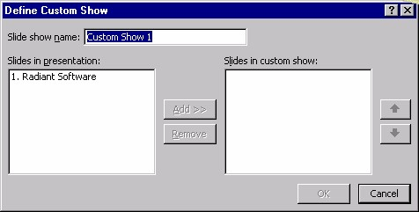

1. PowerPoint will give the name as Custom Show1.
2. Slides in presentation will display all the slides in the current presentation.
3. Select the Slide you want to put in the custom show.
4. Click ‘Add’ button to add the slide to custom show.
5. Repeat the 7th and 8th steps for all the slides you want to have in the custom show.
6. If you want to remove any slide from the selected custom show slides then click on ‘Remove’ button.

You can also change the sequence of the slides in the custom show by clicking the ‘Up’ and ‘Down’ buttons on define custom show dialogue box.

1. Click ‘OK’ button.
2. The Custom Show Dialogue Box will be displayed.
3. Click ‘Show’ button to view the custom slide show.

**148) Write a program for Working with Graphs.**

**Procedure:**

1. Create a new slide.
2. Select any slide having chart in it.
3. Double click on the chart icon.
4. Modify the table as shown in Fig. by going to individual cells and changing the values.

5.

Click outside the chart to see the graph.

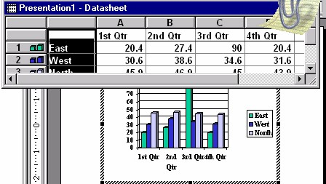

**149) Write a program for adding Transition to the Slide.**

**Procedure:**

1. Select the ‘Slide Show’ option from Main Menu.
2. Click ‘Slide Transition’ option, as shown in Fig.

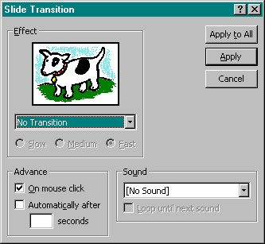

1. Select the effect you want from the effect list box.
2. Click ‘Slow’ radio button.
3. Click ‘Apply’ to apply the change to the current slide.

Or

Click ‘Apply to all’ if you want the same transition for all the slides.

1. View your presentation using slide show to see the effect.

**150) Write a program for adding Slide Animation.**

**Procedure:**

1. Select the bulleted slide from the ‘Radiant Software’ presentation.
2. Select ‘Slide Show’ option from Main Menu.
3. Click ‘Custom Animation’ option, a dialogue box as shown in Fig will display.

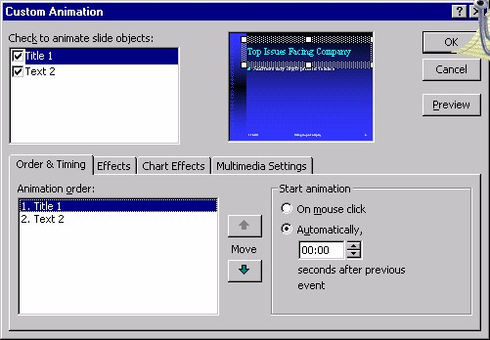

1. Click the ‘Title 1’ object you want to set the animation.
2. Click the ‘Order & Timing’ tab.
3. Click ‘Automatically’ option.
4. Click ‘Preview’ option to view the effect.
5. Click the ‘Effect’ tab. A dialogue box as shown in Fig will appear.
6. Select ‘Fly’ option from ‘Entry Animation’ list.
7. Select ‘From-bottom-right’ option.
8. Click ‘Preview’ button.
9. Click ‘OK’ button.

**151) Write a program for Modify Slide Background Color and Fill Pattern.**

**Procedure:**

To change the background color and fill pattern of individual slides do the following steps:

1. Right click on the slide for which you want to change the color.

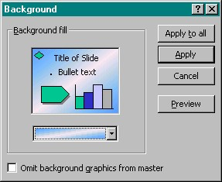

1. Select ‘Background’ option, a dialogue box as shown in Fig will appear.
2. Select the background color from the dropdown list.
3. Click ‘Apply’ button. To change the fill pattern when you select the background color, there is an option for fill effects.
4. Click ‘Fill Effects’, a dialogue box will appear as shown in Fig.

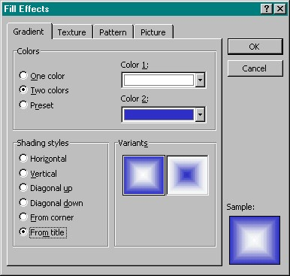

1. Click ‘Preset’ color option.
2. Click ‘Diagonal up’ option from shading styles.
3. Click ‘OK’ button.

**152) Write a program to create the following output?**

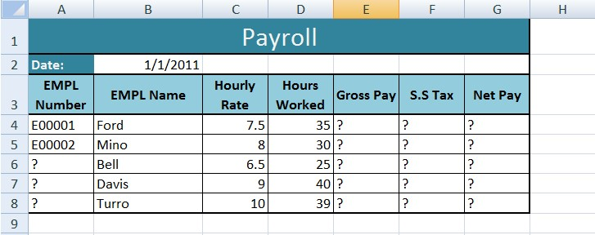

**Procedure:**

1. Open a new workbook and rename sheet1 with the name “Payroll”.
2. Enter the labels and values in the exact cells locations as desired.
3. Use AutoFill to put the Employee Numbers into cells A6:A8.
4. Set the width of all columns to 10.
5. Set the height of row 3 to 35.
6. Align all labels vertically and horizontally at the center.
7. Use warp text and merge cells as desired.
8. Apply borders, gridlines and shading to the table as desired.
9. Use the following format for the date in cell B2 (Saturday, January 1, 2011)
10. Format cells E4:G8 to include dollar sign with two decimal places.
11. Calculate the Gross Pay for employee; enter a formula in cell E4 to multiply Hourly Rate by Hours Worked.
12. Calculate the Social Security Tax (S.S Tax), which is 6% of the Gross Pay; enter a formula in cell F4 to multiply Gross Pay by 6%.
13. Calculate the Net Pay; enter a formula in cell G4 to subtract Social Security Tax from Gross Pay.
14. Set the work sheet vertically and horizontally on the page.
15. Save file as Excel 1.

**153) Write a program to find out the total in the following table?**

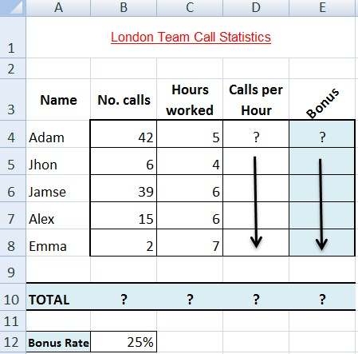

**Procedure:**

1. Open a new workbook delete Sheet 2 & 3, and rename Sheet 1 to (Call Statistics).
2. Enter the labels and values in the exact cells locations as desired.
3. Set the row height of rows 1 & 3 to size 30; and rows 4 until 10 to size 20.
4. Align all labels vertically and horizontally at the center.
5. Use Warp Text, Orientation and merge cells as desired.
6. Apply border, gridlines and shading to the table as desired.
7. Format column E to include euro (€) sign with two decimal places.
8. Format cell B12 to include % sign with 0 Decimal places.
9. Calculate the Calls per Hour, enter a formula in cell D4 to divide numbers of calls by hours worked. Using AutoFill, copy the formula to the remaining cells.
10. Calculate the Bonus. Enter a formula in cell E4 to multiply ‘Calls Per Hours’ by the fixed Bonus Rate in cell B12. Using AutoFill, copy the formula to the remaining cells.
11. Calculate the ‘TOTAL’.
12. Set the worksheet vertically and horizontally on the page.
13. Create a header that includes your name in the left section, and your ID number in the right section. Create the footer that includes the current Date in the center.
14. Save the worksheet as Excel 2.

**154) Write a program to find out total, average, count, maximum, minimum value in the following table?**

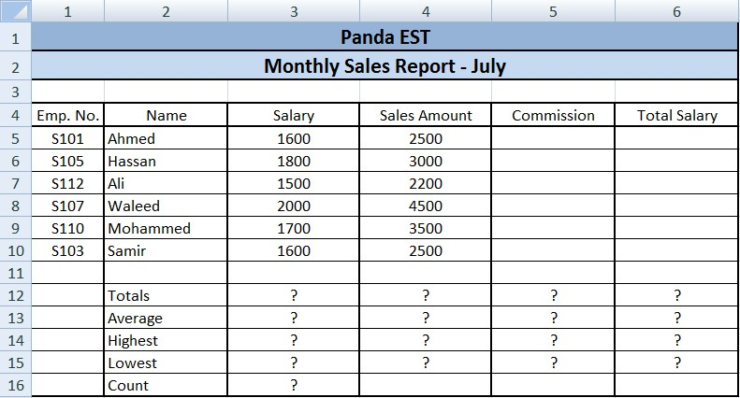

**Procedure:**

1. Create the worksheet shown above.
2. Set the column widths as follows: Column A: 8, Column B: 14, Columns C & D: 15, Columns E & F: 14.
3. Enter the formula to find COMMISSION for the first employee. The commission rate is 2% of sales (i.e. COMMISSION = SALES Amount * 2%). Copy the formula to the remaining employees.
4. Enter the formula to find TOTAL SALARY for the first employee where Total Salary = SALARY + COMMISSION. Copy the formula to the remaining employees.
5. Enter formula to find TOTALS, AVERAGE, HIGHEST, LOWEST, and COUNT values.

Copy the formula to each column.

1. Format numeric data to include commas and two decimal places.
2. Align all column title labels horizontally and vertically at the center.
3. Create a Header that includes your name in the left section, page number in the center section, and your ID number in the right section.
4. Create footer with DATE in the left section and TIME in the right section.
5. Save the file with name Excel 3.

**155) Write a program to find out the total, average, lowest, highest in the below table.**

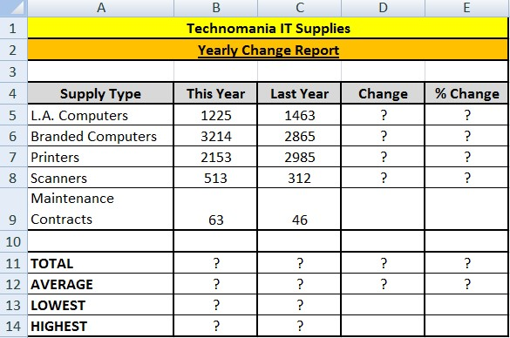

**Procedure:**

1. Create the worksheet shown above.
2. Enter a formula to find CHANGE for the first item where Change = This Year - Last Year. Copy the formula to the remaining items.
3. Enter a formula to find %Change for the first item where %Change = Change / Last Year. Copy the formula to the remaining items.
4. Enter a formula to find TOTALS, AVERAGE, HIGHEST, and LOWEST values.
5. Format column E to include % and two decimal places.
6. Create a Header that includes your ID in the left section and Name in the right section.
7. Create Footer with page number in the center section.
8. Center the worksheet vertically and horizontally on the page.
9. Save the file as Excel 4.

**156) Write a program to create the following table.**

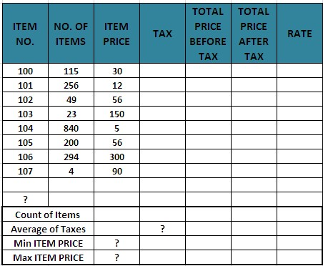

**Procedure:**

1. TAX (If ITEM PRICE is less than 100, TAX is 50, and otherwise it should be 100).
2. TOTAL PRICE BEFORE TAX =NO. OF ITEMS * ITEM PRICE.
3. TOTAL PRICE AFTER TAX = TOTAL PRICE BEFORE TAX + TAX.
4. RATE (If TOTAL PRICE AFTER TAX > 3500 then the rate is “HIGH”, otherwise it is REASONABLE.
5. Find Count of Items, Average of Taxes, Min Item PRICE and Max Item PRICE.
6. Save file as Excel 5.

**157) Write a program to create the following employee table and find out the total?**

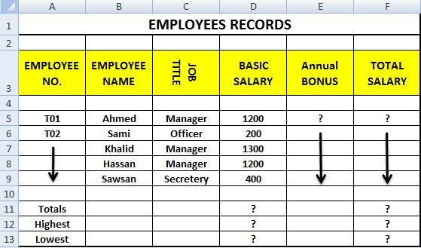

**Procedure:**

1. Create the worksheet shown above and rename it as EMPLOYEE RECORDS.
2. Ensure that the worksheet looks like the one above.
3. Find ANNUAL BONUS; if the BASIC SALARY is smaller than 900, the ANNUAL BONUS is 15% of the Basic Salary (i.e. 15%*Basic Salary); otherwise it will be 5% of the basic salary.
4. TOTAL SALARY= BASIC SALARY + ANNUAL BONUS.
5. Find the Totals, Highest and Lowest basic salary.
6. Save file as Excel 6.

**158) Write a program to find out the sales which are greater than 30,000.**

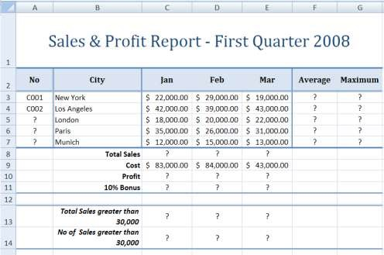

**Procedure:**

1. Open a new workbook and save the file with the name “Sales &Report”.
2. Delete Sheet2 and Sheet3.
3. Enter the labels and values in the exact cells locations as desired.
4. Use AutoFill to put the Series Numbers into cells A3:A7.
5. Set the vertical and horizontal alignment of all labels to center.
6. Use warp text and merge cells as desired.
7. Apply borders, gridlines and shading to the table as desired.
8. Format cells C3:G5, C8:E11, C13:E13 to Accounting Category that include dollar sign with two decimal places.
9. Find the Average Sales and Maximum Sales for each City.
10. Find the Total Sales for each Month.
11. Calculate the Profit for each month , where profit = Total Sales - Cost
12. Calculate the 10% Bonus, which is 10% of the Profit.
13. Find the Total Sales for each Month; only for sales greater than 30,000.
14. Find the No of Sales for each Month; only for sales greater than 30,000.
15. Save file as Excel 7.

**159) Write a program to create the chart for the following table?**

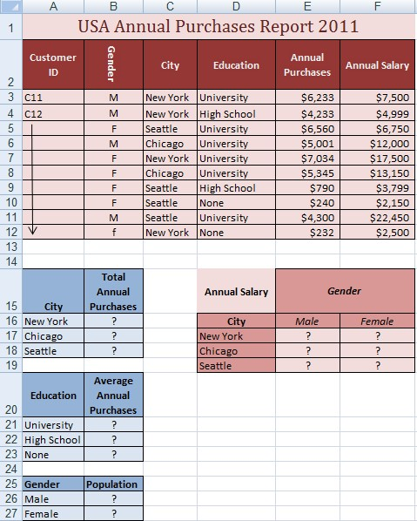

**Procedure:**

1. Open a new workbook save the file as Excel 8.
2. Delete Sheet2 and Sheet3.
3. Enter the labels and values in the exact cells locations as desired.
4. Use AutoFill to insert the Customer IDs.
5. Set labels alignment appropriately.
6. Use Warp Text, Text Orientation and Merge Cells as desired.
7. Apply borders, gridlines and shading to the table as desired.
8. Format Colum E & D to Currency with dollar sign and two decimal places.
9. Find the Total Annual Purchases for each City.
10. Find the Average Annual Purchases for each Education.
11. Find the total number of each gender.
12. Find the total annual salary for each gender in each city.
13. Create the following Chart:

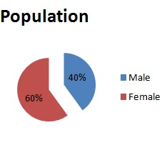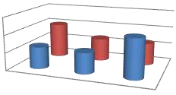

Male

Female

0

10000

20000

30000

New York

Chicago

Seattle

12499

12000

22450

20000

13150

12699

New York

Chicago

Seattle

Male

12499

12000

22450

Female

20000

13150

12699

**Total Annual Salary**

Male

Female

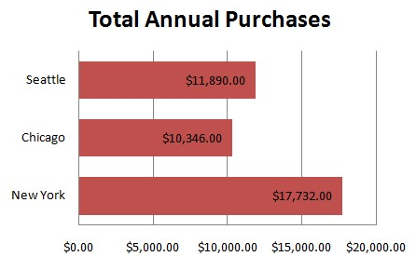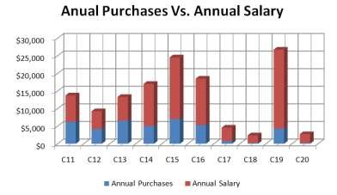

**160) Write a program to find out the solution for the following table?**

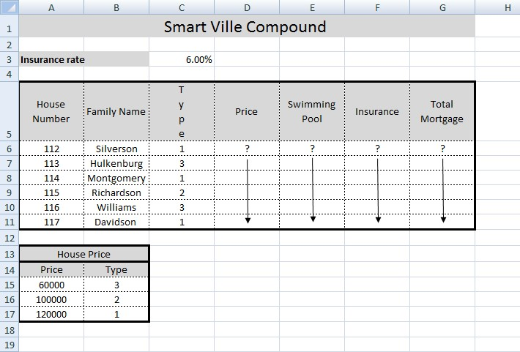

**Procedure:**

1. Create the worksheet shown above and rename it as “SmartVille”.
2. Name the cell range A13:B17 as Price.
3. Using VLOOKUP, find Price base on Type.
4. Find Swimming Pool, if the house type is 1 then print “yes” otherwise leave it blank.
5. Find Insurance, Insurance = Price * Insurance Rate.
6. Find Total Mortgage, Total Mortgage = Price + Insurance.

**161) Write a program to create the following table?**

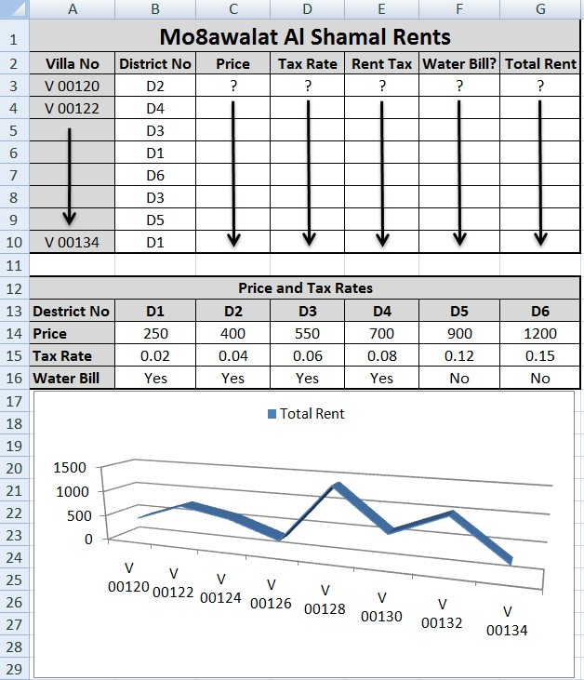

**Procedure:**

1. Create the worksheet shown above and rename as DESTRICT.
2. Using HLOOKUP, find Price based on DESTRICT NO.
3. Find TAX RATE based on DESTRICT NO.
4. Calculate RENT TAX, where RENT TAX = PRICE * TAX RATE.
5. Check if there is WATER BILL based on DESTRICT NO.
6. Calculate TOTAL RENT, where TOTAL RENT = PRICE + RENT TAX.
7. Format all money columns to 1 place of decimal.
8. Create the chart shown above.

**162) Write a program for the following table?**

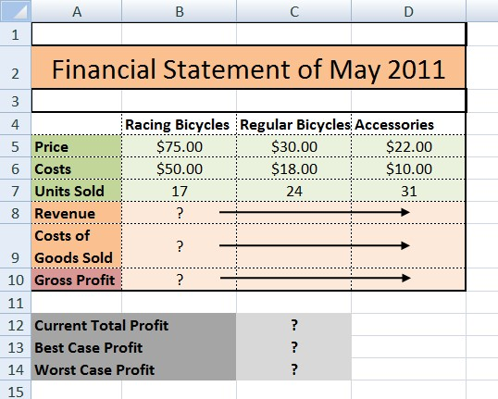

**Procedure:**

1. Create the worksheet shown above and rename it May 2011
2. Find the Revenue, Revenue = Price * Units Sold
3. Find the Cost of Goods Sold, Cost of Goods Sold = Cost * Units Sold
4. Find the Gross Profit, Gross Profit = Revenue – Cost of Goods Sold
5. Find the Current Total Profit, Current Total Profit is the total of all Gross Profits
6. Using the Scenario Manager, find the Best Case Profit and the Worst Case Profit, and save it in a new worksheet

|  |  |  |  |
| --- | --- | --- | --- |
| Best Case Profit |  |  |  |
|  | Racing Bicycles | Regular Bicycles | Accessories |
| Units Sold | 25 | 36 | 42 |

|  |  |  |  |
| --- | --- | --- | --- |
| Worst Case Profit |  |  |  |
|  | Racing Bicycles | Regular Bicycles | Accessories |
| Units Sold | 9 | 12 | 21 |

1. Link the results of the Best Case and Worst Case with the Scenario Summary.

**163) Write a program to find out the grade in the following table?**

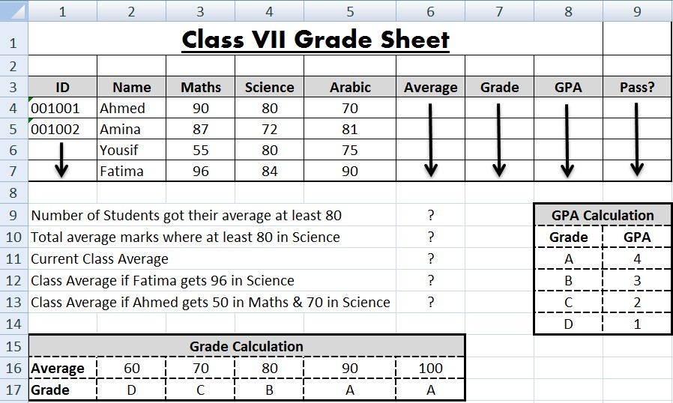

**Procedure:**

1. Create the worksheet shown above and rename it as ‘Section 5’.
2. Calculate the average marks for each student.
3. Find the Grade for each student by using the ‘Grade Calculation’ table.
4. Find the GPA for each student by using the ‘GPA Calculation’ table. Ensure that the results have 2 decimal places.
5. Check if the students failed or passed. If they get less than 60 in any their marks, they Failed otherwise they Passed.
6. Calculate the number of students who got their average marks not less than 80.
7. Calculate the total average marks for those students who scored at least 80 in Science.
8. Calculate the Current Class Average.
9. Using What-if analysis, find the changes to the class average if the following cases take place:
10. If Fatima gets 96 in Science.
11. Ahmed gets 50 in Maths and 70 in Science.
12. *Note: Your results should be obtained from ‘Scenario Summary’ created using Whatif Analysis.*
13. Create a bar chart which includes the Science and Arabic marks for all students.

14. Include your name at the center of the header and the page number at the right section of the footer.

**164) Write a program to change the page orientation in a word document?**

**Procedure:**

1. Select the Page Layout tab.

2. Click the Orientation command in the Page Setup group.

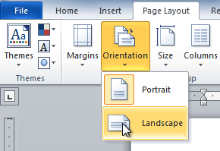

3. Click either Portrait or Landscape to change the page orientation.

Landscape format means the page is oriented horizontally, while portrait format means it is oriented vertically.

**165) Write a program for change the page size in a word document?**

**Procedure:**

1. Select the Page Layout tab.

2. Click the Size command, and a drop-down menu will appear. The current page size is highlighted.

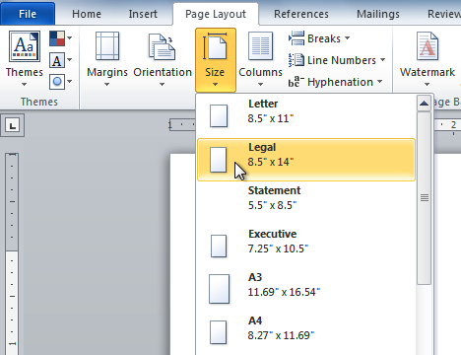

3. Click the size option you want. The page size of the document changes.

**166) Write a program To format page margins in a word document?**

**Procedure:**

1. Select the Page Layout tab.

2. Click the Margins command. A menu of options appears. Normal is selected by default.

3. Click the predefined margin size you want.

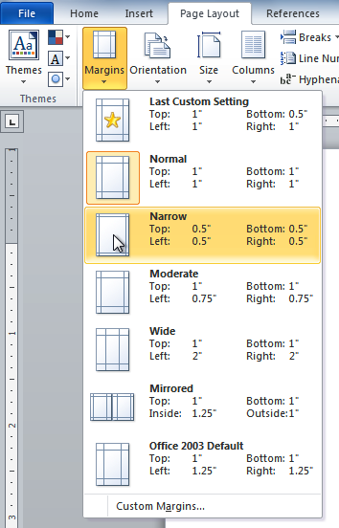

**167) Write a program To use custom margins in word document?**

**Procedure:**

1. From the Page Layout tab, click Margins.

2. Select Custom Margins. This will take you to the Page Setup dialog box.

3. Adjust the margin sizes for each side of the page, then click OK.

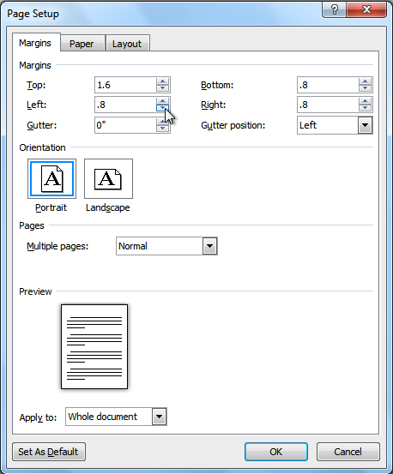

You can use Word's convenient Set as Default feature to save all of the formatting changes you've made and automatically apply them to new documents. To learn how to do this, read our article on [Changing Your Default Settings in Word](http://www.gcflearnfree.org/officetips/word-tips/changing-your-default-settings-in-word).

**168) Write a program To use the spelling check feature in word document?**

**Procedure:**

1. Right-click the underlined word. A menu will appear.

2. Click the correct spelling of the word from the listed suggestions.

3. The corrected word will appear in the document.

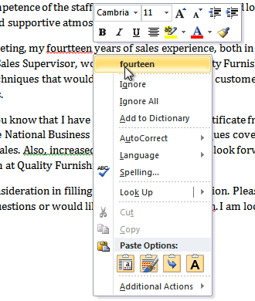

You can choose to Ignore an underlined word, add it to the dictionary, or go to the Spelling dialog box for more options.

**169) Write a program To use the grammar check feature?**

**Procedure:**

1. Right-click the underlined word or phrase. A menu will appear.

2. Click the correct phrase from the listed suggestions.

3. The corrected phrase will appear in the document.

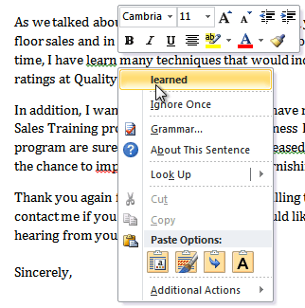

You can also choose to Ignore an underlined phrase, go to the Grammar dialog box, or click About This Sentence for information on the grammar rule.

**170) Write a program To change the automatic spelling and grammar check settings in word document?**

**Procedure:**

1. From Backstage view, click Options.

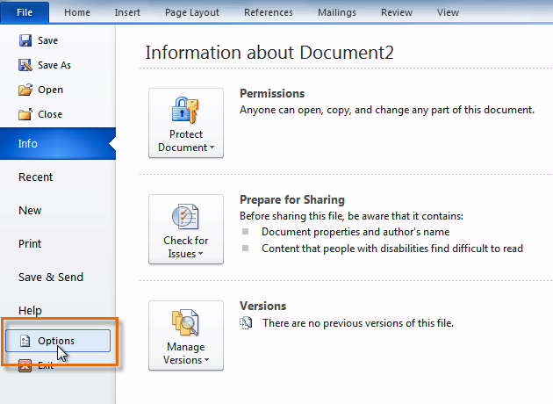

2. Select Proofing. The dialog box gives you several options to choose from.

3. If you don't want Word to automatically check spelling, uncheck Check spelling as you type.

4. If you don't want grammar errors to be marked, uncheck Mark grammar errors as you type.

5. To check for contextual spelling errors, check Use contextual spelling.

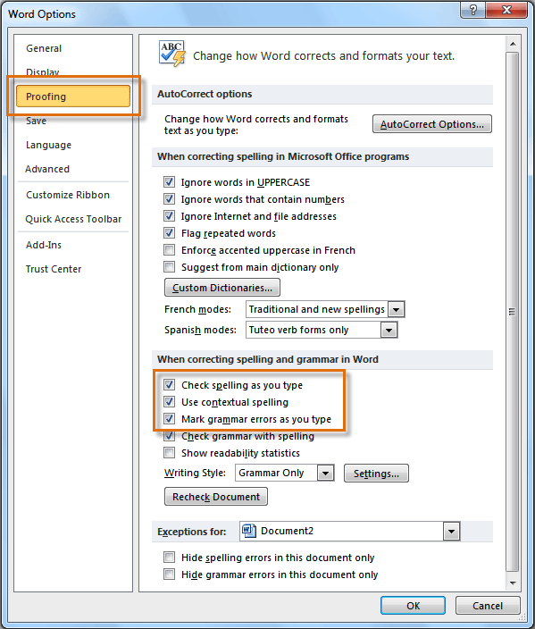

If you've turned off the automatic spelling and/or grammar checks, you can still run a check by going to the Review tab and clicking the Spelling & Grammar button.

**171) Write a program To hide spelling and grammar errors in a document?**

**Procedure:**

If you're sharing a document like a resume with someone, you might not want that person to see those annoying red, green, and blue lines. Turning off the automatic spelling and grammar checks only applies to your computer, so the lines may still show up when someone else views your document. Luckily, you can hide spelling and grammar errors in a document so the lines will not show up on any computer.

1. From Backstage view, click Options.

2. Select Proofing.

3. In the drop-down box next to "Exceptions for:" select the correct document (if you have more than one document open).

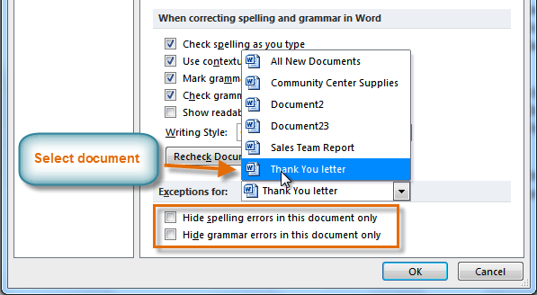

4. Put a check mark next to Hide spelling errors in this document only and Hide grammar errors in this document only.

5. Click OK.

**172) Write a program to view the Print pane?**

**Procedure:**

1. Click the File tab to go to Backstage view.

2. Select Print. The Print pane appears, with the print settings on the left and the Preview on the right.

3. Click the buttons in the interactive below to learn about the Print pane.

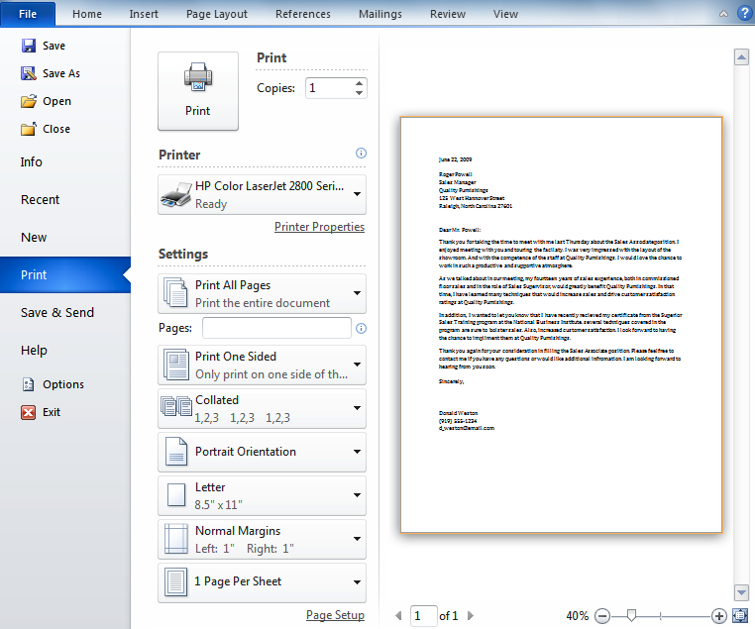

**173) Write a program to access the Quick Print button in a document?**

**Procedure:**

1. Click the drop-down arrow on the right side of the Quick Access toolbar.

2. Select Quick Print if it is not already checked.

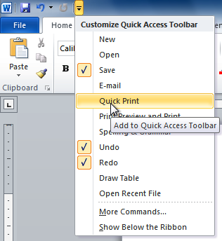

3. To print, click the Quick Print command.

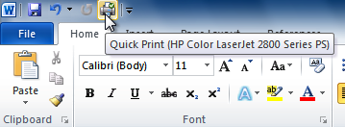

**174) Write a program to create or adjust a first-line indent or hanging indent.**

**Procedure:**

1. Place the insertion point anywhere in the paragraph you want to indent, or select one or more paragraphs.

2. To adjust the first-line indent, drag the first-line indent marker on the ruler.

3. To adjust the hanging indent, drag the hanging indent marker.

4. To move both markers at the same time, drag the left indent marker. This will indent all lines in the paragraph**.**

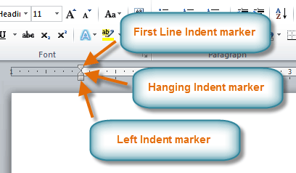

**175) Write a program to insert a hyperlink in word document?**

**Procedure:**

1. Select the text or image you want to make a hyperlink.

2. Right-click the selected text or image, then click Hyperlink. You can also right-click in a blank area of the document and click Hyperlink.

3. The Insert Hyperlink dialog box will open. You can also get to this dialog box from the Insert tab by clicking Hyperlink.

4. Using the options on the left side, you can choose to link to a file, webpage, email address, document, or a place in the current document.

5. If you selected text, the words will appear in the Text to display: field at the top. You can change this text if you want.

6. Type the address you want to link to in the Address: field.

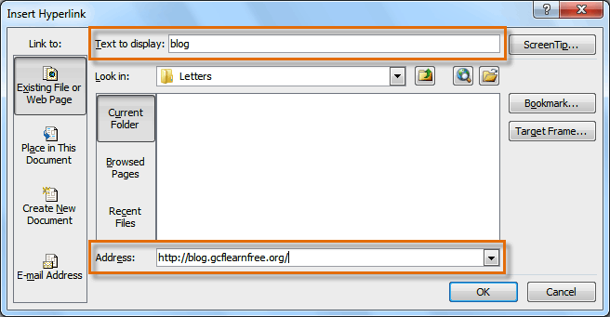

7. Click OK. The text or image you selected will now be a hyperlink.

**176) Write a program To make an email address a hyperlink.**

**Procedure:**

1. Right-click the selected text or image, then click Hyperlink.

2. The Insert Hyperlink dialog box will open.

3. On the left side of the dialog box, click Email Address.

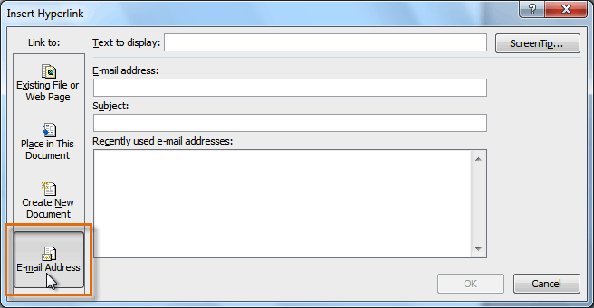

4. Type the email address you want to connect to in the Email Address box, then click OK.

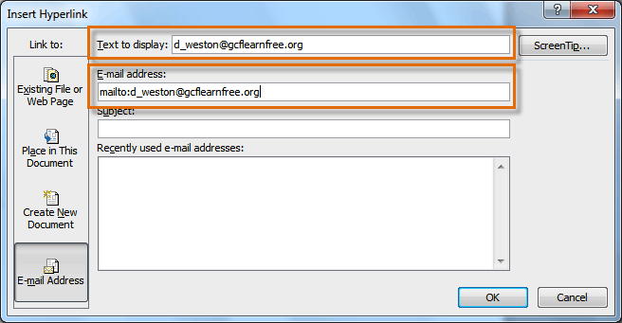

Word often recognizes email and web addresses as you type and will format them as hyperlinks automatically after you press the Enter key or the spacebar.

**177) Write a program To remove a hyperlink?**

**Procedure:**

1. Right-click the hyperlink.

2. Click Remove Hyperlink.

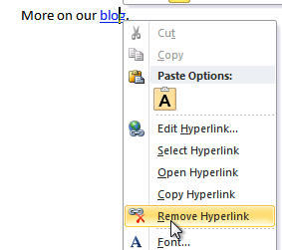

After you create a hyperlink, you should test it. If you have linked to a website, your web browser should automatically open and display the site. If it doesn't work, check the hyperlink address for misspellings.

**178) Write a program To change the order of shapes?**

**Procedure:**

If one shape overlaps another, you may need to change the ordering so the correct shape appears in front. You can bring a shape to the front or send it to the back. If you have multiple images, you can use Bring Forward or Send Backward to fine tune the ordering. You can also move a shape in front of or behind text.

1. Right-click the shape you want to move.

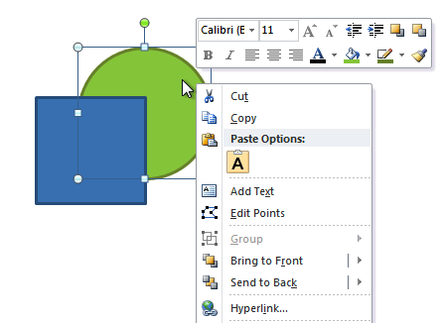

2. In the menu that appears, hover over Bring to Front or Send to Back. Several ordering options will appear.

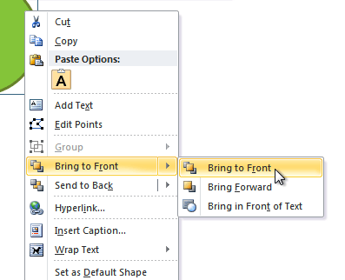

3. Select the desired ordering option. The shapes will reorder themselves.



4. In some cases, the ordering option you select will not affect the ordering of the shapes. If this happens, select the same option again or try a different option.

**179) Write a program to change to a different shape?**

**Procedure:**

1. Select the shape. A new Format tab appears with Drawing Tools.

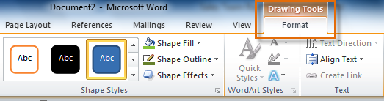

2. Click the Format tab.

3. Click the Edit Shape command.

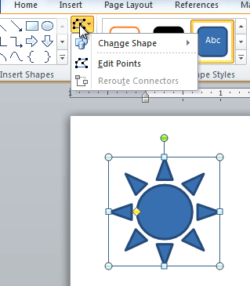

4. Click Change Shape to display a drop-down list.

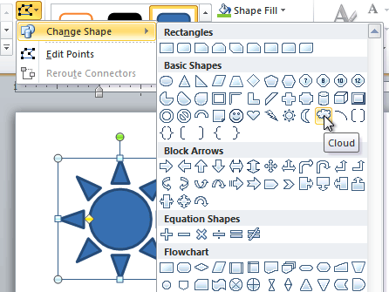

5. Select the desired shape from the list.



**180) Write a program to crop an image to a shape?**

**Procedure:**

1. Select the image. The Format tab will appear.

2. Select the Format tab.

3. Click the Crop drop-down arrow (below the Crop command). A drop-down menu will appear.

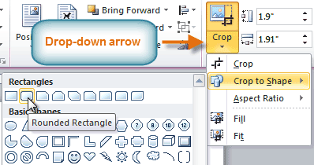

4. Select a shape from the drop-down menu.

5. The image will take the shape you have selected.



**181) Write a program to compress a picture?**

**Procedure:**

1. Select the picture. The Format tab will appear.

2. Select the Format tab.

3. Click the Compress Pictures command in the Adjust group. A dialog box appears.

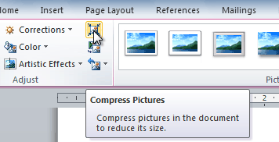

4. Place a check mark next to Delete cropped areas of pictures. You can also choose whether to apply the settings to this picture only or to all pictures in the document.

5. Choose a Target output. If you are emailing your document, you may want to select Email, which produces the smallest file size.

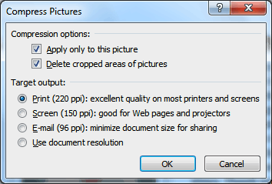

6. Click OK.

**182) Write a program to insert screenshots of a window?**

**Procedure:**

1. Select the Insert tab.

2. Click the Screenshot command in the Images group.

3. The Available Windows from your desktop will appear. Select the window you want to capture as a screenshot.

4. The screenshot will appear in your slide.

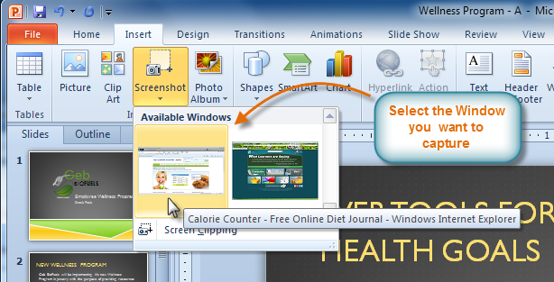

**183) Write a program to insert a screen clipping from a window.**

**Procedure:**

1. Select the Insert tab.

2. Click the Screenshot command, then select Screen Clipping.

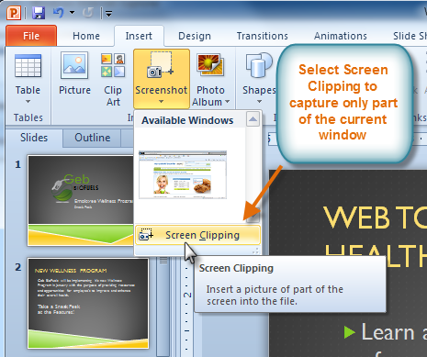

3. A faded view of your current desktop will appear, and your cursor will turn into a cross shape.

4. Click, hold, and drag on the area of the window you want to capture.

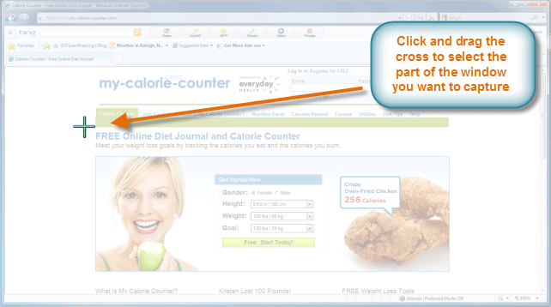

5. The screen clipping will appear in your slide.

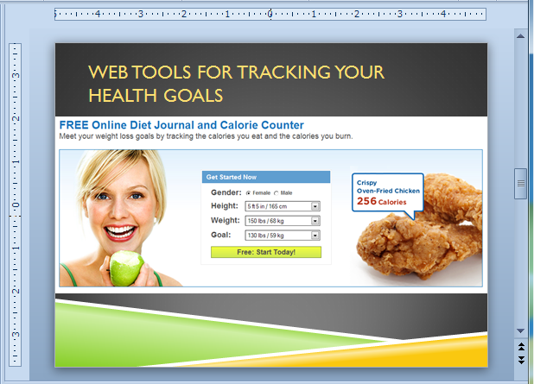

**184) Write a program to apply a transition to slides?**

**Procedure:**

1. Select the slide you want to modify.

2. Click the Transitions tab.

3. Locate the Transition to This Slide group. By default, None is applied to each slide.

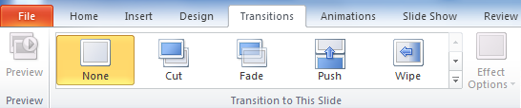

4. Click the More drop-down arrow to display all of the transitions.

5. Click a transition to apply it to the selected slide. This will automatically preview the transition as well.

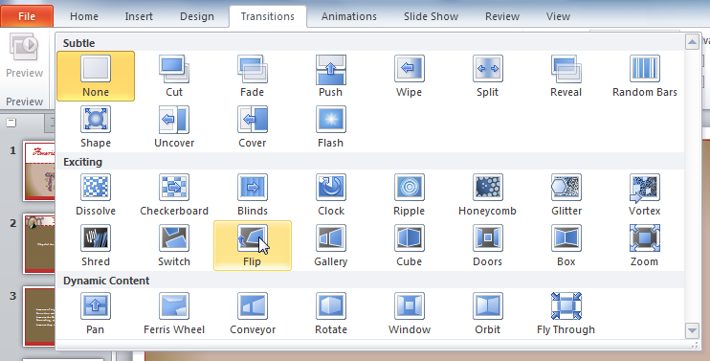

**185) Write a program to group worksheets?**

**Procedure:**

1. Select the first worksheet you want in the group.

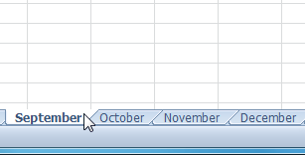

2. Press and hold the Ctrl key on your keyboard.

3. Select the next worksheet you want in the group. Continue to select worksheets until all of the worksheets you want to group are selected.

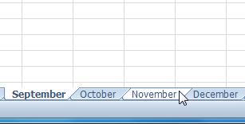

4. Release the Ctrl key. The worksheets are now grouped. The worksheet tabs appear white for grouped worksheets.

**186) Write a program to freeze rows in excel sheet?**

**Procedure:**

1. Select the row below the rows you want frozen. For example, if you want rows 1 and 2 to always appear at the top of the worksheet even as you scroll, then select row 3.

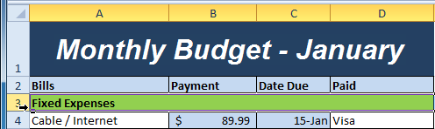

2. Click the View tab.

3. Click the Freeze Panes command. A drop-down menu appears.

4. Select Freeze Panes.

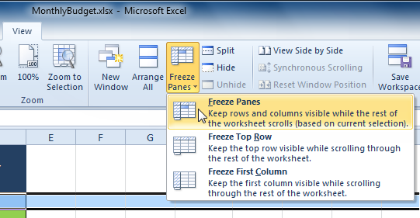

5. A black line appears below the rows that are frozen in place. Scroll down in the worksheet to see the rows below the frozen rows.

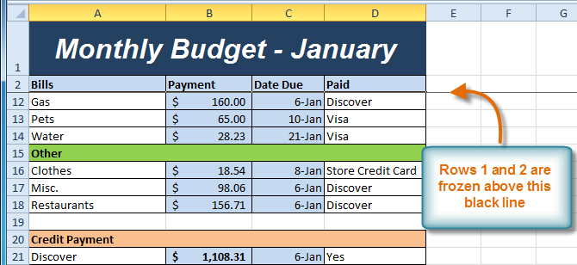

**187) Write a program to freeze columns?**

**Procedure:**

1. Select the column to the right of the columns you want frozen. For example, if you want columns A and B to always appear to the left of the worksheet even as you scroll, select column C.

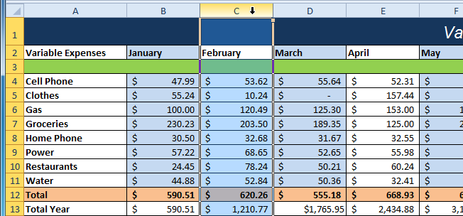

2. Click the View tab.

3. Click the Freeze Panes command. A drop-down menu appears.

4. Select Freeze Panes.

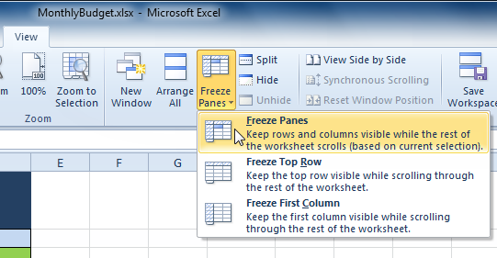

5. A black line appears to the right of the frozen area. Scroll across the worksheet to see the columns to the right of the frozen columns.

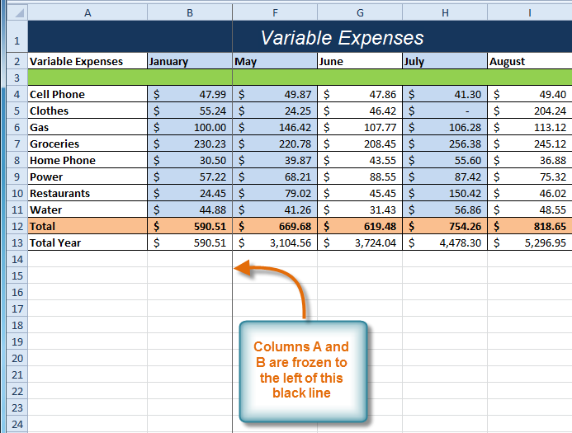

**188)** **write a program to unfreeze panes?**

**Procedure:**

1. Click the View tab.

2. Click the Freeze Panes command. A drop-down menu appears.

3. Select Unfreeze Panes. The panes will be unfrozen, and the black line will disappear.

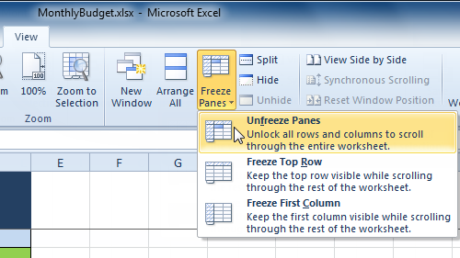

**189) write a program to fit a worksheet on one page?**

**Procedure:**

1. Click the File tab.

2. Select Print to access the Print pane.

3. Select Fit Sheet on One Page from the scaling drop-down menu.

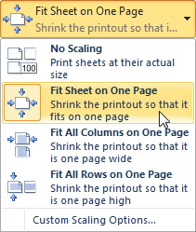

4.Your worksheet is reduced in size until it fits on one page. Remember that if it is scaled too small, it might be difficult to read.

**190) write a program to modify margins while in Print Preview.**

**Procedure:**

1. The margins of your worksheet may need to be adjusted to make data fit more comfortably on the printed page. You can adjust the margins in Print Preview.

2. Click the File tab.

3. Select Print to access the Print pane.

4. Click the Show Margins button. Your margins will appear.

5. Hover your mouse over one of the margin markersuntil the double arrowappears.

6. Click and drag the margin to your desired location.

7. Release the mouse. The margin is modified.

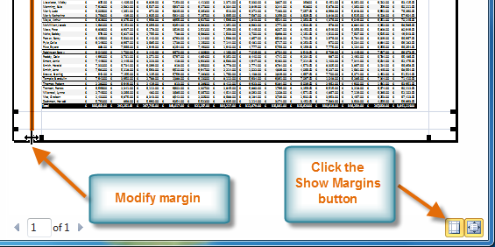

**191) write a program to use print titles?**

**Procedure:**

Imagine how difficult it would be to read a worksheet if the column and row headings only appeared on the first page. The Print Titles command allows you to select specific rows and columns to appear on each page.

1. Click the Page Layout tab.

2. Select the Print Titles command.

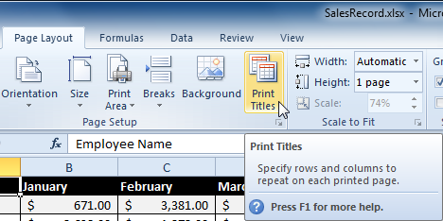

3. The Page Setup dialog box appears. Click the icon at the end of the Rows to repeat at top field.

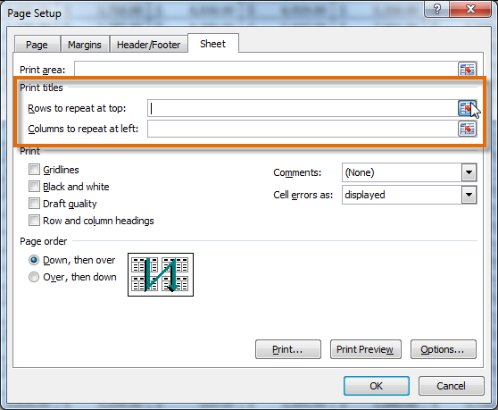

4. Your mouse becomes the small selection arrow. Click the rows you want to appear on each printed page. The Rows to repeat at top dialog box will record your selection.

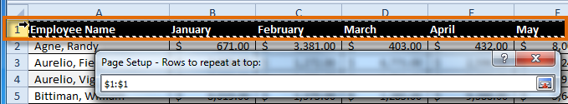

5. Click the icon at the end of the Rows to repeat at top field.

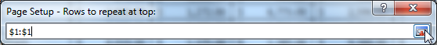

6. Repeat for Columns to repeat at left, if necessary.

7. Click OK. You can go to Print Preview to see how each page will look when printed.

**192)write a program to insert a break?**

**Procedure:**

1. Click the Page Layout tab.

2. Determine the placement of the break by clicking the row below, cell below, or column to the right of where you want the break to appear. For example, select column C, and a break will appear after column B.

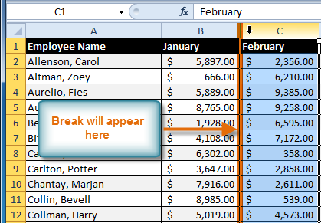

3. Select the Insert Page Break command from the Breaks drop-down menu.

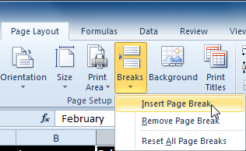

4. The break is inserted. You can go to Print Preview to confirm that it appears in the correct place on the page.

**193) Write a program to create and copy a formula using relative references.**

**Procedure:**

1. Select the first cell where you want to enter the formula (B4, for example).

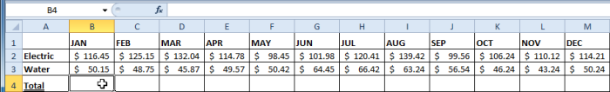

2. Enter the formula to calculate the value you want (B2+B3, for example).

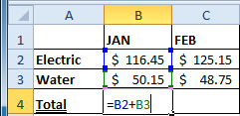

3. Press Enter. The formula will be calculated.



4. Select the cell you want to copy (B4, for example), then click the Copy command from the Home tab.

5.Select the cells where you want to paste the formula, then click the Paste command from the Home tab. You can also drag the fill handle to fill cells.

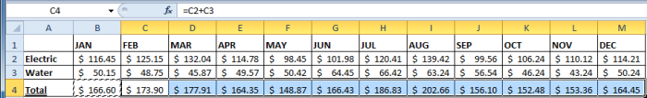

6. Your formula is copied to the selected cells as a relative reference (C4=C2+C3, D4=D2+D3, E4=E2+E3, etc.), and the values are calculated.

**194) write a program to create and copy a formula using an absolute reference.**

**Procedure:**

1. Select the first cell where you want to enter the formula (C4, for example).

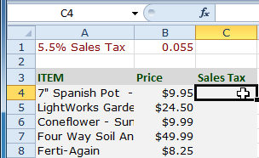

2. Type an equals sign, and then click the cell that contains the first value you want in the formula (B4, for example).

3. Type the first mathematical operator (the multiplication sign, for example).

4. Type the dollar sign ($), then enter the column letter of the cell you are making an absolute reference to (B, for example).

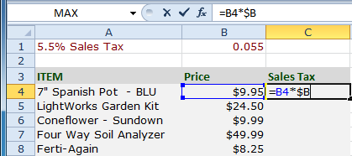

5. Type the dollar sign ($), then enter the row number of the same cell you are making an absolute reference to (1, for example).

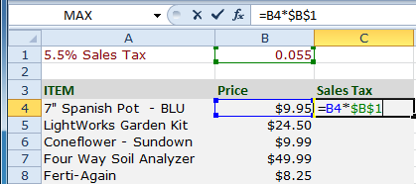

6. Press Enter to calculate the formula.



7. Select the cell you want to copy (C4, for example), then click the Copy command from the Home tab.

8. Select the cells where you want to paste the formula, then click the Paste command from the Home tab. You can also drag the fill handle to fill cells.

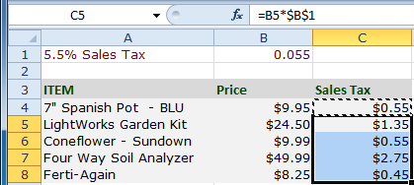

9. Your formula is copied to the selected cells using the absolute reference (C5=B5*$B$1, C6=B6*$B$1, etc.), and your values are calculated.

**195) write a program to sort in alphabetical order?**

**Procedure:**

1. Select a cell in the column you want to sort by. In this example, we'll sort by Last Name.

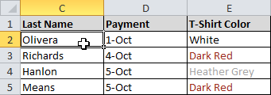

2. Select the Data tab, then locate the Sort and Filter group.

3. Click the ascending commandto Sort A to Z or the descending commandto Sort Z to A.

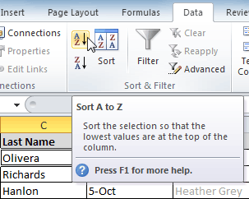

4. The data in the spreadsheet will be organized alphabetically.

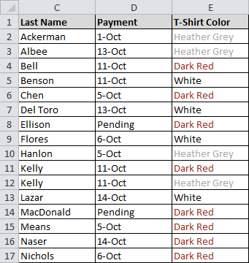

**196) write a program to sort in numerical order?**

**Procedure:**

1. Select a cell in the column you want to sort by.

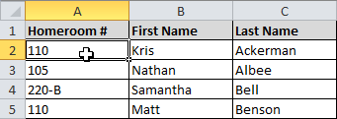

2. From the Data tab, click the ascending commandto Sort Smallest to Largest or the descending commandto Sort Largest to Smallest.

3. The data in the spreadsheet will be organized numerically.

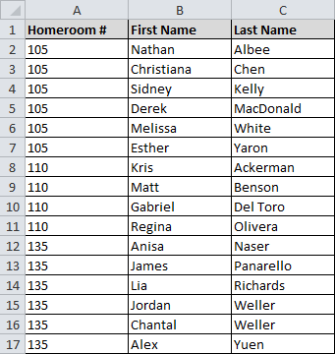

**197) write a program to sort by date or time?**

**Procedure:**

1. Select a cell in the column you want to sort by.

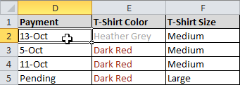

2. From the Data tab, click the ascending commandto Sort Oldest to Newest or the descending commandto Sort Newest to Oldest.

3. The data in the spreadsheet will be organized by date or time.

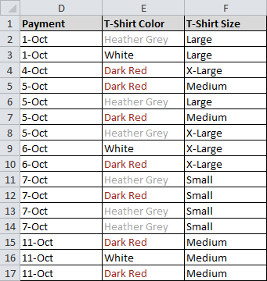

**198) write a program to sort in the order of your choosing?**

**Procedure:**

You can use a Custom List to identify your own sorting order, such as days of the week—or in this example, T-shirt sizes from smallest to largest.

1. From the Data tab, click the Sort command to open the Sort dialog box.

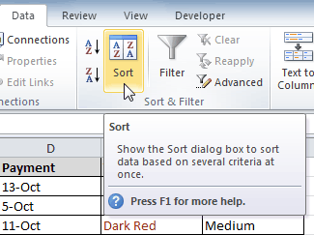

2. Identify the column you want to Sort by by clicking the drop-down arrow in the Column field. In this example, we'll choose T-Shirt Size.

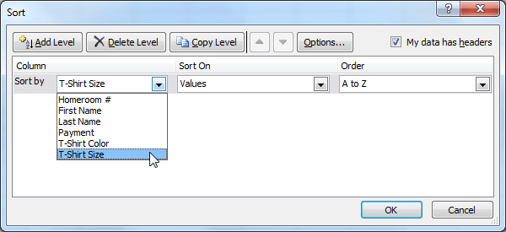

3. Make sure Values is selected in the Sort On field.

4. Click the drop-down arrow in the Order field, then choose Custom List.

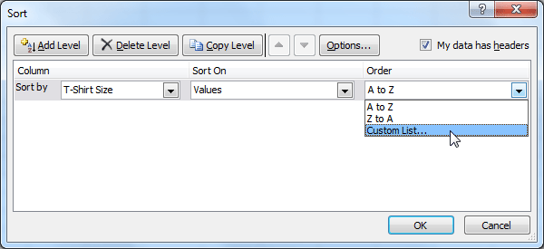

5. Select NEW LIST, and enter how you want your data sorted in the List entries box. We'll sort T-shirt sizes from smallest to largest.

6. Click Add to save the list, then click OK.

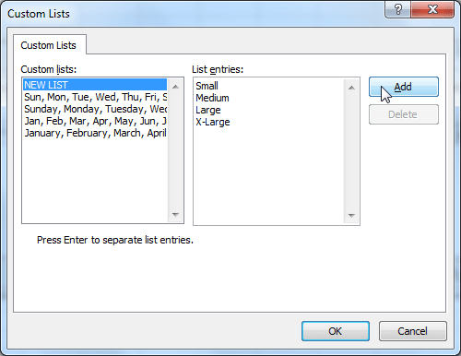

7. Click OK to close the Sort dialog box and sort your data.

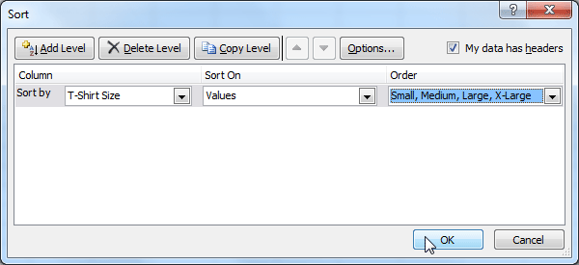

8. The spreadsheet will be sorted in order of Small, Medium, Large, and X-Large.

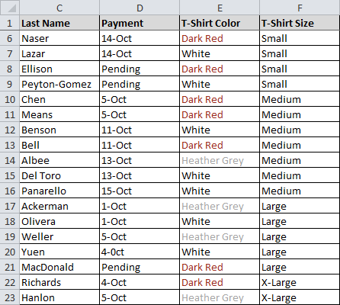

**199) write a program to sort by cell color, font color, or cell icon?**

**Procedure:**

1. From the Data tab, click the Sort command to open the Sort dialog box.

2. Identify the column you want to Sort by by clicking the drop-down arrow in the Column field.

3. Choose whether you want to sort by Cell Color, Font Color, or Cell Icon in the Sort On field. In this example, we'll sort by Font Color.

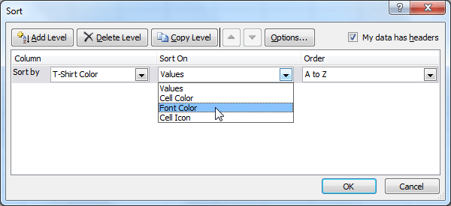

4. In the Order field, click the drop-down arrow to choose a color, then decide whether you want it ordered On Top or On Bottom.

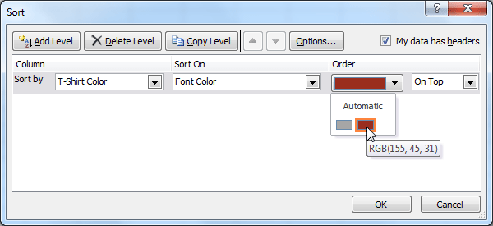

5. Click OK. The data is now sorted by attribute rather than text.

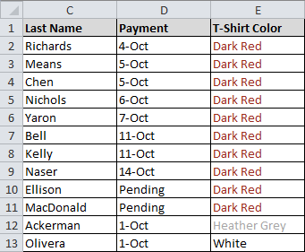

**200) write a program to change the sorting priority?**

**Procedure:**

1. From the Data tab, click the Sort command to open the Custom Sort dialog box.

2. Select the level you want to reorder.

3. Use the Move Up or Move Down arrows. The higher the level is on the list, the higher its priority.

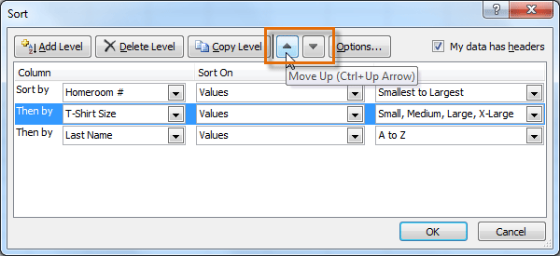

4. Click OK.